
Cal Poly Women’s Club Membership Form
Date _______________________________________
Last Name ___________________________________
First Name __________________________________
Department/Office/Major ______________________
Spouse/Partner/Significant Other Name ____________________________________________
Address ____________________________________________
City & Zip ____________________________________________
Telephone ____________________________________
Email ________________________________________
Newsletter by email delivery? ______ Yes ______ No
Future Club Directory in electronic version?
_______Yes ________ No

Thank you and welcome to the Cal Poly Women’s Club!
Club’s 101st Year 1924-2025!
2025-2026
Membership Dues

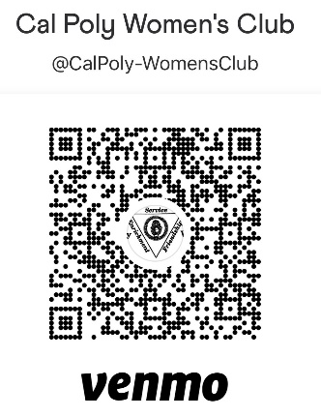
$30 per year (June to May)

- Checks payable to: Cal Poly Women’s Club or CPWC
Mail to: Elaine Ramos Doyle, 2381 Claranita Ave.,
Los Osos, CA 93402 or P.O. Box 1284, SLO 93406

- Venmo: @CalPoly-WomensClub or QR code below
- PayPal $31* to: cpwomensclub@gmail.com
* Includes PayPal’s fee

