High Conservation Value Forests on
Cal Poly Swanton Pacific Ranch

Date: 03/03/17

Swanton Pacific Ranch
California Polytechnic State University-San Luis Obispo
125 Swanton Road
Davenport, CA 95017
This report presents the assessment of High Conservation Value Forest (HCVF) at Swanton Pacific Ranch (SPR) for the certification from the Forest Stewardship Council (FSC). This report is prepared in accordance with Principle 9 of the FSC principles and criteria. The result of the assessment is in Table 1.
Table 1. HCVF attributes, examples, and the identified HCVF designations present at SPR
# | HCVF attributes | Examples | Present at SPR | Identified HCV at SPR
HCV1 | Forest areas containing globally, regionally, or nationally significant concentrations of biodiversity values | Endemism, endangered species, refugia |  | - Coho Salmon Habitat  - Steelhead Trout Habitat  - Red-Legged Frog Habitat  - Monterey pine forests
HCV2 | Forest areas containing globally, regionally, or nationally significant large landscape level forests, contained within, or containing the management unit, where viable populations of most if not all naturally occurring species exist in natural patterns of distribution and abundance
HCV3 | Forest areas that are in or contain rare, threatened or endangered ecosystems |  |  | - Burl forming manzanita stands  - General Smith Stand (previously entered old-growth)  - Residual Old-growth trees  - Second growth reserve  - Inner gorge of Valencia Creek
HCV4 | Forest areas that provide basic services of nature in critical situations | Watershed protection, erosion control |  | - Fisheries
HCV5 | Forest areas fundamental to meeting basic needs of local communities | Subsistence, health
HCV6 | Forest areas critical to local communities’ traditional cultural identity | Areas of cultural, ecological, economic, or religious significance identified in cooperation with local communities

Each of the high conservation values are shown on the following maps. Figure 1 contains the species of special concern at SPR, Figure 2 contains the Forest areas in SPR, and Figure 3 shows the HCVs at the Valencia property.
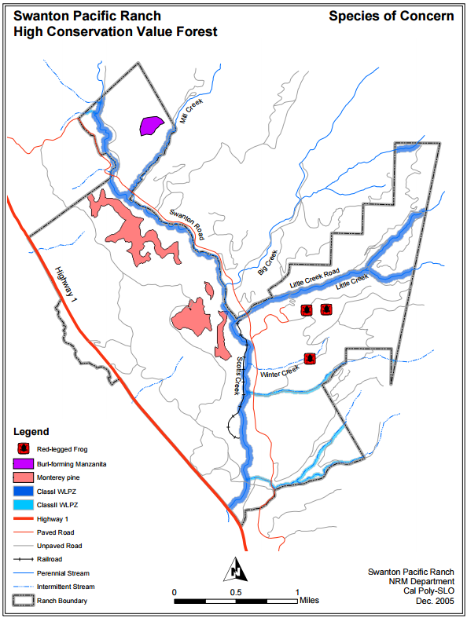
Figure 1. Species of Concern at Swanton Pacific Ranch’s High Conservation Value Forest
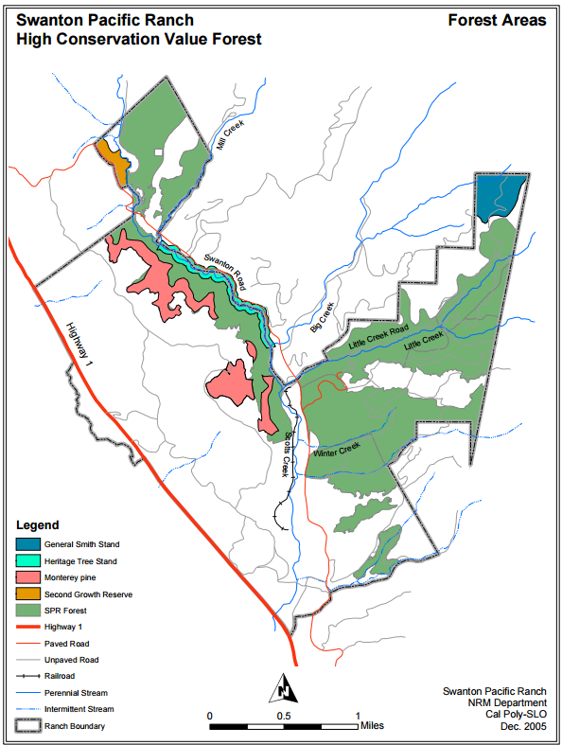
Figure 2. Forest Areas at Swanton Pacific Ranch’s High Conservation Value Forest
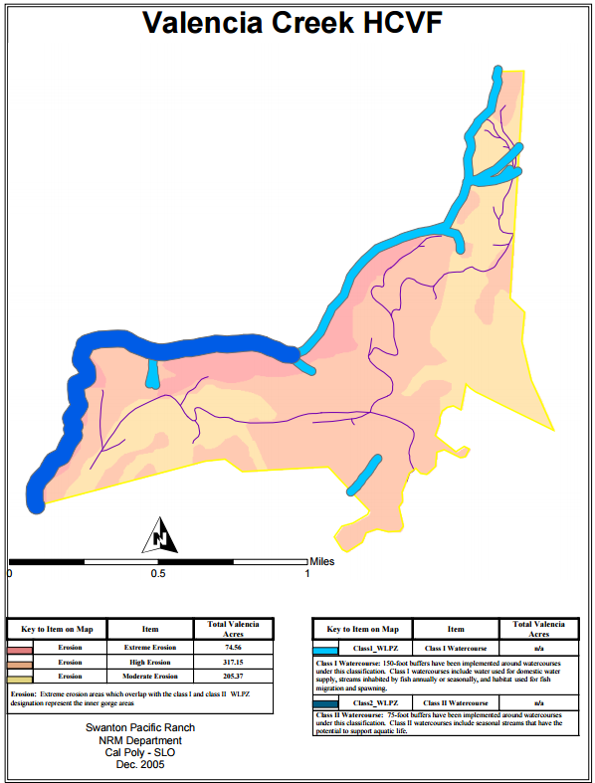
Figure 3. Swanton Pacific Ranch’s High Conservation Value Forest at the Valencia Creek property
Overview of HCVF Assessment on the Swanton Pacific Ranch Forest
The Swanton Pacific Ranch Forest is owned by the California Polytechnic State University Corporation (CPC). CPC is a 501.c.3. nonprofit corporation established as an auxiliary corporation to California Polytechnic State University, San Luis Obispo. The mission of the Cal Poly Corporation is to provide self-supporting, responsible, diversified, creative, and high quality services, which complement the instructional program of the University and assist the institution in achieving its educational mission. The University strives to stimulate creativity and develop dynamic professionalism among its faculty, students, and staff. CPC will help support this objective with innovative services and programs sought by the University, which will enhance the educational and social environment of the institution. Swanton Pacific Ranch is managed by the College of Agriculture, California Polytechnic State University under a Memorandum of Understanding between Cal Poly State University, and Cal Poly Corporation.
The forest areas of Swanton Pacific Ranch along with the habitat and riparian areas are utilized by the Natural Resources Management and Environmental Sciences (NRES) Department for its “School Forest”. The forest is utilized extensively for field trips to support classroom instruction, applied research for senior projects and master’s level research, summer short courses, and internships.
The management of the ranch for timber resources is subject to all the applicable rules and regulations of the California Forest Practice Rules which result from the Z’Berg Nejedly Forest Practice Act of 1973. This legislation includes rules specific to the commercial management of timber lands in Santa Cruz County. SPR also falls within the extended region of the California Coastal Commission. Most of the main unit of the ranch lies within an area of Santa Cruz County that is designated as Agricultural Resource under the County General Land Use Plan. The main unit also lies entirely within the expanded Coastal Zone of the County and therefore has special restrictions and regulations placed upon it. The Valencia Creek Unit by Aptos is not within the Coastal Management Zone.
Cal Poly Corporation, following the recommendation of the NRES Department faculty, sought FSC certification for the forest lands of the SPR in 2004. As part of the certification requirement, Swanton Pacific Ranch Forest (SPRF) must include an assessment for HCVF values using the definition Forest Stewardship Council’s Principle 9. According to the definition, High Conservation Value Forests are those that possess one or more of the following attributes as shown in Table 1. Virtually all of the SPR has conservation value, but the only HCV categories that apply to the ranch are Categories 1, 3, and 4. Within each category, Table 1 identifies which HCVs are found on Swanton Pacific Ranch.

Annual Monitoring and Assessment of the HCV’s
In assessing HCVFs for the SPRF, the NRES Department faculty have been inclusive in their approach with regard to the FSC Principles and Criteria. The faculty does not claim that the prescriptions and approaches are perfect, but they have been thoughtfully prepared and are based upon the best available scientific information. The monitoring plan is thought to be effective in determining the efficiency of the prescriptions without being overly cumbersome or time consuming. The plan for the HCVF approach will be continually reviewed to determine the completeness of the inclusions and the effectiveness of the prescriptions and monitoring.
Part of the HCV methodology must be an ongoing process for keeping records and prescriptions up to date. The primary driver for the upkeep of information is the timber management plan, THP and NTMP processes, which is the open public record of how and why the SPR forest is managed as it is. It is a public record of forest management process and decision-making. Reporting on HCVs is a necessary and important part of the FSC process. The contents of this HCVF report need to be reviewed periodically to ensure that it is complying with FSC Principle 9.
The following report details each HCV’s rank status, description, current management, and annual monitoring protocol. Comments and suggestions are welcome at any time and should be directed to Dr. Brian Dietterick, Director of SPR: bdietter@calpoly.edu or Steve Auten, Operations Manager of SPR: sauten@calpoly.edu

Category 1) Forest areas containing globally, nationally or regionally significant concentrations of biodiversity values
Based on a review of habitat requirements, current threats, range maps, known occurrences on the Swanton Pacific Ranch Forest, potential impacts from forest operations, the status of populations and a supplementary literature review, the HCV designations of Category 1 includes:
- Coho salmon (riparian areas of Scotts and Mill Creek)
- Steehead (riparian areas of Scotts, Little and Mill Creek)
- California red-legged frog (Staub House and Winter Creek ponds)
- Monterey pine (Scotts Creek stand)

The descriptions of the HCV species with records of occurrence within the boundaries of the timber management area of the SPRF are shown in Table 1. The table also includes species that are considered to be “at risk” (special concern, threatened, or endangered) nationally or statewide as well as other species that are not “at risk” but are considered to be “rare”. Swanton Pacific Ranch is implementing a monitoring procedure to assess the condition of the areas within the certified forest designated as possessing high conservation value as seen in Table 3.
Table 2. Category 1’s HCV species and their conservation status by United States Fish & Wildlife Service (USFWS), California Department of Fish and Wildlife (CDFW), and California Native Plant Society (CNPS), as well as their description and management at Swanton Pacific Ranch
Scientific name | Common name | - Rank Status  - Description  - Management

FISH
Oncorhynchus kisutch | Coho salmon | - This fish is listed as federally endangered (USFWS) in the ESU South of San Francisco and was first listed in November, 1996. It is also listed as endangered by CDFW under the CESA (California Endangered Species Act) since December, 1995.  - The Scotts Creek Watershed has been identified as critical habitat for the Coho salmon and is a stream identified in the Coho recovery plan adopted in 2004. Spawning of wild and hatchery populations occurs in Scotts Creek and Mill Creek on SPR. These streams are classified as Class I streams under the Forest Practice Rules (FPR).  - Scotts Creek watershed is considered a Watershed in the Coastal Anadromy Zone (CAZ) and SPR must follow the Anadromous Salmonid Protection (ASP) Rules. These rules provide adequate protection of the species from incidental take and for protection of the critical habitat features, since there is a potential high risk from forestry and other land use activities to the critical habitat. The ASP rules will be implemented fully on all the covered class streams on SPR, especially the Class I and Class II streams.
Oncorhynchus mykiss | Steelhead | - This fish is listed as federally threatened (USFWS) and was first listed in October, 1997.  - The Scotts Creek Watershed has been identified as critical habitat for the steelhead. Spawning of wild and hatchery populations occurs in Scotts Creek, Little Creek, and Mill Creek on SPR. These streams are classified as Class I streams under the FPR.  - Potential high risk from forestry and other land use activities to the critical habitat. Special protection measures are imposed in the FPR’s for California for under the ASP Rules. These rules provide adequate protection for protection of the species from incidental take and for protection of the critical habitat features. The ASP rules will be implemented fully on all the covered class streams on SPR, especially the Class I and Class II streams.

AMPHIBIANS
Rana aurora draytonii | California red-legged frog | - The California red-legged frog is listed as threatened by USFWS since 1996. The species is also a CDFW Species of Special Concern as of 1994.  - Critical habitat for this frog consists of still water with no significant introduced predators, such as large-mouthed bass or bull frogs. This habitat is provided mostly by reservoirs or lakes. On the SPR there are numerous livestock watering ponds that have been constructed and now house a large population of frogs. Little natural habitat occurs in the area, with only one naturally occurring pond in the Swanton area.  - The threat from forestry activities is low to most of the habitat, since most of the ponds occur outside of harvest areas, forested areas, or near haul routes. Seasonal restrictions on logging activities further acts to reduce the risk of incidental take while the frogs are active in upland movement or migration. Restrictions on proximity to ponds and seasonal timing of operations as required in our Non-Industrial Timber Management Plans (NTMP) and Timber Harvest Plans (THP) to provide adequate protection. Only two ponds are identified where potential impacts of forestry activities could present significant risk, the Staub House pond and the Winter Creek pond. These two ponds are considered for designation as HCV.

PLANTS
Pinus radiata | Monterey pine | - The CNPS listed Monterey pine as California Rare Plant Rank 1B.1: Plants Rare, Threatened, or Endangered in California and Elsewhere. Plants with a California Rare Plant Rank of 1B are rare throughout their range, as Monterey pine is endemic to California. Threat Rank 0.1 means that this species is seriously threatened in California with over 80% of occurrences threatened/high degree and immediacy of threat as ranked by CNPS. A listing under the CESA was attempted by the CNPS; however, the petition was pulled prior to hearing by the Fish and Game Commission.  - The native populations are of extreme value in the world as a source of new genetic material for the radiate pine industry around the world. This species of pine is the most widely planted outside its native range of any pine species. Populations have declined significantly over the last century. The main threat seems to be from development in two of the mainland stands of Monterey pine, Cambria and Monterey. The Año Nuevo stand is under much less development pressure, since most of the stand is zoned TPZ or CA or is under ownership of State Parks. Some believe that pitch canker poses a significant threat to the species; however, earlier projections of mortality have not been observed.  - Low risk from forestry operations. The stand is of great value as a research area for multiple projects on pitch canker and is managed as a research area for Monterey pine at SPR. Harvest access routes could be constructed through the stands.

Table 3. Category 1’s HCV Monitoring Protocol for Swanton Pacific Ranch
HCV | Annual Monitoring Protocol
Coho salmon | - CDFW and SPR staff routinely ensure the WLPZ prescription is applied appropriately.  - The Regional Water Quality Control Board (RWQCB) establishes monitoring requirements for each THP/NTMP, based on resources and specific plan features. Monitoring efforts are conducted by SPR staff and reviewed by RWQCB staff at a 24 hour notice and in an annual report.  - SPR is conducting watershed measurements on Little Creek, monitoring the water quality and quantity.  - NOAA monitors the Coho salmon population in Scotts Creek.  - CDFW does habitat evaluations of streams on a periodic basis to determine habitat condition.
Steelhead | - CFDW and SPR staff routinely ensure the WLPZ prescription is applied appropriately.  - The Regional Water Quality Control Board (RWQCB) establishes monitoring requirements for each THP/NTMP, based on resources and specific plan features. Monitoring efforts are conducted by SPR staff and reviewed by RWQCB staff at a 24 hour notice and in an annual report.  - SPR is conducting watershed measurements on Little Creek, monitoring the water quality and quantity.  - NOAA monitors the Steelhead population in Scotts Creek.  - CDFW does habitat evaluations of streams on a periodic basis to determine habitat condition.
California Red-legged Frog | - CDFW and SPR staff routinely ensure that any timber harvesting prescriptions are applied appropriately.  - USFW is responsible for population studies
Monterey pine | - SPR staff periodically monitor the conditions of the stands

Recognized for its high biodiversity and abundant resources, Swanton Pacific Ranch provides a valuable opportunity to study the methods of resource conservation applied through sustainable management techniques. Professionals, Cal Poly faculty, graduate students, and undergraduates actively pursue research opportunities, utilizing the forest, range, crop, and watershed resources within the ranch. Periodically, research papers will be released on these different subjects that state the conditions of these HCVF’s. Monitoring of the HCV areas to confirm that the resources are protected is an important aspect of the assurance that these resources are in fact protected by the special management guidelines. This research ultimately assesses the efficiency of management practices in maintaining and/or enhancing the HCVs. The following are identified Category 1 HCVFs on the Swanton Pacific Ranch Forest as well as a few examples of the associated projects and papers that have researched and monitored these areas.

- Coho Salmon/Steelhead Trout Habitat:
Bond, M. H. 2006. The Importance of Estuarine Rearing to Central California Steelhead (Oncorhynchus mykiss) Growth and Marine Survival. University of California Santa Cruz. MS Thesis.
Bond, M.H., S. A. Hayes, C. V. Hanson, and R. B. MacFarlane. 2008. Marine survival of steelhead (Oncorhynchus mykiss) enhanced by a seasonally closed estuary. Canadian Journal of Fish Aquatic Science.
Bond, M. H., S. A. Hayes, C. V. Hanson, and R. B. MacFarlane. 2008 Marine survival of steelhead (Oncorhynchus mykiss) enhanced by a seasonally closed estuary. Canadian Journal of Fisheries and Aquatic Sciences.
Frechette, D.M. 2010. Impacts of avian predation on juvenile salmonids in central California watersheds. San Jose State, San Jose. MS Thesis.
Frechette, DM. et al. (2013) A bioenergetics approach to assessing potential impacts of avian predation on juvenile steelhead (Oncorhyncus mykiss) during freshwater rearing. North American Journal of Fisheries Management.
Hayes, S.A., Ammann, A.J., Bond, M.H., et al. (2007) Bar-built estuaries and salmonids on the central coast: A case study of Scott Creek. California Estuarine Research Society. Bodega Bay Marine Lab, Mar 18-20th.
Hayes, S.A., Bond, M.H., Harding, J., et al. (2007) From barriers to beaches, monitoring central California coho and steelhead in Scott Creek. AFS 137th Annual Meeting. San Francisco, California Sept 2-6th.
Hayes, S.A., Hanson, Chad V., MacFarlane R. Bruce; Bond, Morgan H. (2008) Marine survival of steelhead (Oncorhynchus mykiss) enhanced by a seasonally closed estuary.Canadian Journal of Fisheries & Aquatic Sciences. Oct 2008.
Hayes, Sean A., et al. “Down, Up, Down And ‘Smolting’ Twice? Seasonal Movement Patterns By Juvenile Steelhead In A Coastal Watershed With A Bar Closing Estuary.” Canadian Journal of Fisheries & Aquatic Sciences. March 2011.
Pearse, D. E. Hayes, S.A., Bond, M.H., Hanson, C.V., Anderson, E.C., MacFarlane, R.B., and Garza, J.C. 2009. Over the falls? Reproductive isolation and ecotype evolution in resident trout and anadromous steelhead. Journal of Heredity.
Pipal, Kerrie A., et al. "Estimating Escapement for a Low-Abundance Steelhead Population Using Dual-Frequency Identification Sonar (DIDSON). North American Journal of Fisheries Management. September 2012.
Smith, J.J. 2013. Distribution and abundance of juvenile coho and steelhead in Gazos, Waddell, and Scott Creeks in 2012. San Jose State University, San Jose.
Sturm, E. A., E. A. Gilbert-Horvath, J. C. Garza, and R. B. MacFarlane. 2009. Creation of a captive broodstock program for southern coho salmon (Oncorhynchus kisutch): results from the initial rearing and spawning of the first brood year. NOAA Technical Memorandum.
- Red-Legged Frog Habitat
Research external to Cal Poly includes a study by USFWS of the red-legged frog’s migration patterns:
Bulger, John B., Scott, Norman J., Seymour, Richard B. Terrestrial activity and conservation of adult California red-legged frogs (Rana aurora draytonii) in coastal forests and grasslands. Journal of Herpetology. June 2007.
- Monterey pine Forests
Current graduate student, Tori Norville, is studying the silvicultural effects of Pitch Canker on Monterey Pine seedlings in the Año Nuevo native stand.

Ferchaw, Valerie A.L, Elicia Goldsworthy, Jason Pinkerton, David In Yun, Ulric Lund, Walter Mark, Sauli Valkonen, and Douglas Piirto. Management strategies for pitch canker infected Año Nuevo Stands of Monterey pine. Forest Ecology and Management. 2013

Garbelotto, M., Smith, T., and Schewigkofler, W. Variation in Rates of Spore Deposition of Fusarium circinatum, the Causal Agent of Pine Pitch Canker, Over a 12-Month-Period at Two Locations in Northern California. American Physiological Society Journal. 2008.
Piirto, D. and S. Valkonen. Structure and development of pitch canker infected Monterey pine stands at Año Nuevo, California. Forest Ecology and Management. 2005.
Pinkerton, K., 2006. Silvicultural management strategies for pitch canker infected Año Nuevo s tands of Monterey pine: Second year gap regeneration results. M.S. Thesis, California Polytechnic State University, San Luis Obispo, CA

Stephens, Scott L., Douglas D. Piirto, and Domenico F. Caramagno. “Fire Regimes and Resultant Forest Structure in the Native Año Nuevo Monterey Pine (Pinus radiata) forest, California.” The American Midland Naturalist. 2004.
Wise, E., 2004. Silvicultural strategies for pitch canker infected Año Nuevo stands of Monterey pine: First year gap regeneration results. M.S. Thesis, California Polytechnic State University, San Luis Obispo, CA

Category 3) Forest areas that are in or contain rare, threatened, or endangered ecosystems.
Based on Category 3’s assessment from CNPS, World Wildlife Fund (WWF) Ecoregion Assessment, Conservation International, local botanical surveys, and the Scotts Creek Watershed Council, these are the HCV’s designations and corresponding locations:
- Burl forming manzanita communities ((Arctostaphylos tomentosa ssp. crinita) Schoolhouse ridge between Scotts and Mill Creek)
- General Smith Stand of previously entered old-growth redwood, Type II old-growth. (North Fork Unit)
- Residual old-growth trees (Located intermittently around SPR forestland)
- Second growth reserve (Area of SPR Forest between Swanton Road and Scotts Creek at the north end of the ranch)
- Inner gorge of Valencia Creek (At SPR’s Valencia Creek property)

Swanton Pacific Ranch has been noted by well-recognized botanists as a California floristic hotspot. This identifies California as an area of great biodiversity and the SPR is certainly part of this, with over 600 California native plants occurring in the Scotts Creek watershed, representing 10-12 percent of the California native flora. The SPR Forest contains two forest types that contain unique species and communities and are considered rare ecosystems: Monterey pine forest and the old-growth redwood forest stands (General Smith Stand). The Monterey pine forest communities have already been identified as HCV’s in previous categories, see Category 1 for more information. The ranch also contains a manzanita that is endemic to the region. The descriptions, management, and status of Category 3’s HCVs are shown in Table 4 and the monitoring programs for each HCV are shown in Table 5.
Table 4. Category 3’s HCV Assessment at Swanton Pacific Ranch
Swanton Pacific Ranch HCV | 1.Description  2. Management  3. Status
Burl forming manzanita communities | - Whoolyleaf manzanita (Arctostaphylos tomentosa ssp. crinita) found on the ridge between Scotts Creek and Mill Creek are a dynamic and taxonomically confusing community of unique specimens as told by native botanist, Jim West. The diversity of these specimens precludes clear definition of the taxonomic identity, although the aforementioned scientific name is as close as one can come. The adjacent community is at risk from wildfire, since it is adjacent to and mixed with knobcone pine stands. The burl-forming characteristic is an adaption to fire.  - These populations warrant further study and protection until the taxonomic studies can be completed. No timber activities are allowed in these communities. Recreational trails and fire breaks can be placed and maintained in the community.  - Current visual evaluations suggest that the burl-forming manzanita are maintaining their area of occupation and are recovering.
General Smith Stand | - This stand is a previously harvested old growth stand located at the Northeast section of SPR in the North Fork Unit. It is considered by FSC as a Type II Old Growth and was only partially entered during the harvesting before 1920. The stand is relatively small, approximately 10 acres. Numerous examples of old growth redwood trees in the age range of 350 to 500 years old are present. The stand appears to have originated from fire from an earlier redwood forest, due to the clumped nature of the old-growth trees. Several snags from previous fires are present in the stand.  - SPR will maintain the character and functionality of this stand which is considered by FSC as a Type II Old Growth. Only thinning from below will be allowed to extend or enhance these stands. Single tree harvesting may be conducted in this stand. Residual old growth trees will be protected during harvest, per SPR and FSC policy.  - Current visual evaluations suggest that the General Smith Stand appears to be stable.
Residual old-growth trees | - These unique specimens are located throughout the forest at various locations. Many are located in the WLPZ areas along Scotts Creek. These old growth trees are remnant individuals from the old growth forests that were largely clearcut from the SPR holdings prior to 1920 and were established prior to 1800 AD. Recent work on individual old growth tree importance, shows that these trees provide significant value in terms of wildlife habitat and stand diversity. Old growth and legacy characteristic redwood trees can be described as being approximately 60 inches at DBH and were present in the dominant overstory during the late successional stages of forest development of the first-growth stands (pre 1800's). These trees have outward indicators such as platy bark with deep fissures, basal hollows with fire scars of multiple ages, large complex branching structures, flat tops, and limbs at least 8-10 inches in diameter that provide an opportunity for platforms/nesting. T  - No old growth or legacy trees live or dead will be harvested on lands of Swanton Pacific Ranch. These trees are preserved based on a policy that protects by age, size, function and characteristic by species. Only thinning from below will be allowed in these stands to extend or enhance these stands  - Current visual evaluations suggest that the residual old-growth trees appear to be stable.
Second growth reserve | - An area of SPR Forest between Swanton Road and Scotts Creek at the north end of the ranch is designated as a second growth reserve. The purpose of this area is to have a baseline to compare unentered second-growth to managed second-growth.  - No harvest activity is allowed in this stand. No road construction is allowed. Trails and recreational use is allowed in these areas.  - Current visual evaluations suggest that the second growth reserve appears to be stable.
Inner gorge of Valencia Creek | - Running from north to south, the property begins at Valencia Creek and is extremely steep with significant inner gorge characteristics. When approaching the ridgetops, these steep slopes become more gradual after transitioning through steep perennial and intermittent streams to Valencia’s upper watershed headwaters. Valencia Creek is a tributary to Aptos Creek, which flows through the coastal community of Aptos, CA. This stream has had significant flooding in the past during El Nino events.  - During the evaluation of the Valencia Creek property for the NTMP, the inner gorge area of the watershed was designated as a special cut area. This area requires that any trees to be cut have to be pre-marked and reviewed by the California Geological Survey to assess the potential to cause erosion or landslide problems. During the timber sales in 2000/2001 and 2013/2014, no trees were cut in the inner gorge designation area.  - Current visual evaluations suggest that the inner gorge of Valencia Creek continues to be active, but is predominantly stable.

Table 5. Category 3’s HCV Monitoring Protocol for Swanton Pacific Ranch
Swanton Pacific Ranch HCV | Annual Monitoring Protocol
Burl forming manzanita stands | Visual monitoring takes place periodically by Jim West and SPR staff. Mr. West provides information on the burl-forming manzanita in Traversing Swanton Road.
General Smith stand | This stand contains two Continuous Forest Inventory (CFI) plots to monitor field conditions over time. CFI plots are part of the long term forest monitoring program on the lands of Cal Poly's Swanton Pacific Ranch. The CFI system contains approximately two hundred, 1/5 acre fixed plots spaced out in a systematic random sampling system over forested areas that results in a 2-3% sample size. Information taken at each of these plots consists of: plot number, slope, aspect, declination, date, crew, number in crew, plot notes, regeneration tally, tree and snag inventory, species, witness trees, distance and bearing to each tree in the plot, diameter at breast height (DBH) to a .10 inches, height, crown class, height to crown base (HTCB), damage and disease, breast height age, radial growth, plot photos, plot comments, Herbaceous Vegetative Groundcover (consists of species identification and % occupation), student use difficulty, and Poison Oak Level (P.O. level). Plot measurement began in 1997 and re-measurement occurs every 10 years. The main purpose of the CFI monitoring system is to monitor forest trends over time and evaluate sustainable levels of harvest. SPR staff is responsible for data collection. Monitoring information is periodically updated through NTMP amendments.
Residual old-growth trees | Individual trees are marked for preservation, recorded, and digitized as foresters and inventory crews visit these trees annually. In very rare instances, an old growth or legacy tree might have to be cut for workplace or public safety issue. These trees have been identified and documented in the Swanton Pacific Ranch Legacy Tree Report and can be found on the Forest Management Section of the SPR website. 23 redwoods (Sequoia sempervirens), 1 Douglas-fir (Pseudotsuga menziesii var. menziesii), and two other types of trees are included in the report. These trees are monitored each year to determine changes in their conditions and changes are provided in the Legacy Tree Report which can be found at www.spranch.org
Second growth reserve | In addition to the old-growth forests, there is great interest in knowing what the development of second-growth forests would be without intervention. Permanent plots will be established in 2017 as part of the CFI monitoring program (See above). In addition, a list of published monitoring and research articles provided below.
Inner gorge of Valencia Creek | SPR staff, California Department of Forestry and Fire Protection (CAL FIRE), and California Geological Survey (CGS) monitor this area as part of the timber harvest sale preparation and inspection with monitoring during and after operations.

Auten, Steve R.; Hamey, Nadia. 2012. Damage and mortality assessment of redwood and mixed conifer forest types in Santa Cruz County following wildfire. Gen. Tech. Rep. PSW-GTR-238. Albany, CA: Pacific Southwest Research Station, Forest Service, U.S. Department of Agriculture. pp. 347-355
D. D. Piirto, S. E. Sink, D. Ali, S. Auten, C. Hipkin, and R. Cody. 2011. Using FORSEE and Continuous Forest Inventory Information to Evaluate Implementation of Uneven-aged Management in Santa Cruz Coast Redwood Forests. The peer reviewed paper published in the USDA Forest Service General Technical Report PSW-GTR-238.
Piirto, D. D. R. Thompson and K. Piper. 1997. Uneven-aged coast redwood management. Presented at the IUFRO Interdisciplinary Uneven-aged Silviculture Symposium, September 15-19, 1997. Oregon State University, Corvallis.
Thompson, Richard P.; Auten, Steve R. 2012. Is it economical to manage jointly for wood and carbon under the Climate Action Reserve Protocol? Gen. Tech. Rep. PSW-GTR-238. Albany, CA: Pacific Southwest Research Station, Forest Service, U.S. Department of Agriculture. pp. 627-636.

Category 4: Forest areas that provide basic services of nature in critical situations.
Based on Category 4’s assessment of landslide maps, road and landslide inventory for Scotts Creek, and the Scotts Creek Watershed Council, there is only one HCV designation:
- Fisheries (Scotts Creek just below Big Creek)
The descriptions, management, and status of Category 4’s HCV are shown in Table 6.
Table 6. Category 4’s HCV Assessment at Swanton Pacific Ranch
Swanton Pacific Ranch HCV | 1. Description  2. Management  3. Status
Fisheries | - Recreational fishing is an important social activity on the SPR Forest on Scotts Creek below Big Creek.  - Scotts Creek fishing is limited to fishing for steelhead with barbless hooks. The stream is designated as a catch and release stream. No fishing for Coho salmon is permitted in the stream. Forest management activities in riparian areas on the SPR Forest are implemented in a way to minimize harmful alteration or disruption of fish habitat. Important production areas warrant increased protection from forest operations that have already been addressed in Category 1.  - Varies depending on conditions related to storm activity, drought and ocean conditions to name a few.

There are abundant monitoring assessment protocols and fisheries data on Scotts Creek due to an extensive research effort by Federal, State, private and university entities. See Category 1 for its annual monitoring protocol and research publications.

