School of Education  Memorandum | 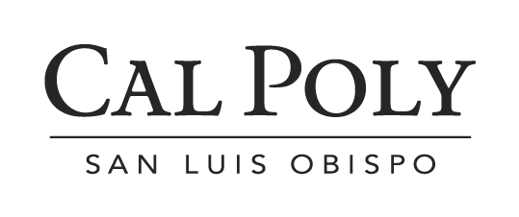

To: Click here to enter name  From: Click here to enter name |  | Date:  Cc: | Click here to enter a date  Dr. Chance Hoellwarth, Program Coordinator  Daniel Parsons, Credential Analyst
Subject: Disposition Memo

Dear Click here to enter name,

I have concerns about

In order to address these concerns I would like

School of Education Dispositions

Professionalism

  - Responsibility and Accountability — Acts ethically, responsibly, and with integrity, and is considerate, respectful, punctual, and appropriate in appearance, in conduct, and in all interactions with students, families, mentors, and colleagues. Is creative and self-reliant in finding solutions to problems and managing dilemmas. Is open to constructive feedback from others, manages situations of conflict and their own stress appropriately, and takes responsibility for own actions.

  - Creating Positive Climate — Develops curricula and programs that provide equitable access to learning opportunities for each and every student and educator through both content and processes. Promotes a climate in which learning is valued and on-going. Provides choices to enable all to share in and contribute to social and intellectual life. Upholds fair and equitable standards for conduct that encourage responsibility, mutual respect, and civic values, and that safeguard the physical, intellectual, and emotional well-being of each and every student and education professional.

Ethical Practice

- Cross-Cultural Competence — Promotes respect for self, students, families, and cultures. Demonstrates belief that everyone can learn and values human diversity and equity in the learning environment. Examines own biases and prejudices and develops necessary awareness, attitudes, knowledge, and skills for effectively and respectfully teaching and mentoring people whose culture differs from their own.

  - Collaboration — Actively engages in a community of learners that develops relationships, programs, and projects with colleagues in P-20 schools and educational agencies designed to improve the quality of education for each and every student and education professional. Contributes professionally to the field at local, regional, state, and national levels.

Shaping Change

  - Inquiry and Innovation — Is prepared to engage in and fosters in others life-long learning, continuous reflection, and research (on own practice or beyond). Creates learning opportunities for self and others. Maintains currency with professional knowledge, effective and ethical practices, and scholarship in the field. Tries new methods and tools. Incorporates knowledge-building technologies; critical, creative, and metacognitive thinking; conceptual understanding; independent and interdependent problem solving; and experiential approaches to learning.

  - Social Justice — Seeks to understand own privileges and prejudices, the stereotypes embedded in educational materials, and the cultural bias institutionalized in schools and other education-related organizations. Works toward realizing a nation and world where all have basic human rights and actively seeks to eliminate social, political, and economic inequities. Promotes social and environmental responsibility. Independently and collaboratively identifies opportunities, goals, and avenues for social and organizational development toward excellence and equity. Empowers others to achieve organizational and personal goals.

