CLASS SCHEDULE
PLANNING PHASE REQUESTS

To: | University Scheduling, Office of the Registrar
From:
Department:
Term: | Choose an item
Date: | Click here to enter a date

All Design Mode (Planning) edits should be made directly in CourseLeaf CLSS.
As a reminder, during Design Mode, information only lives in CLSS. It will not push to PeopleSoft until your schedule is in Refine Mode. Once in Refine Mode, PeopleSoft will always be the source for accurate class schedule information as students enroll based on PeopleSoft data.

For the following items, you should enter information directly in the Comments field in CLSS:

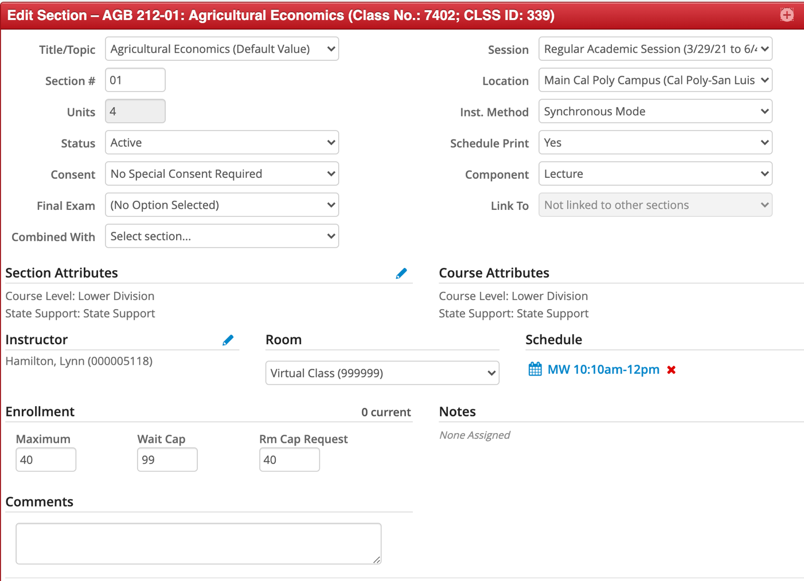

- Medical Requests
Provide brief information on medical need, not specifics about the condition. (e.g. mobility issue, must be near accessible parking).
Medical requests will be accommodated based on need. This means a suitable room will be located, but meeting days and times may need to be adjusted based upon room availability.

- Room Preference
Meeting days and times may need to be adjusted, based upon room availability for pedagogical need. Due to demand on University Lecture Rooms, back-to-back and requests for specific locations may not be possible.
Note that general room attributes when requesting a University Lecture Room can be self-identified using the drop-down. The only room preference information Scheduling needs is for items that cannot be selected in the drop-down menu.
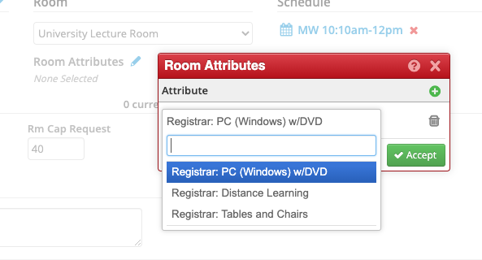

- Sections with Non-Standard Meeting Patterns (Non-Standard patterns are subject to approval)
Approved meeting patterns can be found on the Office of the Registrar website. Any meeting pattern that is not on the website is considered a Non-Standard Meeting Pattern. A brief explanation of why a Non-Standard Pattern is being requested should be provided in the Comments field. This includes lecture, seminar, discussion, activity and lab sections, whether they are scheduled in department or university managed space.
Note that when entering meeting patterns in CLSS, if a standard pattern is missing, reach out to classschedule@calpoly.edu and we will evaluate.

- Variable Unit Classes with “Fixed” Unit Value
For sections that are variable unit in the catalog, the department has the option to fix the unit value for a particular section. The department should set up the appropriate notes and meeting pattern to support the fixed unit value in CLSS. However, note in the Comments the request so the University Scheduling team updates PeopleSoft. (e.g. Section should be fixed at 2 units.)

- Hybrid or Sections Requiring ‘TBA’ Contact Hours
Any required TBA contact hours should be noted in the Comments field. This will ensure the Scheduling team updates PeopleSoft. The TBA hours cannot be added directly in CLSS.

- Intentional Conflicts
Intentional conflicts can only be scheduled in spaces that are shared in CLSS. If you have multiple sections meeting in the same department-managed space and are receiving an error in CLSS, reach out to classschedule@calpoly.edu.

- Reserve Capacity
In PeopleSoft, Reserve Capacity enables a department to hold a specified number of seats for specific majors during enrollment appointments. Once open enrollment starts, seats are no longer reserved in the system. Reserve caps roll from previous like term, but cannot be adjusted in CLSS. Ensure notes are also monitored when working with Reserve caps.

Subject-Course #-Section  Class # | Reserve Seats for the Following Major(s) | Number of Seats Reserved | Total  Enrollment Capacity
Example: IME 141-01 (Class #2960) | Example: Industrial Engineering, Manufacturing Engineering, Mechanical Engineering | Example: 15 | Example: 22

- Combined Section Information
A combined section may be created in the class schedule for two or more sections of a course that are cross-listed at the catalog-level, for example POLS/RELS 380, Religion and Politics in the Israeli-Palestinian Conflict.
Combined sections have a section number in the -70 range, for example POLS 380-70 and RELS 380-70. It is the departments responsibility to communicate with the department offering the partner course to determine details (days, times and enrollment capacity) and which will be the “parent” section in CLSS.
For combined sections, departments have the option to distribute seats in a variety of ways. Enrollment may come from “both sides” of the course until the total enrollment capacity is reached *or* seats may be “split” with a specific number allocated to either side of the course.
Note: The cleanest method to allocate seats is splitting them between both sides of the course. Keep in mind that if enrollment will not occur on the “other” side of the course, it does not need to be added to the schedule. For example: HNRS/ENGL 145, if students will never enroll on the ENGL-side of the class, there is no need to set up the corresponding ENGL section as it will not be utilized.
Combined sections may be created directly in CLSS. Refer to the CLSS Training Guide for assistance. Double check enrolment cap for each section and confirm appropriate notes are listed in each class section.

- Additional Considerations
The following section may be used to provide information that needs to be brought to the attention of the University Scheduling team. Any items you were unable to convey using the CLSS Comments section can be included here.

Subject-Course #-Section  Class # | Instructor | Meeting Days | Meeting Time | Location | Notes
Example: MATH 241-01 (Class #1278) and MATH 241-02 (Class #2467) | Example: Smith, Jayne | Example: MTWF | Example: 8:10am-9am | Example: TBD | Example: Instructor teaches large lecture MWF 8:10-9am for MATH 241-01 and MATH 241-02 and individual small lecture (35 cap) Tuesday and Thursday respectively.  Sections should be group coded so workload is calculated correctly.
Example: AEPS 400-01 (Class #1237) | Example: Smith, Jayne | Example: TBA | Example: TBA | Example: NA | Example: Section should be fixed at 2 units

