Phase/Grain Size Measurement With IQ Materials Imaging Software
Light Microscopes
Standard Operating Procedure
Last Edited: 10/9/11

Note: IQ materials software is only used for measuring phase percentages or grain sizes in microstructure. To capture images, use Qcapture software.
Phase % Measurement
- Capture a clear image using the appropriate imaging software for your microscope (Qcapture for the leica, imagepro for the Olympi). Be sure the image is in focus and has good contrast between phases you want to measure. The analysis will not turn out correctly if the image is not clearly focused with good contrast, so take the time to get a quality image. Keep the image as a .tif file, as this is the kind of file the measurement software uses.

- Open IQ Materials software by clicking on the icon on the desktop.

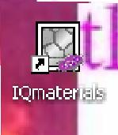

- In the upper left corner of the software window, click on the icon of which measurement you would like to do.
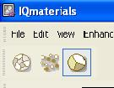

Grain size measurement
Percent area measurement
Particle size measurement

- Follow the on screen directions to complete the measurement process.
  - When prompted to open your image from a file, open the .tif image you acquired in step one.
  - Some images will require further contrast adjustment to obtain good results. After converting the image (prompted just after opening it), select the contrast adjustment icon near the upper right of the software window to change brightness, contrast, and gamma of your image.
  - The image you use for analysis should have as much contrast and clear boundaries between the phases as possible. If you are measuring more than two phases, or to more precisely measure two, you have the option during the process to adjust measurement sensitivity and can change this to precisely detect up to 5 phases.

