Cal Poly MatE

Common Metallographic Etchants

Common Metallographic Etchants

This book contains information on the most commonly used metallographic etchants. If the etchant you desire is not found within this book, please consult the ASM Handbook (which can be found online in the Kennedy Library database).

General Notes About Etching

- All etchants described herein are extremely corrosive. Gloves, apron, splash goggles, long pants and closed toed shoes are required for etching.

- MSDS are available above the chemical storage cabinet in the etching room, and should be read before working with unfamiliar chemicals.

- Always measure and mix chemicals at arm’s length inside fume hood.

- When measuring chemicals, ensure any measuring vessel is clean and dry of other residue.

- When mixing acids, always add acid to water.

- Use appropriate measuring and mixing vessels.
  - Hydrofluoric acid can etch through glass, always measure, mix and store in HDPE vessels.

- Always dispose of chemicals in appropriate disposal vessel. If unsure which vessel to dispose in, receive confirmation before disposal.

For Chemical Safety and Disposal Information Contact:
Tom Featherstone
Chemical Hygiene Specialist
Building 80, Room 103
Telephone: (805) 756-6661
Fax: (805) 756-1602
tfeather@calpoly.edu
FORGENG SOLUTIONll lllllllllllllllllllllllllllllllllllllllll

Lubricant: | Components: | Amounts: | Application: | Notes:
For 6μm, 3μm, 1μm, and 0.5μm polishing pads | Distilled Water  Ethylene Glycol  Ethanol | 2400ml (80%)  300ml (10%)  300ml (10%) | Spray 1-2 times on polishing pads as needed | Store in plastic spray bottle

Preparation
- Make sure you have the proper attire (i.e., safety goggles, long pants, close-toe shoes, apron, and gloves) as well as proper set-up and clean-up items (graduated cylinder, storage vessels, petri dish, etc.) before mixing.
- Ensure measuring vessels are clean and dry of water or any other residue.

Mixing
- Mix all chemicals under fume hood.
- Do not mix ethylene glycol and ethanol before adding to water. Add each chemical separately to water (in either order).

Clean -up
- Transfer prepared Forgeng Solution into pre-existing spray bottle.
- Wash all graduated cylinders and mixing utensils when finished.

ALUMINUM ALLOYS

Etchant: | Components: | Amounts: | Application: | Notes:
Keller’s Etch | Distilled water  Nitric Acid  Hydrochloric Acid  Hydrofluoric Acid | 190 ml  5 ml  3 ml  2 ml | Immerse 10-30 sec | Use Fresh

Preparation
- Make sure you have the proper attire (i.e., safety goggles, long pants, close-toe shoes, apron, and gloves), as well as proper set-up and clean-up items (graduated cylinder, storage vessels, petri dish, etc.) before starting.
- Ensure measuring vessels are clean and dry of water or any other residue.

Mixing Etchant
- Always mix acid into water!
- Hydrofluoric acid attacks glass! HDPE vessels should be used for measuring, etching and storage.

Etching Sample
- Immerse sample for 10 – 30 seconds.
- Use fresh etchant!

Clean -up
- Dispose of etchant in acid waste container.
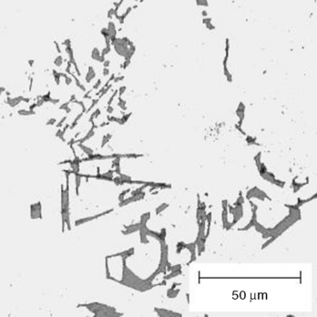

Unmodified as-cast A356 etched in Keller's Reagent^{[1]}
ALUMINUM ALLOYS

Etchant: | Components: | Amounts: | Application: | Notes:
General Purpose Al Etch | Distilled water  Hydrofluoric Acid | 90-100ml  .1-10 ml | Immerse 10-30 sec | Very Common Al Etch

Preparation
- Make sure you have the proper attire (i.e., safety goggles, long pants, close-toe shoes, apron, and gloves), as well as proper set-up and clean-up items (graduated cylinder, storage vessels, petri dish, etc.) before starting.
- Ensure measuring vessels are clean and dry of water or any other residue.

Mixing Etchant
- Always mix acid into water!
- Hydrofluoric acid attacks glass! HDPE vessels should be used for measuring, etching and storage.

Etching Sample
- Immerse sample for 10 – 30 seconds.

Clean -up
- Dispose of etchant in acid waste container.

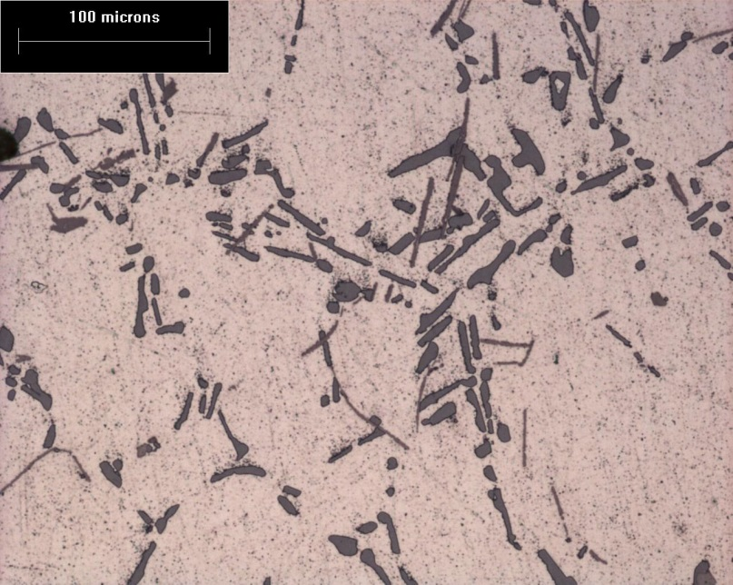
Aluminum Alloy A356-T6 etched 30 sec in 1% HF.
ALUMINUM ALLOYS

Etchant: | Components: | Amounts: | Application: | Notes:
Kroll's Reagent | Distilled water  Nitric Acid  Hydrofluoric Acid | 92 ml  6 ml  2 ml | Immerse 10-15 sec | For Cu-Al Alloys

Preparation
- Make sure you have the proper attire (i.e., safety goggles, long pants, close-toe shoes, apron, and gloves), as well as proper set-up and clean-up items (graduated cylinder, storage vessels, petri dish, etc.) before starting.
- Ensure measuring vessels are clean and dry of water or any other residue.

Mixing Etchant
- Always mix acid into water!
- Hydroflouric acid attacks glass! HDPE vessels should be used for measuring, etching and storage.

Etching Sample
- Immerse sample for 10 – 15 seconds.

Clean -up
- Dispose of etchant in acid waste container.

COBALT ALLOYS

Etchant: | Components: | Amounts: | Application: | Notes:
General Cobalt Etch | Ethanol  Hydrofluoric Acid  Nitric Acid | 200 ml  7.5 ml  2.5 ml | Immerse 2-4 min | For Cobalt and Cobalt Alloys

Preparation
- Make sure you have the proper attire (i.e., safety goggles, long pants, close-toe shoes, apron, and gloves), as well as proper set-up and clean-up items (graduated cylinder, storage vessels, petri dish, etc.) before starting.
- Ensure measuring vessels are clean and dry of water or any other residue.

Mixing Etchant
- Always mix acid into ethanol!
- Hydroflouric acid attacks glass! HDPE vessels should be used for measuring, etching and storage.

Etching Sample
- Immerse sample for 2 – 4 Minutes.

Clean -up
- Dispose of etchant in acid waste container.

COPPER ALLOYS

Etchant: | Components: | Amounts: | Application: | Notes:
Macro Copper Etchant | Distilled water  Nitric Acid | 50 ml  50 ml | Immerse 5-120 sec | Reveals Grain Boundaries and Cracks in Copper, Brasses, and Aluminum Bronze

Preparation
- Make sure you have the proper attire (i.e., safety goggles, long pants, close-toe shoes, apron, and gloves), as well as proper set-up and clean-up items (graduated cylinder, storage vessels, petri dish, etc.) before starting.
- Ensure measuring vessels are clean and dry of water or any other residue.

Mixing Etchant
- Always mix acid into water!

Etching Sample
- Immerse sample for 5 – 120 seconds.

Clean -up
- Dispose of etchant in acid waste container.

COPPER ALLOYS

Etchant: | Components: | Amounts: | Application: | Notes:
Copper and Copper Alloys | Ammonium Hydroxide  Distilled Water  Hydrogen Peroxide (3%) | 25 ml  25 ml  25-50 ml | Swab 15-45 seconds | Use Fresh, add Peroxide last

Preparation
- Make sure you have the proper attire (i.e., safety goggles, long pants, close-toe shoes, apron, and gloves), as well as proper set-up and clean-up items (graduated cylinder, storage vessels, petri dish, etc.) before starting.
- Ensure measuring vessels are clean and dry of water or any other residue.

Mixing Etchant
- Mix Ammonium Hydroxide into water, thoroughly mix, add peroxide last.

Etching Sample
- Swab sample for 15 – 45 seconds.
- Use fresh etchant!

Clean -up
- Dispose of etchant in alkaline waste container.
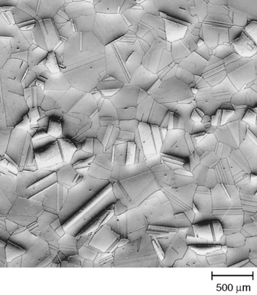

Annealed Cartridge Brass.^{[2]}
COPPER ALLOYS

Etchant: | Components: | Amounts: | Application: | Notes:
Kroll's Reagent | Distilled Water  Hydrofluoric Acid  Nitric Acid | 92 ml  2 ml  6 ml | Immerse 10-15 seconds | For Cu-Al Alloys

Preparation
- Make sure you have the proper attire (i.e., safety goggles, long pants, close-toe shoes, apron, and gloves), as well as proper set-up and clean-up items (graduated cylinder, storage vessels, petri dish, etc.) before starting.
- Ensure measuring vessels are clean and dry of water or any other residue.

Mixing Etchant
- Mix Nitric Acid into water, then add Hydrofluoric Acid.
- Hydroflouric acid attacks glass! HDPE vessels should be used for measuring, etching and storage.

Etching Sample
- Immerse sample for 10 – 15 seconds.

Clean -up
- Dispose of etchant in acid waste container.

IRON ALLOYS

Etchant: | Components: | Amounts: | Application: | Notes:
Nital | Ethanol  Nitric Acid | 100 ml  1-10 ml | Immerse 5-120 sec | For Cast Iron, Carbon Steel, Low Alloy Steel

Preparation
- Make sure you have the proper attire (i.e., safety goggles, long pants, close-toe shoes, apron, and gloves), as well as proper set-up and clean-up items (graduated cylinder, storage vessels, petri dish, etc.) before starting.
- Ensure measuring vessels are clean and dry of water or any other residue.

Mixing Etchant
- Always mix acid into Ethanol!
- Do Not Exceed 10 ml Nitric Acid - EXPLOSIVE!

Etching Sample
- Immerse sample for 10 – 120 seconds.

Clean -up
- Dispose of etchant in acid waste container.
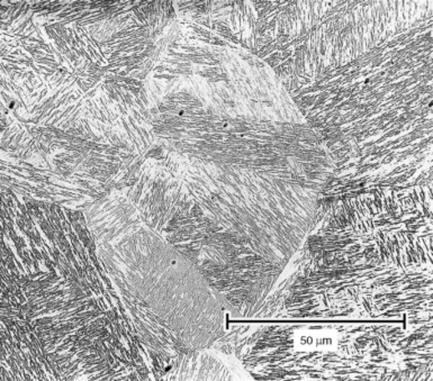
Water quenched low alloy steel etched in 2% Nital.^{[3]}
IRON ALLOYS

Etchant: | Components: | Amounts: | Application: | Notes:
Glyceregia | Hydrochloric Acid  Glycerol  Nitric Acid | 15 ml  10 ml  5 ml | Swab | For Stainless Steels Reveals Grain Boundaries and Cracks

Preparation
- Make sure you have the proper attire (i.e., safety goggles, long pants, close-toe shoes, apron, and gloves), as well as proper set-up and clean-up items (graduated cylinder, storage vessels, petri dish, etc.) before starting.
- Ensure measuring vessels are clean and dry of water or any other residue.

Mixing Etchant
- Thoroughly mix Hydrochloric Acid and Glycerol, then add Nitric Acid

Etching Sample
- Swab sample.

Clean -up
- DO NOT dispose of in waste container. May produce Nitroglycerine or Nitrosyl Chloride in presence of Sulphuric Acid!
- Place in labeled HDPE bottle in fume hood and contact Tom Featherstone for disposal. (805) 756-6661 (contact before mixing)
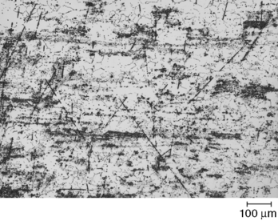
Duplex Stainless Steel etched in Glyceregia.^{[4]}
IRON ALLOYS

Etchant: | Components: | Amounts: | Application: | Notes:
Acetic Glyceregia | Hydrochloric Acid  Acetic Acid  Nitric Acid  Glycerol | 15 ml  10 ml  5 ml  2 drops | Swab | For High Alloy Stainless Steels. Reveals Grain Boundaries and Cracks

Preparation
- Make sure you have the proper attire (i.e., safety goggles, long pants, close-toe shoes, apron, and gloves), as well as proper set-up and clean-up items (graduated cylinder, storage vessels, petri dish, etc.) before starting.
- Ensure measuring vessels are clean and dry of water or any other residue.

Mixing Etchant
- Thoroughly mix Hydrochloric Acid, Acetic Acid and Glycerol, then add Nitric Acid

Etching Sample
- Swab sample.

Clean -up
- DO NOT dispose of in waste container. May produce Nitroglycerine or Nitrosyl Chloride in presence of Sulphuric Acid!
- Place in labeled HDPE bottle in fume hood and contact Tom Featherstone for disposal. (805) 756-6661 (contact before mixing)

IRON ALLOYS l

Etchant: | Components: | Amounts: | Application: | Notes:
Nitro Hydrochloric Acid | Hydrochloric Acid  Nitric Acid | 40 ml  10 ml | Immerse in hot etchant up to 5 minutes | For High Alloy Steels

Preparation
- Make sure you have the proper attire (i.e., safety goggles, long pants, close-toe shoes, apron, and gloves), as well as proper set-up and clean-up items (graduated cylinder, storage vessels, petri dish, etc.) before starting.
- Ensure measuring vessels are clean and dry of water or any other residue.

Mixing Etchant
- Begin with Hydrochloric Acid, then add Nitric Acid.

Etching Sample
- Immerse sample hot etchant for up to 5 minutes.
- Will fume!
- Use immediately after mixing!

Clean -up
- Do not store.
- Dispose of etchant in acid waste container.

NICKEL ALLOYS

Etchant: | Components: | Amounts: | Application: | Notes:
Glyceregia | Hydrochloric Acid  Glycerol  Nitric Acid | 15 ml  10 ml  5 ml | Swab 5-60 seconds | For Ni Alloys Reveals Grain Boundaries and Cracks
Preparation
- Make sure you have the proper attire (i.e., safety goggles, long pants, close-toe shoes, apron, and gloves), as well as proper set-up and clean-up items (graduated cylinder, storage vessels, petri dish, etc.) before starting.
- Ensure measuring vessels are clean and dry of water or any other residue.

Mixing Etchant
- Thoroughly mix Hydrochloric Acid and Glycerol, then add Nitric Acid

Etching Sample
- Swab sample for 5 – 60 seconds.

Clean -up
- DO NOT dispose of in waste container. May produce Nitroglycerine or Nitrosyl Chloride in presence of Sulphuric Acid!
- Place in labeled HDPE bottle in fume hood and contact Tom Featherstone for disposal. (805) 756-6661 (contact before mixing)
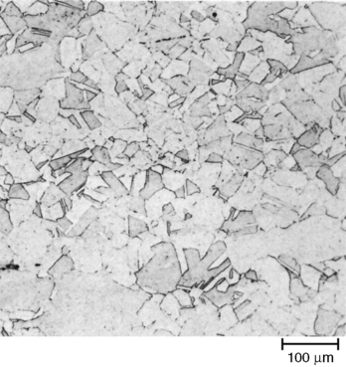
Hot rolled Monel K-500 etched in Glyceregia.^{[5]}
NICKEL ALLOYS

Etchant: | Components: | Amounts: | Application: | Notes:
Modified Glyceregia | Glycerol  Hydrochloric Acid  Nitric Acid | 60 ml  50 ml  10 ml | Swab 10-60 seconds | For High-Nickel Superalloys  Reveals Precipitates.

Preparation
- Make sure you have the proper attire (i.e., safety goggles, long pants, close-toe shoes, apron, and gloves), as well as proper set-up and clean-up items (graduated cylinder, storage vessels, petri dish, etc.) before starting.
- Ensure measuring vessels are clean and dry of water or any other residue.

Mixing Etchant
- Thoroughly mix Hydrochloric Acid and Glycerol, then add Nitric Acid

Etching Sample
- Swab sample for 10 – 60 seconds.

Clean -up
- Do not store, and discard when solution turns yellow.
- DO NOT dispose of in waste container. May produce Nitroglycerine or Nitrosyl Chloride in presence of Sulphuric Acid.
- Place in labeled HDPE bottle in fume hood and contact Tom Featherstone for disposal. (805) 756-6661 (contact before mixing)

NOBLE ALLOYS

Etchant: | Components: | Amounts: | Application: | Notes:
Silver Etch | Ammonium Hydroxide  Hydrogen Peroxide (3%) | 25 ml  10 ml | Swab up to 60 seconds. | For Sterling Silver, use 50:50 mix.

Preparation
- Make sure you have the proper attire (i.e., safety goggles, long pants, close-toe shoes, apron, and gloves), as well as proper set-up and clean-up items (graduated cylinder, storage vessels, petri dish, etc.) before starting.
- Ensure measuring vessels are clean and dry of water or any other residue.

Mixing Etchant
- Mix Ammonium Hydroxide and Hydrogen Peroxide

Etching Sample
- Swab sample for up to 60 seconds.

Clean -up
- Discard after use
- Dispose of etchant in alkaline waste container.

NOBLE ALLOYS lllllllllllllllllllllllllllllllllllllllllll

Etchant: | Components: | Amounts: | Application: | Notes:
Aqua Regia | Hydrochloric Acid  Nitric Acid | 25 ml (30 ml for pure Au)  25 ml (10 ml for pure Au) | Immerse up to 60 seconds | For High Noble Alloys

Preparation
- Make sure you have the proper attire (i.e., safety goggles, long pants, close-toe shoes, apron, and gloves), as well as proper set-up and clean-up items (graduated cylinder, storage vessels, petri dish, etc.) before starting.
- Ensure measuring vessels are clean and dry of water or any other residue.

Mixing Etching
- Begin with Hydrochloric Acid, add Nitric Acid.

Etching Sample
- Immerse sample in etchant for up to 60 seconds.
- Use fresh etchant!
- Will Fume!

Clean -up
- Dispose of etchant in acid waste container.

NOBLE ALLOYS lllllllllllllllllllllllllllllllllllllllllll

Etchant: | Components: | Amounts: | Application: | Notes:
Platinum Etch | Distilled Water  Hydrochloric Acid  Nitric Acid | 30 ml  25 ml  5 ml | Immerse in hot etchant up to 5 minutes

Preparation
- Make sure you have the proper attire (i.e., safety goggles, long pants, close-toe shoes, apron, and gloves), as well as proper set-up and clean-up items (graduated cylinder, storage vessels, petri dish, etc.) before starting.
- Ensure measuring vessels are clean and dry of water or any other residue.

Etching
- Mix Hydrochloric acid into distilled water first, then add Nitric Acid.

Etching Sample
- Immerse sample hot etchant for up to 5 minutes.

Clean -up
- Dispose of etchant in acid waste container.

REFRACTORY ALLOYS

Etchant: | Components: | Amounts: | Application: | Notes:
Kroll's Reagent | Distilled Water  Hydrofluoric Acid  Nitric Acid | 100 ml  1-3 ml  2-6 ml | Swab or Immerse 3-30 seconds | For Titanium Alloys

Preparation
- Make sure you have the proper attire (i.e., safety goggles, long pants, close-toe shoes, apron, and gloves), as well as proper set-up and clean-up items (graduated cylinder, storage vessels, petri dish, etc.) before starting.
- Ensure measuring vessels are clean and dry of water or any other residue.

Mixing Etchant
- Mix Nitric Acid into water, then add Hydrofluoric Acid.
- Hydroflouric acid attacks glass! HDPE vessels should be used for measuring, etching and storage.

Etching Sample
- Immerse sample for 3 – 30 seconds.

Clean -up
- Dispose of etchant in acid waste container.

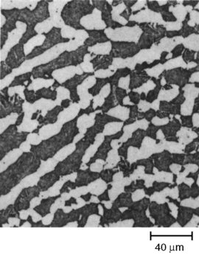

Ti-6Al-4V, as-forged, Kroll's Reagent.^{[6]}
REFRACTORY ALLOYS

Etchant: | Components: | Amounts: | Application: | Notes:
Titanium and Zirconium Etch | Distilled Water  Hydrofluoric Acid | 200 ml  1 ml | Swab or Immerse | Higher concentrations may be used, may stain

Preparation
- Make sure you have the proper attire (i.e., safety goggles, long pants, close-toe shoes, apron, and gloves), as well as proper set-up and clean-up items (graduated cylinder, storage vessels, petri dish, etc.) before starting.
- Ensure measuring vessels are clean and dry of water or any other residue.

Mixing Etchant
- Always mix acid into water!
- Hydroflouric acid attacks glass! HDPE vessels should be used for measuring, etching and storage.

Etching Sample
- Immerse or swab sample.

Clean -up
- Dispose of etchant in acid waste container.

REFRACTORY ALLOYS

Etchant: | Components: | Amounts: | Application: | Notes:
DuPont Niobium Reagent | Distilled Water  Sulphuric Acid  Nitric Acid | 50 ml  14 ml  5 ml | Immerse

Preparation
- Make sure you have the proper attire (i.e., safety goggles, long pants, close-toe shoes, apron, and gloves), as well as proper set-up and clean-up items (graduated cylinder, storage vessels, petri dish, etc.) before starting.
- Ensure measuring vessels are clean and dry of water or any other residue.

Mixing Etchant
- Always mix acid into water!

Etching Sample
- Immerse sample.

Clean -up
- Dispose of etchant in acid waste container.

SINTERED CARBIDESllllllllllllllllllllllllll lllllllllllllllll

Etchant: | Components: | Amounts: | Application: | Notes:
Carbide Etch | Distilled Water  Nitric Acid | 97 ml  3 ml | Immerse in boiling etch up to 60 seconds | Reveals WC, Mo₂C, and TiC

Preparation
- Make sure you have the proper attire (i.e., safety goggles, long pants, close-toe shoes, apron, and gloves), as well as proper set-up and clean-up items (graduated cylinder, storage vessels, petri dish, etc.) before starting.
- Ensure measuring vessels are clean and dry of water or any other residue.

Mixing Etchant
- Always mix acid into water!

Etching Sample
- Immerse sample in boiling etchant for up to 60 seconds.

Clean -up
- Dispose of etchant in acid waste container.

References

- D.M. Stefanescu and R. Ruxanda, Solidification Structures of Aluminum Alloys, Metallography and Microstructures, Vol 9, ASM Handbook, ASM International, 2004, p. 107–115
- L.E. Samuels, Metallographic Polishing by Mechanical Methods, 4th ed., ASM International, 2003
- B.L. Bramfitt and S.J. Lawrence, Metallography and Microstructures of Carbon and Low-Alloy Steels, Metallography and Microstructures, Vol 9, ASM Handbook, ASM International, 2004, p. 608–626
- G.F. Vander Voort, G.M. Lucas, and E.P. Manilova, Metallography and Microstructures of Stainless Steels and Maraging Steels, Metallography and Microstructures, Vol 9, ASM Handbook, ASM International, 2004, p. 670–700
- W.L. Mankins, Metallography and Microstructures of Nickel and Nickel-Copper Alloys , Metallography and Microstructures, Vol 9, ASM Handbook, ASM International, 2004, p. 816–819
- L.M. Gammon, R.D. Briggs, J.M. Packard, K.W. Batson, R. Boyer, C.W. Domby, Metallography and Microstructures of Titanium and Its Alloys, Metallography and Microstructures, Vol 9, ASM Handbook, ASM International, 2004, p. 899–917

These and many more etchants may be found in the ASM Handbook from ASM International

