1. Place heater around the mold cylinder and turn on the machine | 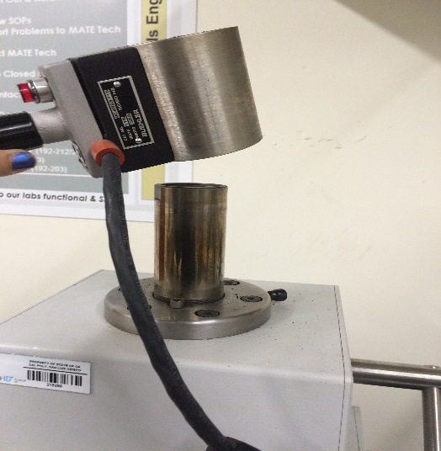
2. Screw the mold top assembly (piece with two black handles) on top and allow it to warm for 15-20 minutes while the machine is on | 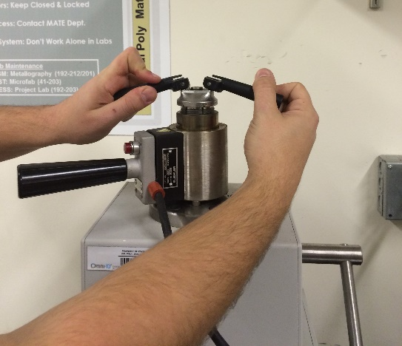
3. Close the pressure valve on the front of the mounting press by turning it clockwise | 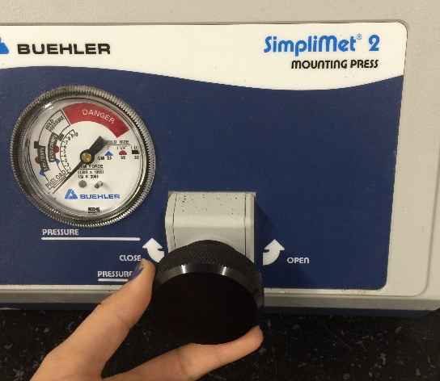
4. Unscrew the mold top assembly. CAUTION: the mold assembly may be hot, be sure to wear gloves | 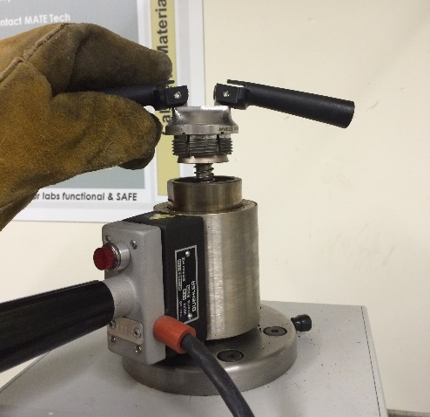
5. Pump up ram with the handle on the right side of the mounting press until the mounting stage reaches the top of the mold cavity | 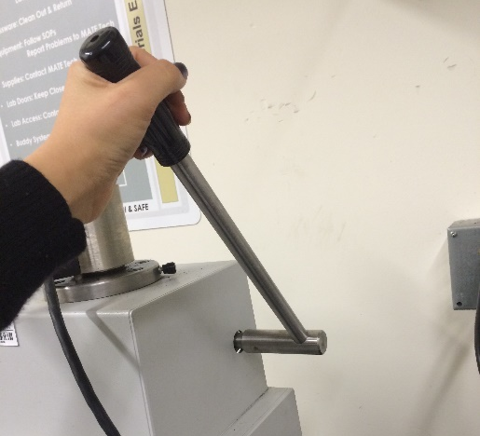
6. Place the sample in the center of the mounting stage cylinder | 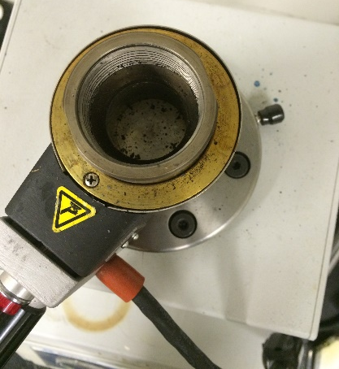
7. Open the pressure valve by turning it counterclockwise and lower the mounting stage approx. 3 inches.  Close the pressure valve on the front of the mounting press by turning the knob clockwise.  Use a cotton swab to wipe the mold release powder onto the inside of the mold cavity | 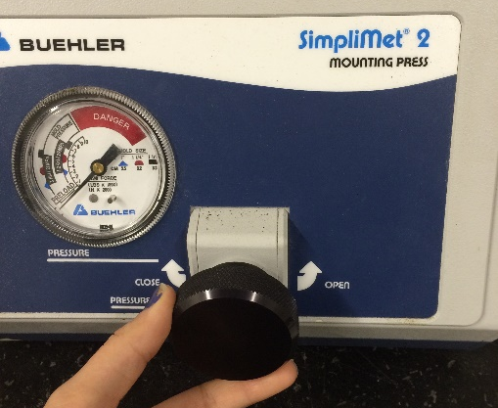

8. Using a funnel, add less than 1 level scoop of black Buehler powder in the mold cavity.  Screw the top assembly clockwise onto the mold (turn until the assembly is screwed on hand tight then turn counterclockwise back 1/8th of a turn) | 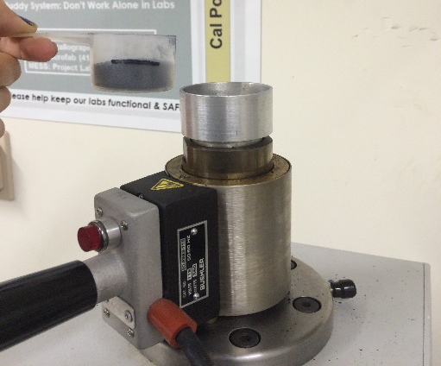

9. Pump the ram up using the handle on the side of the unit until you reach 4200 psi. Hold at this level for 1 minute.  Open the pressure valve on the front of the press only briefly and then close it. Tap the top assembly with a rubber mallet gently. Make sure to hit the top assembly and not the heater | 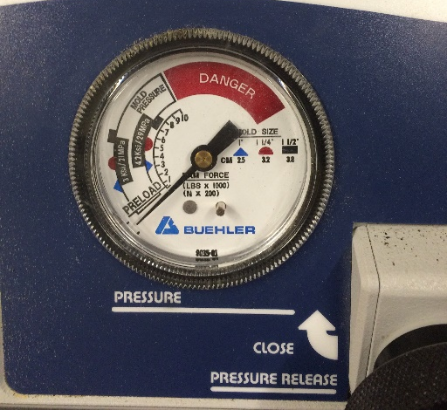

10. Again pump the ram up using the handle on the side of the press until the gauge reads 4200 psi. Hold at this level for 8 minutes, if the pressure drops, pump the handle to maintain 4200 psi

11. Remove the heater from the top of the assembly, (the pressure must stay at 4200 psi during this process) and place the cooling cylinder on the mold for two minutes. | 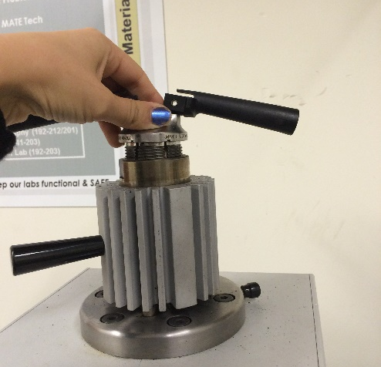

12. Remove the cooling cylinder and place the heater on the assembly. Turn the pressure valve on the front of the press counterclockwise to release built up pressure then close the valve. CAUTION: wear gloves
Pump up the ram using the handle on the right side of the press to eject the mounted sample

