Standard Operating Procedure: Changing the
Kalamazoo Belt Grinder
1. Open the belt grinder by releasing the clasps on both sides of the grinder. | 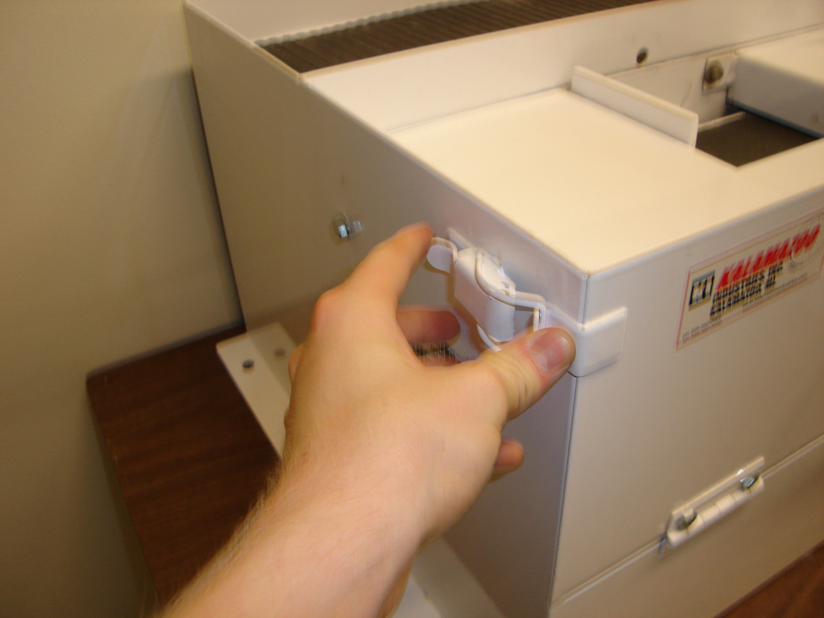

2. Using a 9/16” hex nut ratchet from 192-203, loosen the bolt that lies on the inside of the right wheel until the bolt no longer rests upon the flat surface above. Do NOT remove the used belt yet. | 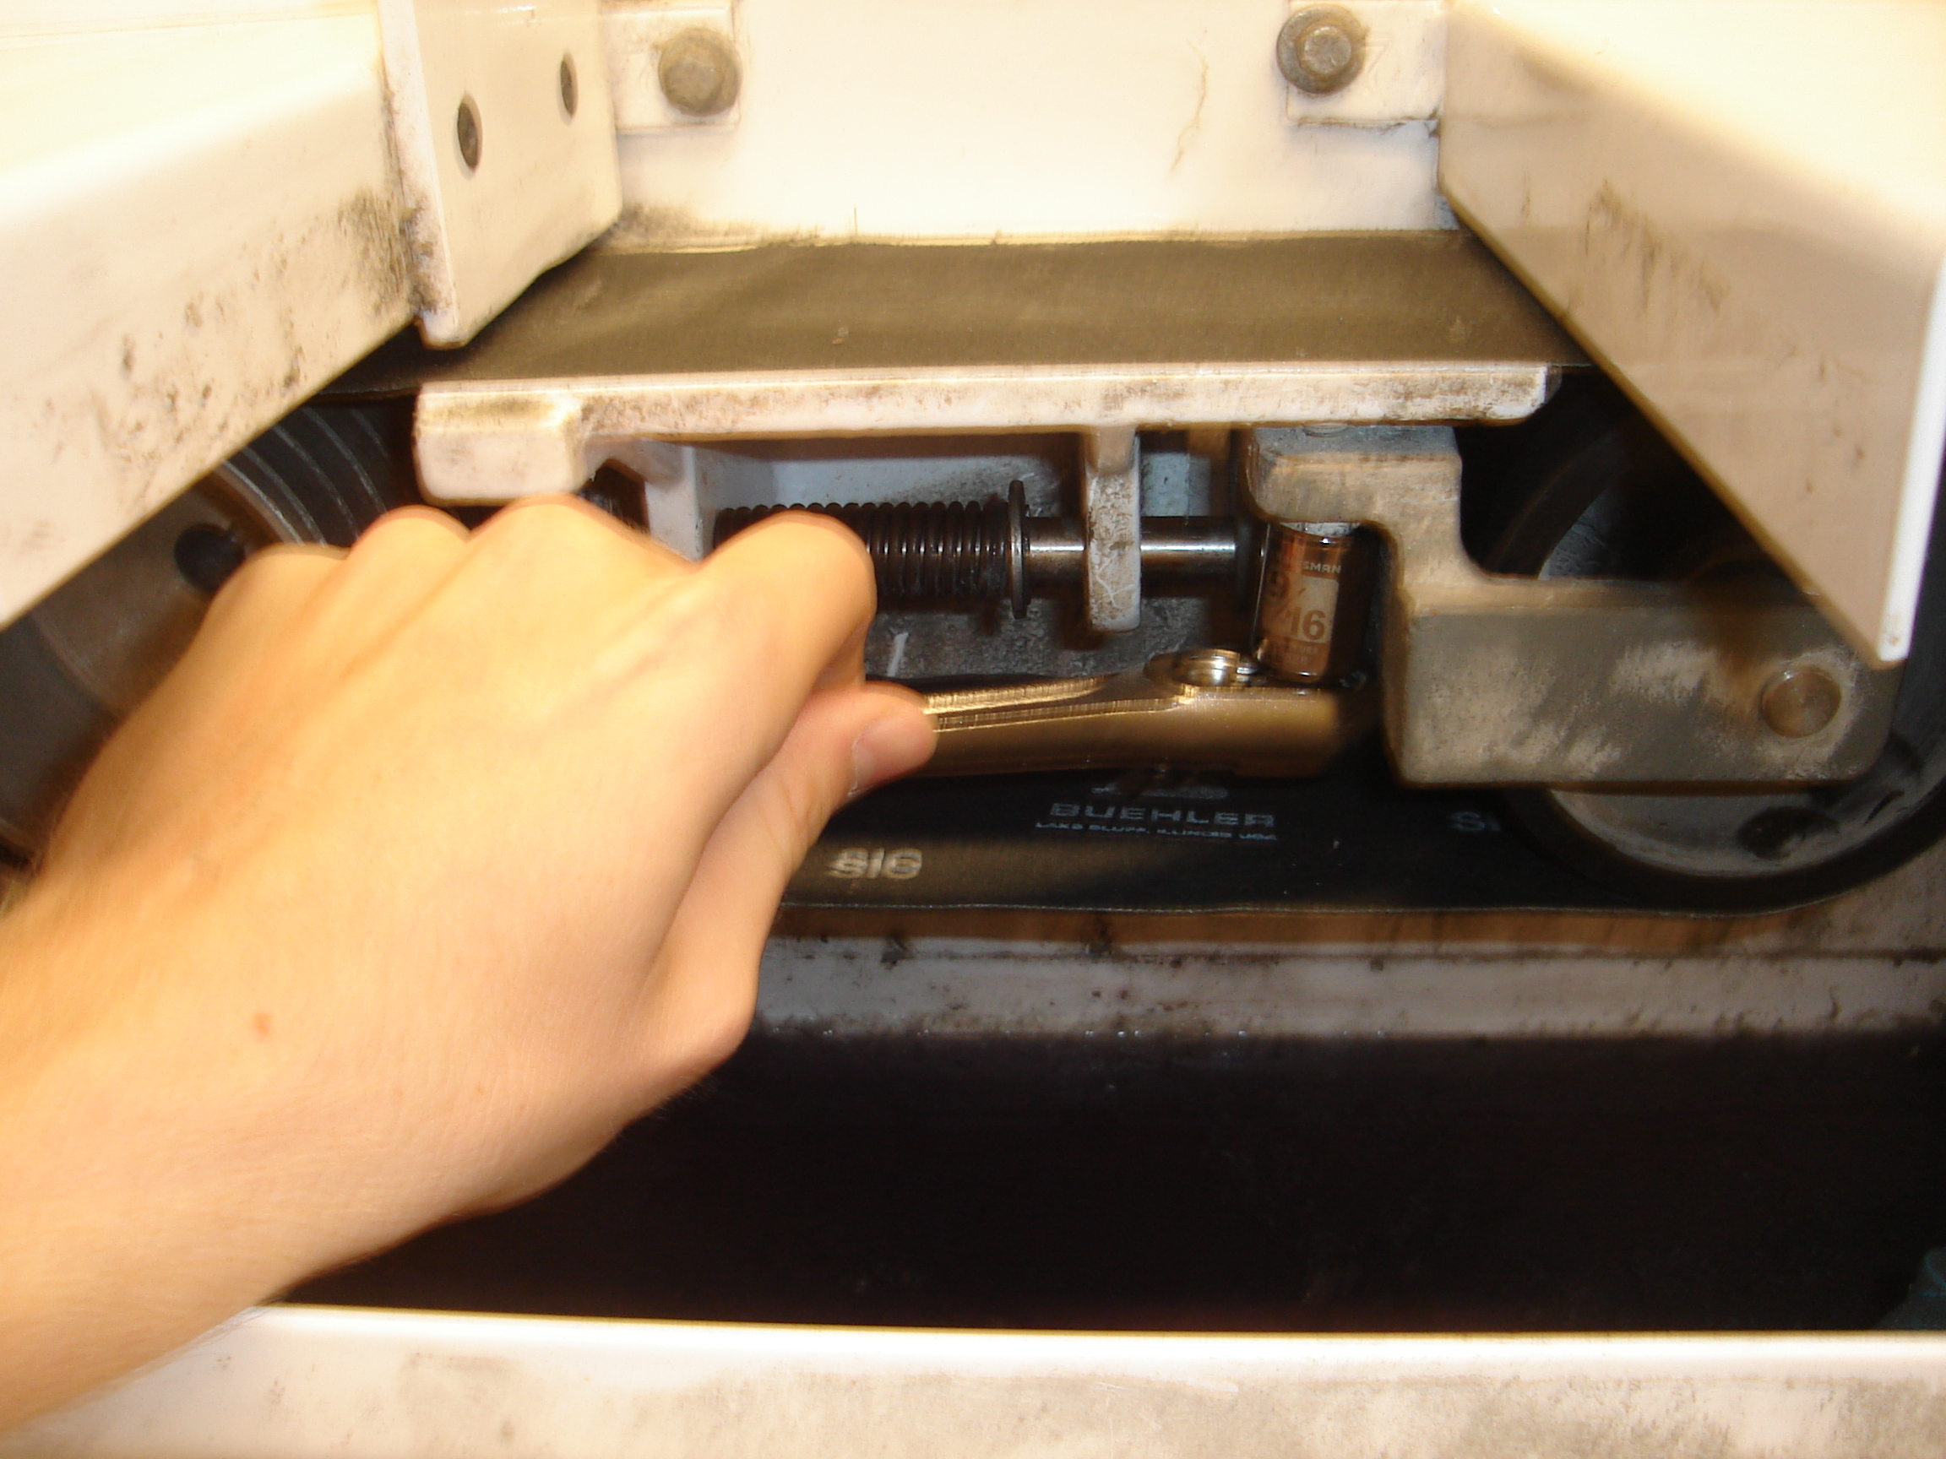

3. Apply pressure to the bottom of the loop of the used belt in order to bring the wheels closer together and lock into place by rotating the small metal tab 90°.  (See picture of metal tab on step 5) | 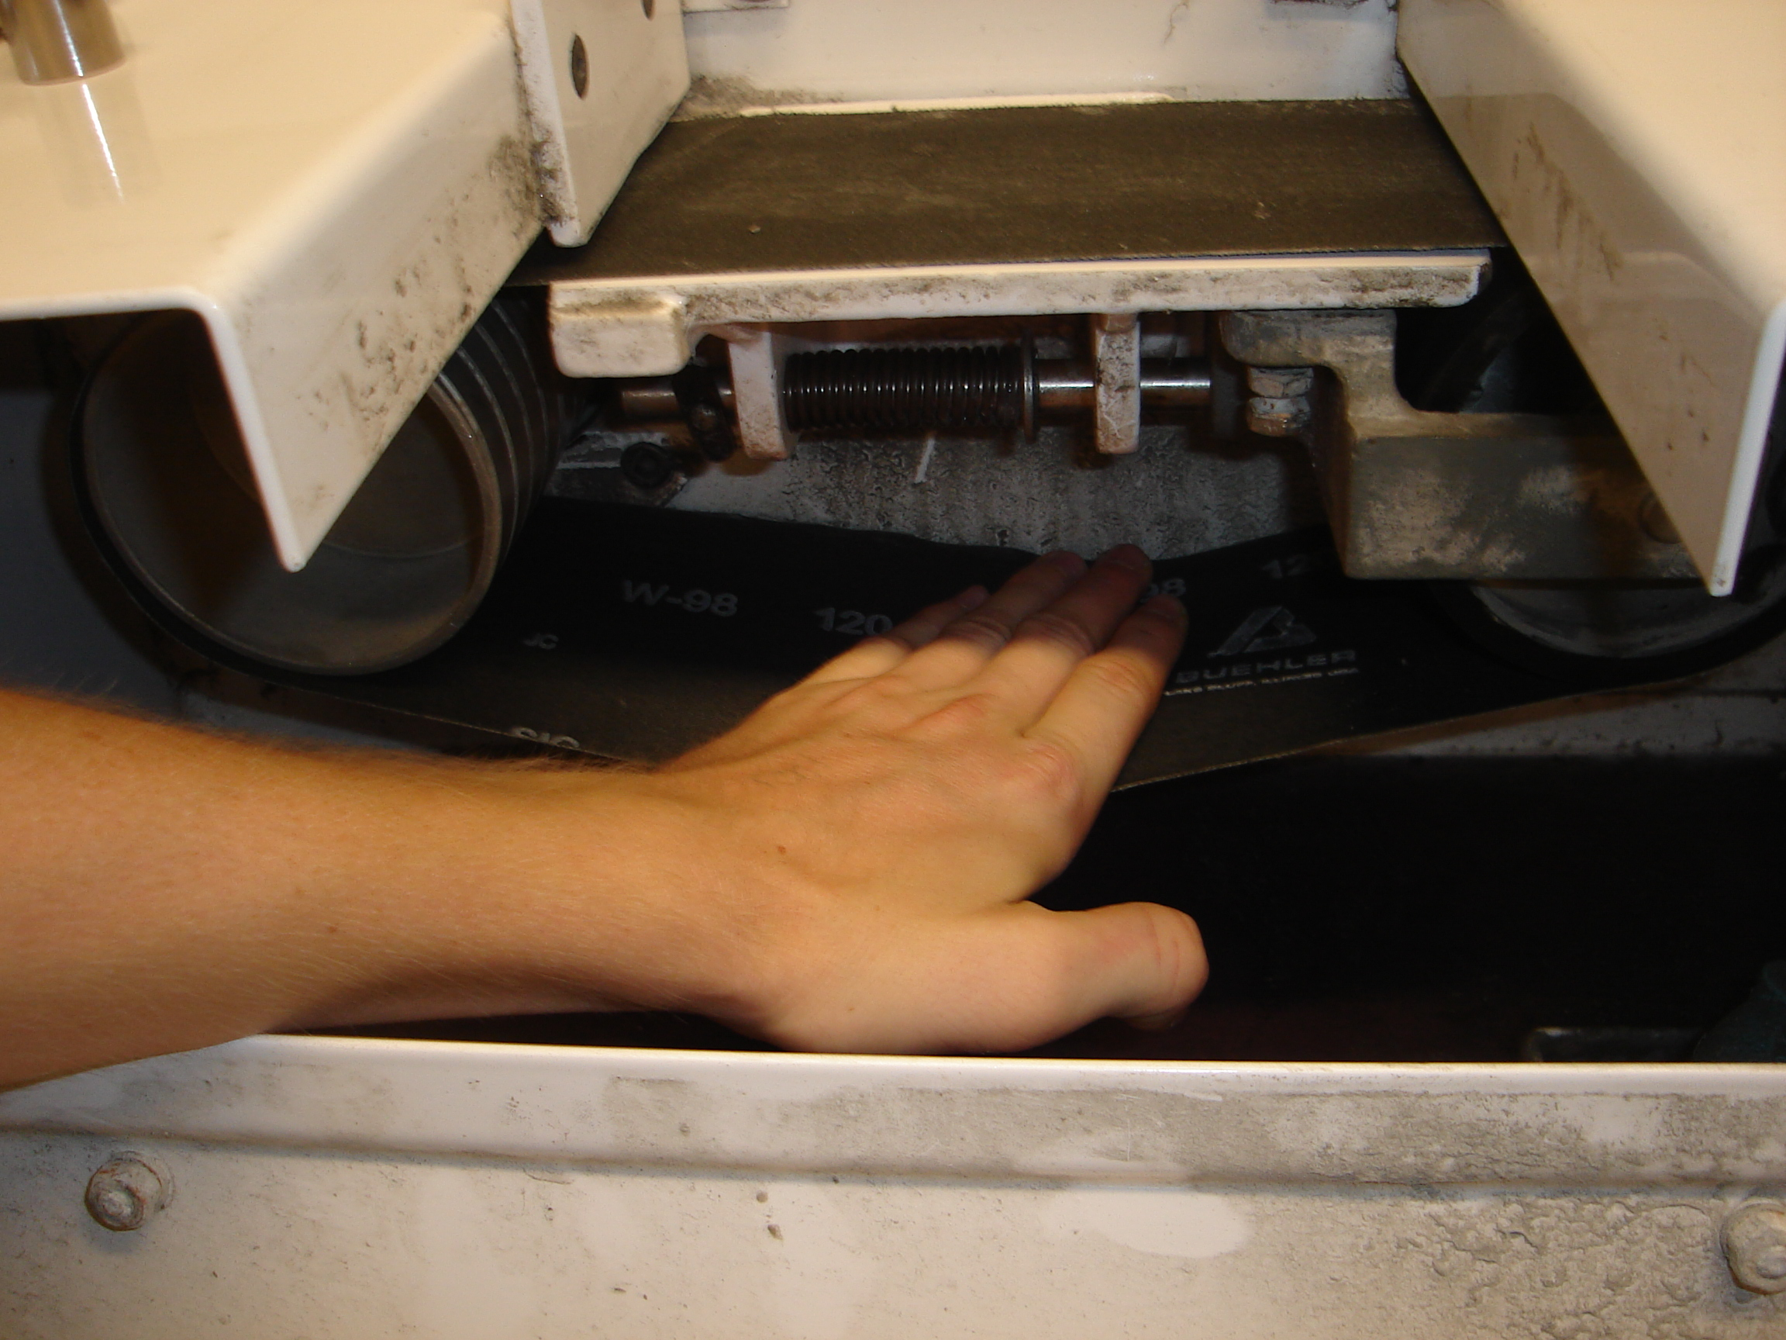  Metal tab

4. Remove the used belt and throw it away. Replace with a new one located in a box underneath the machine. | 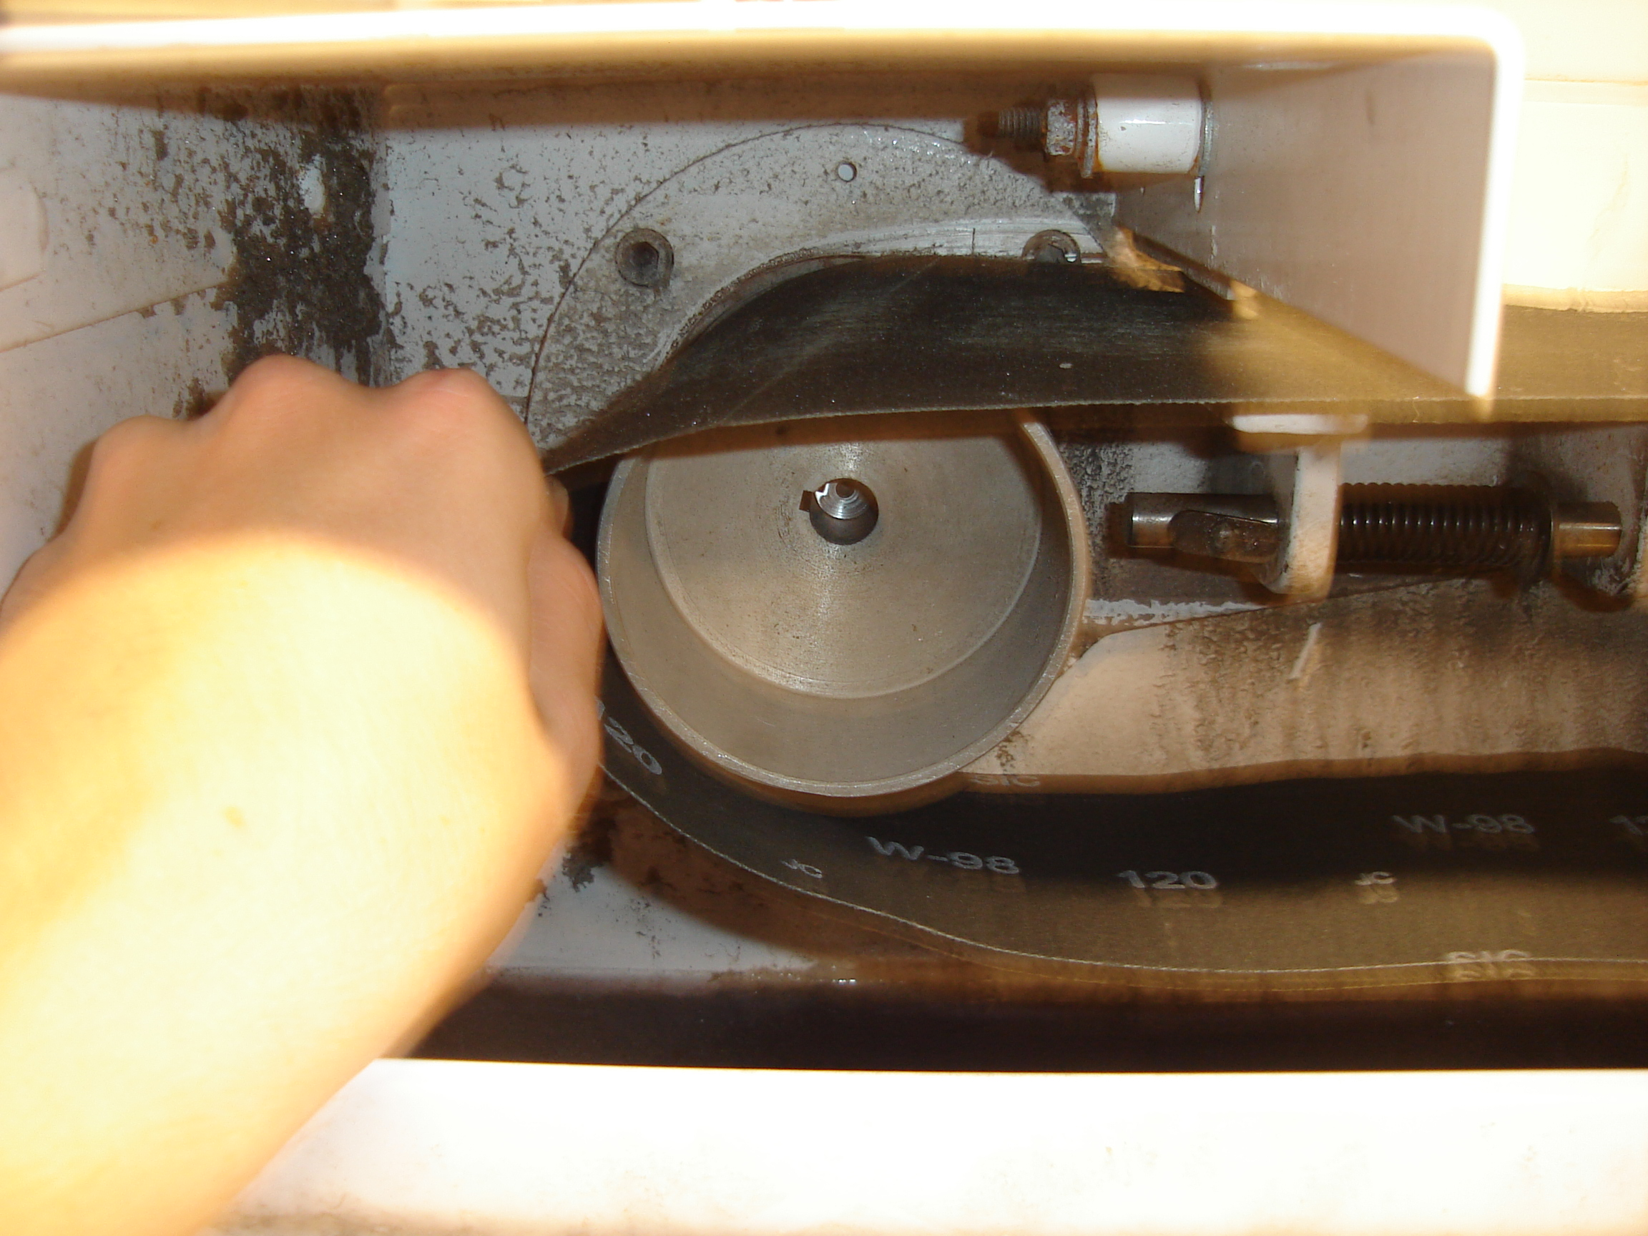

5. Press down on the belt and release the tab and allow the wheels to move apart so that the belt is taut. | 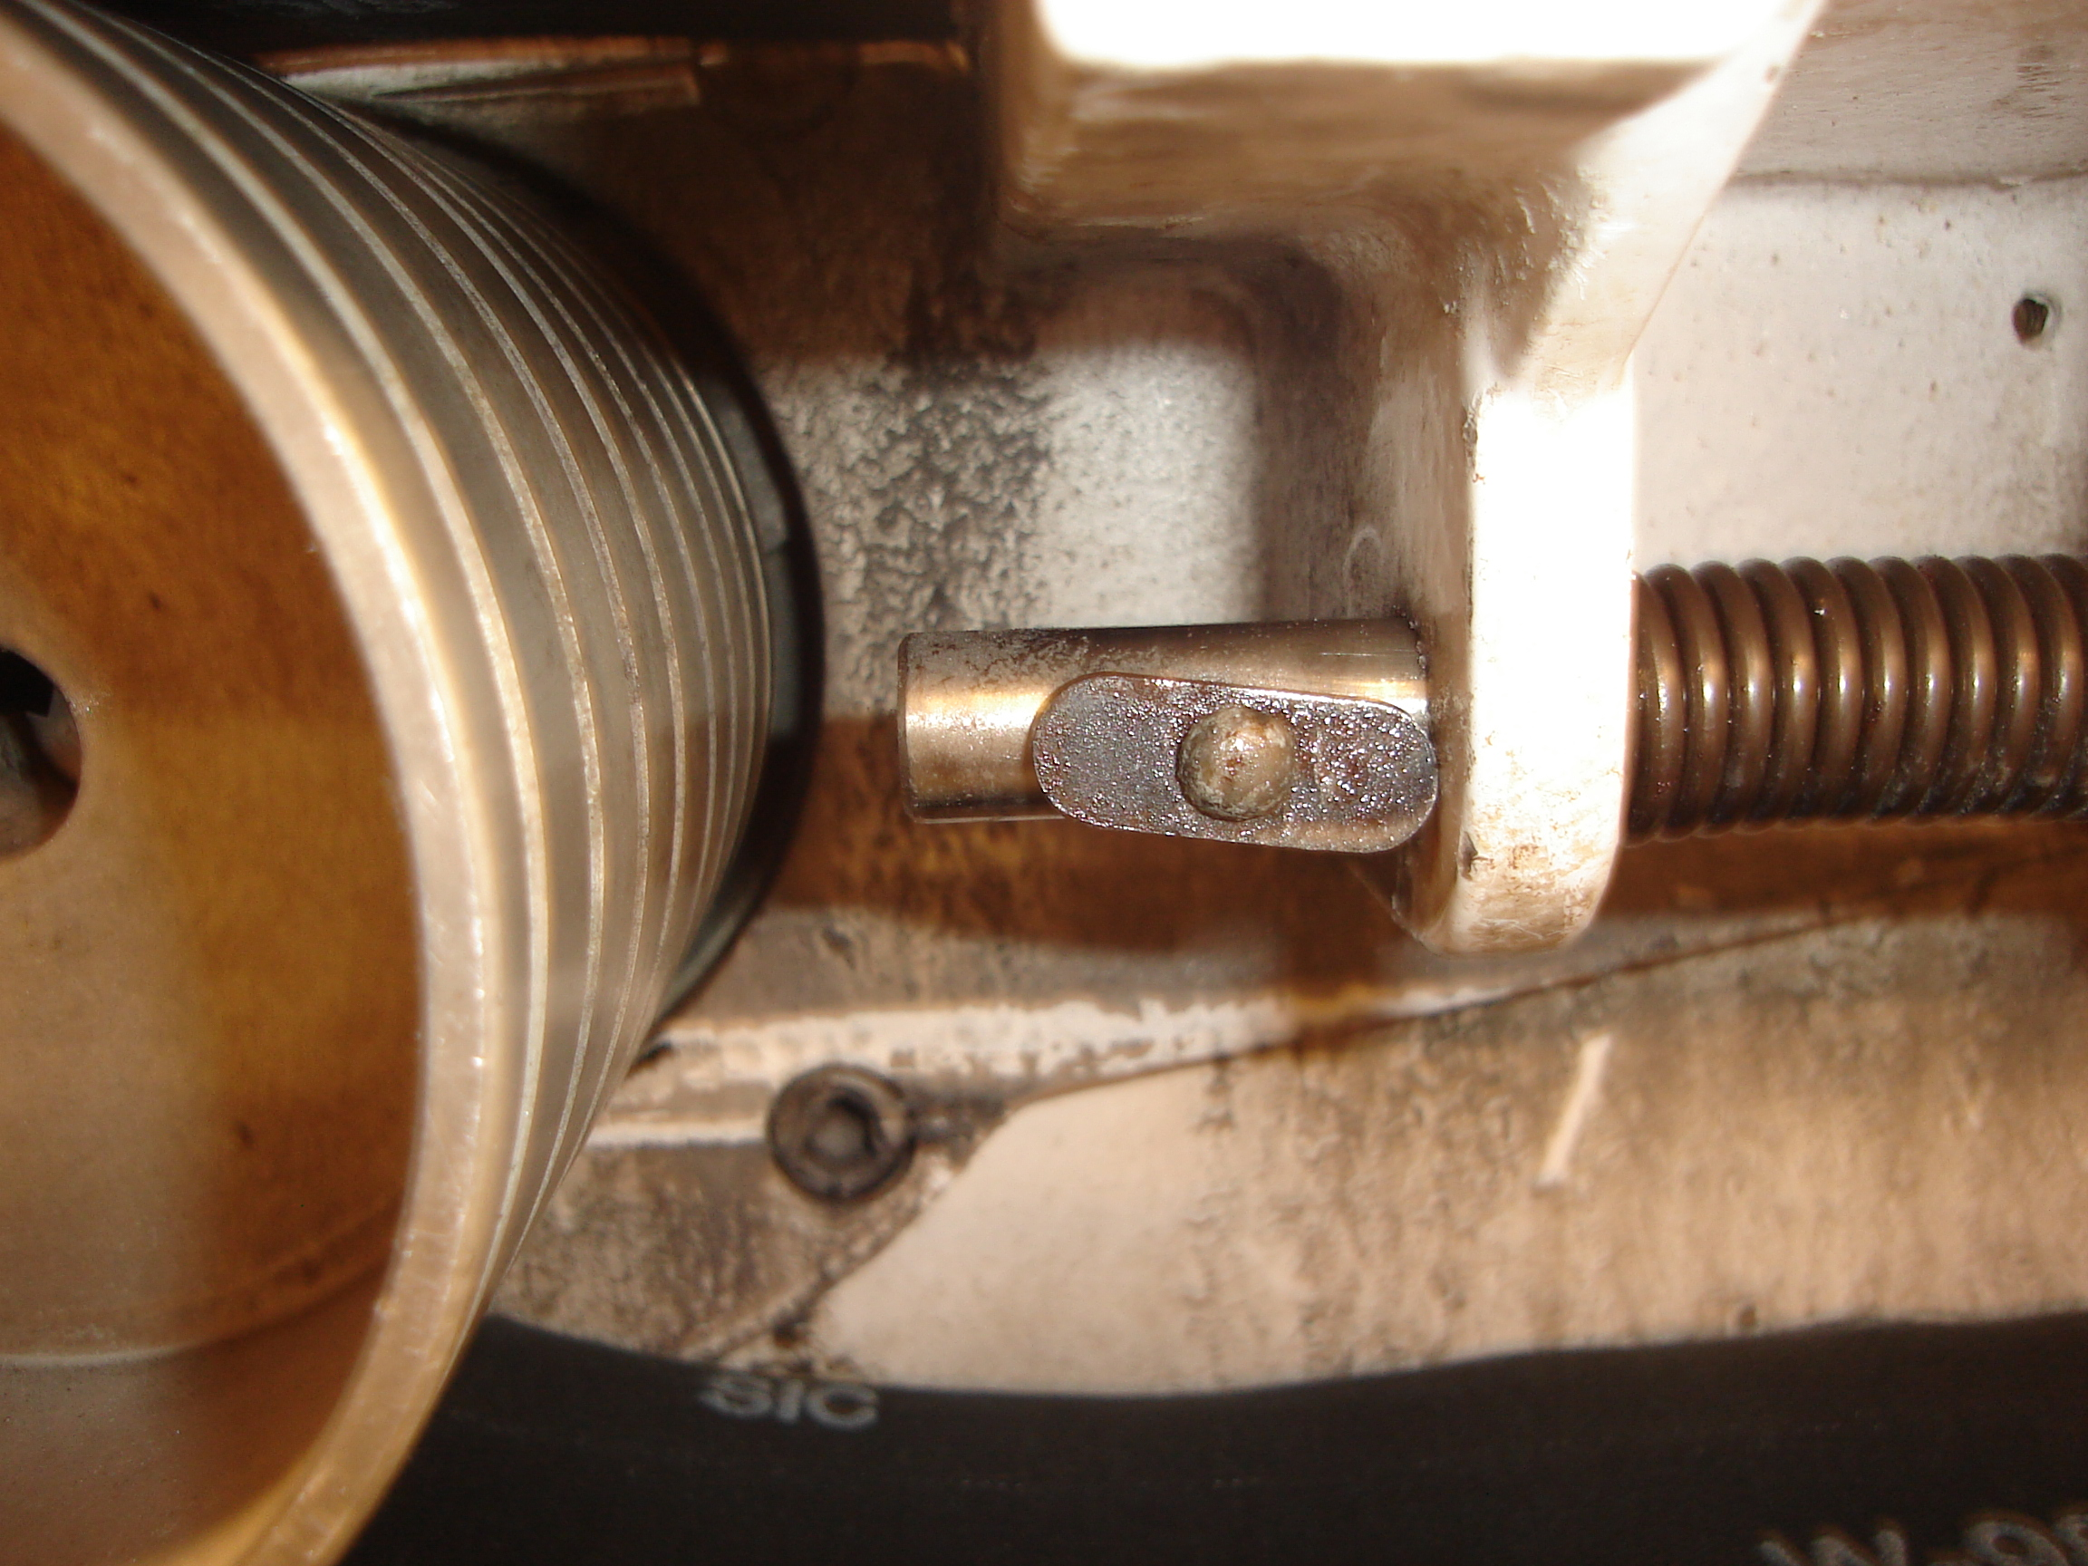  Turn 90° to Unlock  Tab Locked

7. Tighten the bolt until the top nut is up against the plate above. | 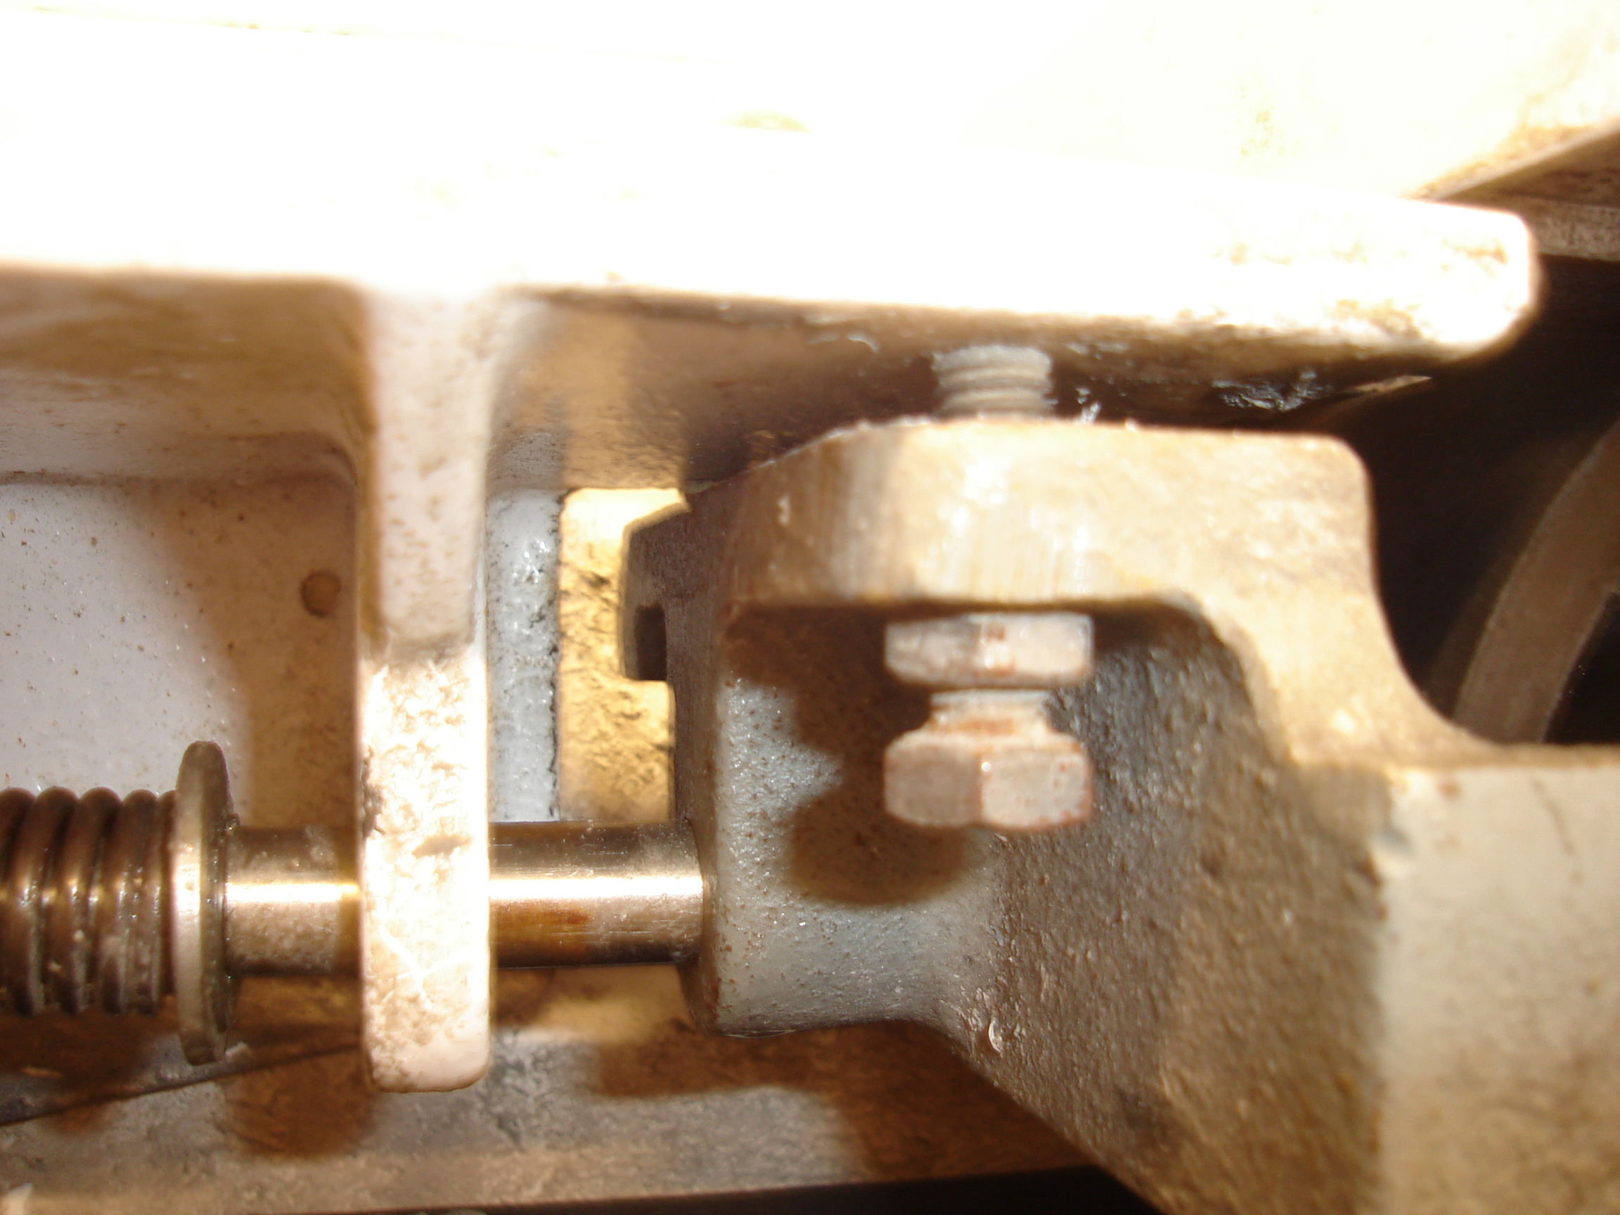

8. Quickly turn the grinder on to ensure that the belt does not drift during operation. If the belt drifts towards you while standing in front of the open grinder, tighten the nut. If the belt drifts away from you, loosen the nut. Close the grinder when finished and return any tools used. | 