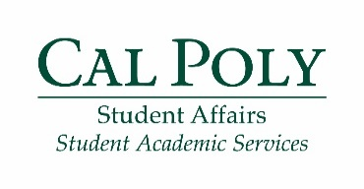
Fall 2017

First Year Seminar Series: Transfers
Educational Opportunity Program

Friday: 12-1 p.m. in Building 35-511 (CAFES, CLA, OCOB) Phone: (805) 756 2301
1-2 p.m. in Building 35-511 (CENG, CSM, CAED) Email: fys@calpoly.edu
Instructor: Nury Baltierrez and Lyzette Martin Office location: 52- E7

First Year Seminar (FYS) Expectations*:
- Be on time to all eight seminars
- Set up a meeting and meet with an EOP counselor during fall quarter
- Complete two activities outside of the seminar and turn in reflections by October 27
* Failure to meet these expectations will result in a hold on your registration until you have met with an EOP counselor to discuss the lack of communication

Week | Topic | Due this week
#1: September 15 | Introduction: Reflection, goal setting, growth mindset
#2: September 22 | Time management and Clothing Closet: weekly and quarterly planning, explore Career Services’ Clothing Closet | Bring syllabus for each class
#3: September 29 | Cal Fresh and Food Pantry: explore options for affordable food within the campus community
#4: October 6 | StrengthsQuest: exploring your strengths | StrengthsFinder Insider Report
#5: October 13 | Well-being and mindfulness: tips on self-care amid the fast paced quarter system
#6: October 20 | Reflection: looking back on your Cal Poly journey so far
#7: October 27 | Registration: how to register for classes in regards to your specific situation | Printed copy of flowchart and curriculum sheet
Reflections for two outside activities due October 27
#8: November 3 | Recharge social: almost done with your first quarter!

