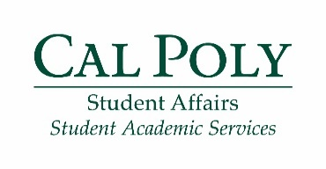
Fall 2017

First Year Seminar Series: Freshmen
Educational Opportunity Program

Fridays 1-2 p.m. in 192,106 Phone: (805) 756 2301 Email: fys@calpoly.edu
Instructor: Jon Diaz and Cassie Pitkin Office location: 52-E7

First Year Seminar (FYS) Expectations*:
- Be on time to all eight seminars
- Set up a meeting and meet with an EOP counselor during fall quarter
- Complete two activities outside of the seminar and turn in reflections by October 27
* Failure to meet these expectations will result in a hold on your registration until you have met with an EOP counselor to discuss the lack of communication

Week | Topic | Due this week
#1: September 15 | Introduction: Reflection, goal setting, growth mindset
#2: September 22 | Time management and communication: weekly and quarterly planning, Student Ombuds Services | Bring syllabus for each class
#3: September 29 | Diversity and inclusion: intentional discussion with Women’s Basketball team | Study plan (handed out in previous class)
#4: October 6 | Financial Aid and personal budget: maintaining a budget and lingering FAFSA questions | Statement of inclusivity
#5: October 13 | Career exploration and StrengthsQuest: how to get the most out of your major or explore change of major process | StrengthsFinder Insider Report
#6: October 20 | Reflection: looking back on your Cal Poly journey so far | A draft of your resume
#7: October 27 | Registration: how to register for classes in regards to your specific situation | Printed copy of flowchart and curriculum sheet
Reflections for two outside activities due October 27
#8: November 3 | Recharge social: almost done with your first quarter!

