Drupal User Guide

Getting Help With Your Website |  | 2
What You Can Do/What We Can Do |  | 3
Logging In |  | 4
Editing Pages – Update Office Hours |  | 5
Editing Pages – Update Faculty Table |  | 6
Editing Pages – Add Links |  | 7
Adding Pages – Add Basic Pages |  | 8
Adding Pages – Add News/Event Pages |  | 10
Adding Pages – Add Hero Item |  | 12
Adding Pages - Clone a Page |  | 14
Working with Documents - Upload a Photo or Document Using the File Browser |  | 15
Working with Documents – Insert a Photo |  | 17
Working with Documents - Insert a Document |  | 20
Accessing Forms |  | 22

Getting Help With Your Website
If you need help or support for your website, the CLA Communications team is here to help. We have created a ticket desk to make our web support more efficient.

You will find a link to our ticket desk on your website’s “Contact” page, in the bottom right-hand corner: a life ring icon.

You can also find a link to the ticket desk on the college websites on the “Faculty & Staff Resources” page: http://cla.calpoly.edu/faculty-staff
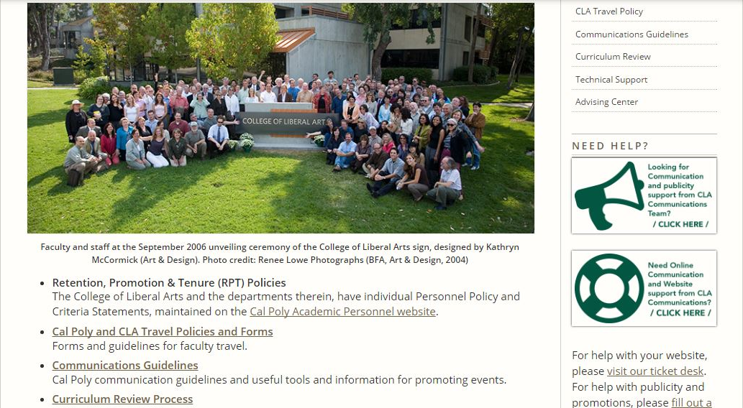

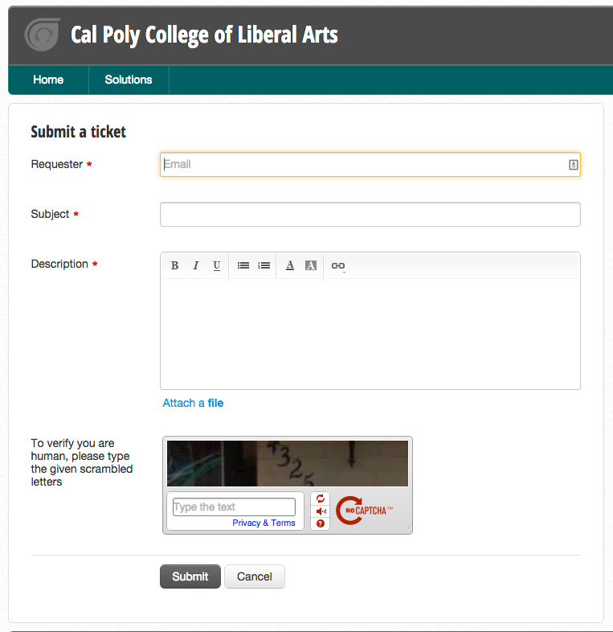
You can also go straight to the CLA helpdesk at https://calpolycla.freshdesk.com/support/home. Fill in your details and we’ll try to get back to you as quickly as possible, either by email or by phone.

What You Can Do/What We Can Do
There are a lot of small edits to your website that are easy, quick and efficient for you to make. If you can use Microsoft Word, you can easily do 90% of the tasks you need to accomplish for your website.

Responsibilities | Departments | CLA Comm Team
Minor edits
Adding/editing office hours | x
Adding/editing Tentative Course Offerings pages | x
Adding/editing Faculty information (phone/office numbers, name changes etc.) | x
Uploading a document | x
Creating links to a documents | x
Content
News item (Event listing, classroom report etc.) | x
Basic page and link article to another page | x
Rich media embedding (video, soundcloud player etc.) |  | x
Creating online newsletter |  | x
Graphics
Image editing |  | x
Anything requiring extensive graphic design or more than basic web page design |  | x
Site management
New website section |  | x
New site set up |  | x
Adding admins/users |  | x

Of course, the main reason you might want to contact us is that you are stuck and want to get unstuck!

Then log a ticket and the CLA Communications team will be happy to help you.

Logging In

- Type in the url with ‘/user’ at the end: ‘department.calpoly.edu/user’
- Log in with My Cal Poly Portal login

Updating Office Hours

- When logged in, navigate to the office hour page.
- Click ‘New draft’

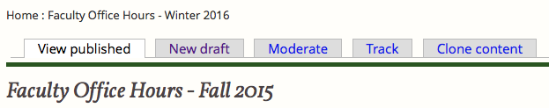

- Make necessary changes
- When finished, click ‘Publishing options’
- Under ‘Moderation state’ choose ‘Published’

6. Click ‘Save’ to return to the updated page

Updating Faculty Table

- When logged in, navigate to the ‘Faculty & Staff’ page
- Click ‘New draft’
- Make changes
- To add or delete and new faculty member, right click on the row
- Choose “Insert Row Before’, ‘Insert Row After’, or ‘Delete Row’

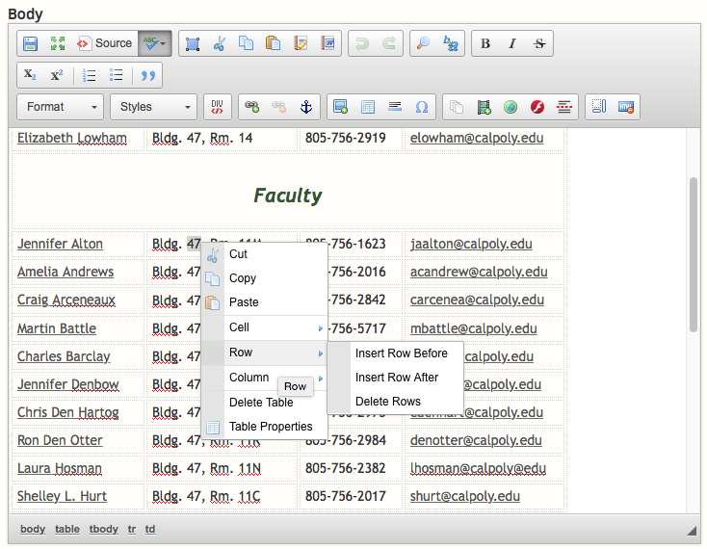

6. Remember to publish and save before leaving the page

Adding Links

- Click ‘New draft’ on the page to edit
- Highlight the text to become a link
- Click the add link button

Internal link
- Internal links link to page within the department website
- Under ‘Link Type’ choose ‘Drupal’
- Under ‘Link’ type the node and number like ‘node/##’ or, start typing the title of the page you wish to link and Drupal will provide some choices.
Click ‘OK’
Where’s My Node?
To find the node of the correct page, click ‘New draft’, the node will appear in the URL.

External link
- External links link to other websites
- Under ‘Link Type’ choose ‘URL’
- Insert the URL
- Click ‘OK’

Email link
- Link emails
- Under ‘Link Type’ choose ‘Email’
- Insert email under ‘E-Mail Address’
- Click ‘OK’

Adding a Basic Page
Most of your website is made up of an item type called “Basic page,” which is perfect for most forms of content.

- In the main menu click ‘Add content’ – you’ll be taken to the ‘Create content’ page.

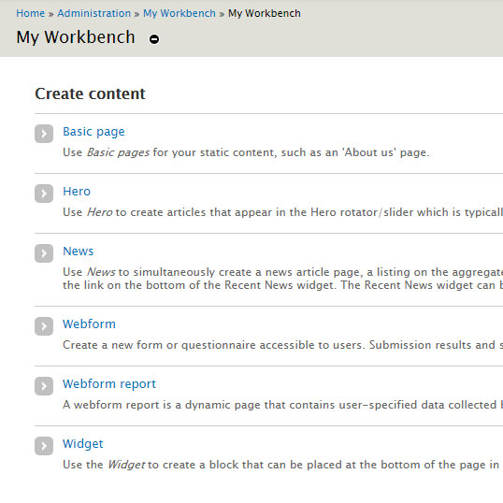
- Choose ‘Basic Page’ to create a new page
- Add a title
- Add page content to the ‘Body’ portion
- Under ‘Section’ choose ‘This Site’
- Uncheck ‘Generate automatic URL alias’
- Add URL alias, for example, ‘students/…’
- Click ‘Publishing options’
- If you are not ready to make your page public, select “Draft” under “Moderation state,” then click “Save” and it will save your work; you can then return to work on it at your convenience.
- Once you are ready to make your page public, select “Published” under “Moderation state,” click “Save” and share it with the world!

A word about URLs

When you create a new page in Drupal, by default it will assign a URL to the page, but these are unstructured – ie. they don’t tell you what part of the site the page belongs to – and they often pretty lengthy (bad). Structuring your URLs in the following way will help orientate visitors to your site.

Always add a url in the following way:
“[section of website ie. ‘students’]/[page-name]”

For example:
“students/ tentative-course-offerings-2015-16”

or “faculty-staff/a-newfaculty

or “news/2016/hot-off-the-press”

If you have questions, please drop us an email at clawebteam@calpoly.edu or log a ticket from icon in the bottom righthand corner of your site’s contact page.

Adding a News Article/Event
For news of any kind, updates, department news, event announcements, new class offerings or classroom activities, a “News Article” will be ideal. This content type also appears in a couple of other places – such as “more_news” and the little “Latest News” widget on the homepage – making it highly visible.

- In the main menu click ‘Add content’

- Choose ‘News’ to create a new article
- Add a title
- Add news article to the ‘Body’ portion

- Click ‘Insert Teaser Break’ after the first paragraph

- Under ‘Section’ choose ‘This Site’
- Uncheck ‘Generate automatic URL alias’
- Add URL alias, ‘news/2016/title’
- Click ‘Publishing options’
- Under ‘Moderation state’ click ‘Published’
- Click ‘Save’
Adding a Hero Item
The slideshow on your website homepage is used to draw attention to the most useful or important information or news on your website. Creating a new "Hero" item (or slide) for the slideshow has a couple of separate steps: creating the image, creating the Hero item and configuring it. If you need help creating this item, please submit a ticket: https://calpolycla.freshdesk.com/support/tickets/new
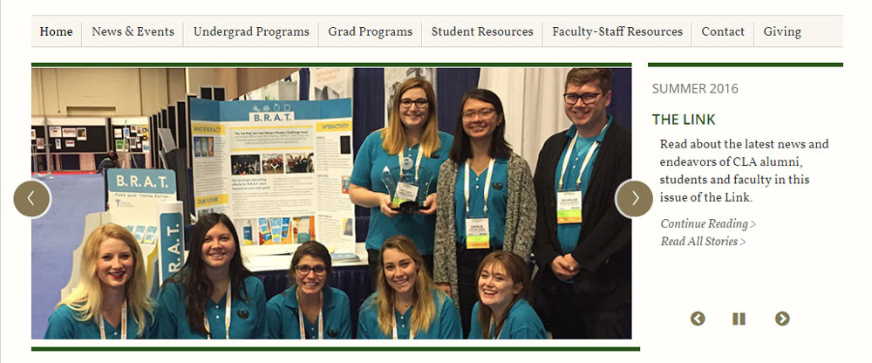

- First go to "Add content." Here you'll see all the different content types. Pick "Hero."
- Now you will need a hero image. This needs to be 730 x 330 pixels; time for Photoshop.
- Upload this image and add alt text description.
- Add a title and teaser text, which will be displayed beside the Hero item. Adding a Date line can be useful for time-sensitive items, like events.
- Add a link to the page you want it to link to; remember to use nodes for linking to internal pages. (See above for how to link.)
- Add the section; this is required for all content.
- Finally, you will need to choose where in the order of your slideshow you want your slide to appear. T (-99 to +99, where lower is further forward in the order.

Cloning a page
Sometimes you will find that you need to create a page that is almost the same as an existing page, but for specific details.

Good examples are Faculty pages, where the format is the same (or should be!) across the faculty or Tentative Course Offerings pages, which have a lot of the same content from one academic year to the next. This is when you will want to copy (or “clone” in Drupal terminology) the content. Here’s how.

- Go to the page that you want to copy - click the “Clone content” tab
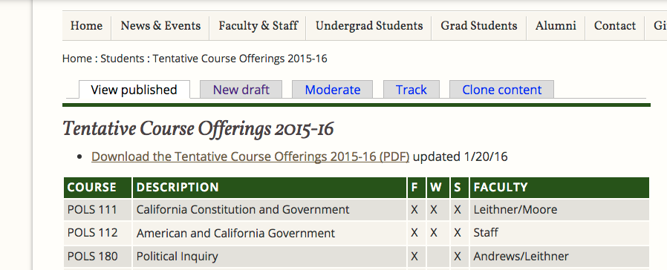

- The cloned page will be an exact called “Copy of [whatever the page is called]
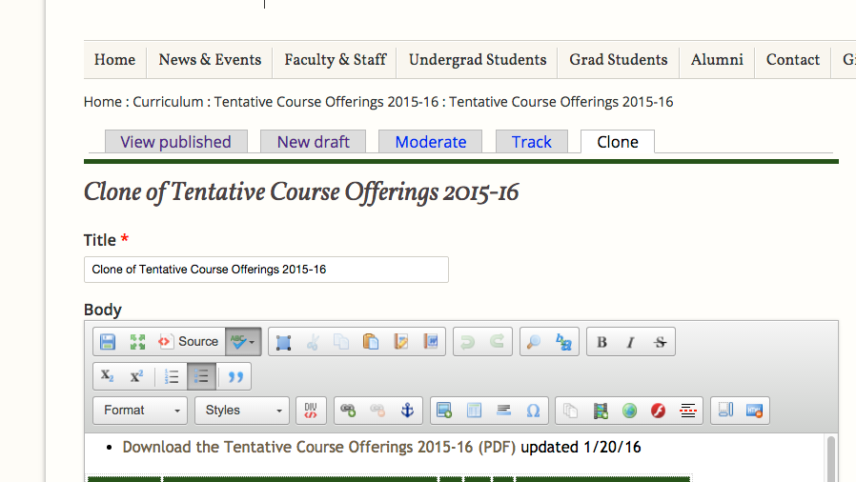
- Edit this page as you like.
- Under ‘Section’ choose ‘This Site’
- Uncheck ‘Generate automatic URL alias’
- Add URL alias, “[section of website ie. ‘students’]/[page-name]”
- Click ‘Publishing options’ - Under ‘Moderation state’ click ‘Published’
- Click ‘Save’
Upload a photo or document to the File Browser

To insert a photo or document to a page on your website, you will need to upload the file to the website.

There are two ways to add images or documents to your website:
- Uploading a file to your website’s File Browser.
- Uploading a file from within a page on your website.

To insert a photo or document to your website, you will need to upload the file to the “File Browser.”

- Click on “File Browser” in the dashboard tool bar.

- Navigate to the correct folder

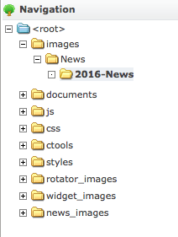
- Click ‘Upload’

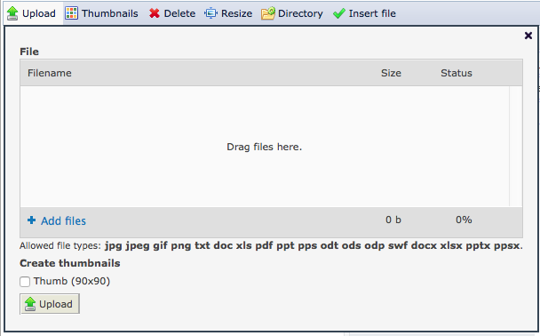

- Drag image or document and click ‘Upload’
- The image or document will show up in the browser

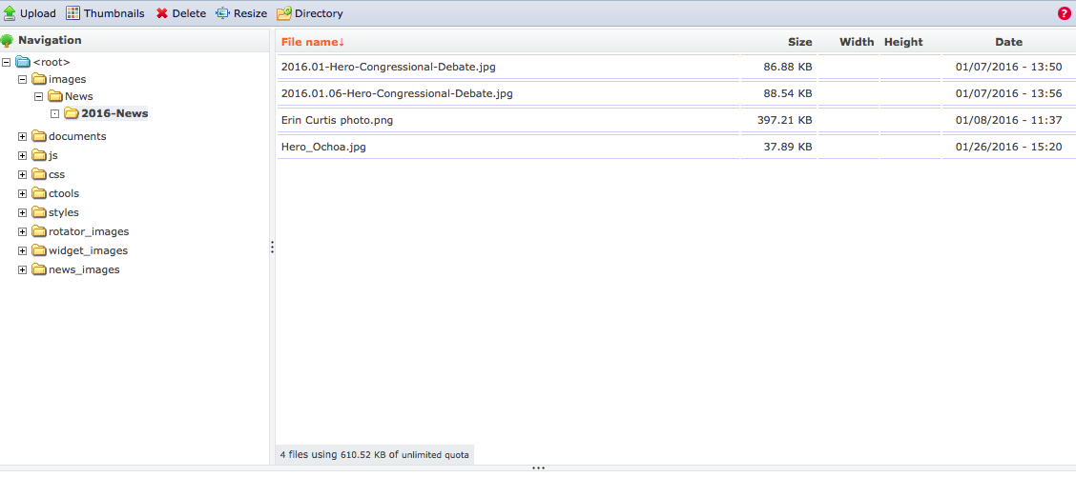

Insert a Photo into a Page

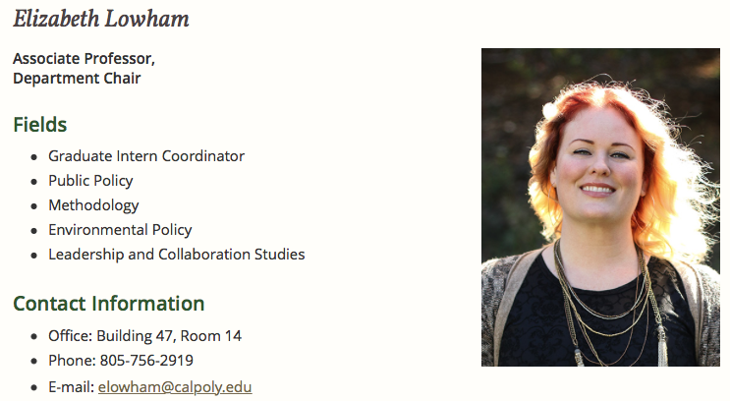

- Click ‘New draft’ on the page to edit
- Click the ‘Image’ icon

- In the ‘Image Properties’ box choose ‘Browse Server’

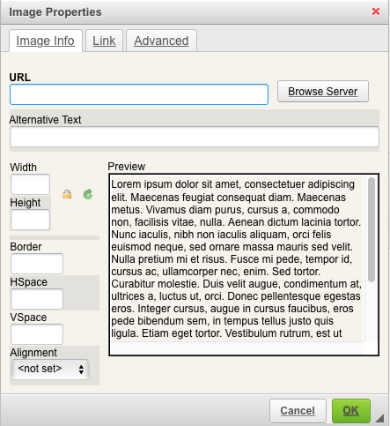

- Navigate into the images folder

- Click ‘Upload’

- Drag image and click ‘Upload’
- Double click on the file
- Back in the ‘Image Properties’ box, set the width (ex, 365)
- Put ‘Alternative Text’ – a description of the image – into your image properties.
- Click ‘OK’
- Under ‘Styles’ choose ‘Img, Lft noborder’ for left alignment or ‘Img, Lft noborder’ for right alignment. There are lots of different styles; experiment and choose one that suits your purpose.

- Click ‘Publishing options’
- Under ‘Moderation state’ click ‘Published’
- Click ‘Save’

Making your images accessible

When you place an image in a page, it is considered best practice to put ‘Alternative Text’ or “alt text” into your image properties. Alternative text describes an image for those who cannot see it. Alt text both helps search engines, like google, identify relevant content, and facilitate users of your website who may be visually impaired and using a screen reader.

For example:
“Students and Faculty at End of Year Barbecue 2015-16”

or, in the example above, “Professor Elizabeth Lowham, Chair of Cal Poly Political Science Department”

If you have questions, please drop us an email at clawebteam@calpoly.edu or log a ticket from icon in the bottom righthand corner of your site’s contact page.

Inserting a Document in a Page

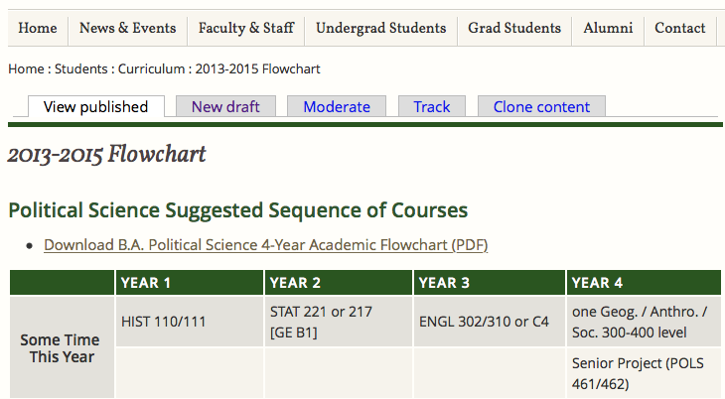

- Click ‘New draft’ on the page to edit
- Highlight the text to link the document
- Click the add link button

- Under ‘Link Type’ choose ‘URL’
- Then click ‘Browse Server’

- Navigate into the documents folder

- Click ‘Upload’

- Drag the document and click ‘Upload’
- Double click on the file
- Back in the ‘Link’ box, click ‘OK’
- Click ‘Publishing options’
- Under ‘Moderation state’ click ‘Published’
- Click ‘Save’

Accessing Alumni Stay in Touch Form
One of the new features that we have added to CLA Department websites is alumni contact forms, so that alumni can easily stay in contact with their departments.

There may be a widget button to this page on your website homepage. Otherwise there will be a widget on your website’s “Contact” and “Alumni” pages.

You will need to check this section of the website periodically; at the end of each quarter should be sufficient.

Finally, as well as responding to these submissions as appropriate, you will need to email these results to gift-bio-updates@calpoly.edu.

- Navigate to the Alumni page
- Click on ‘Results’

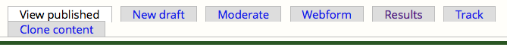

- Under ‘Submissions’ you can view individual entries
- Click ‘View’ to see the results

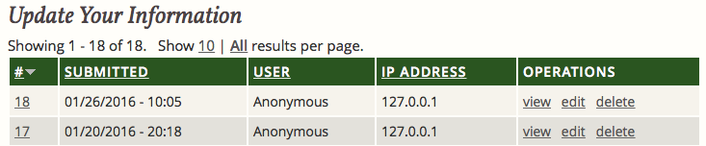

- Click ‘Table’ to view the results as a spreadsheet

- To download the table click ‘Download’ in the menu

- Choose your download settings

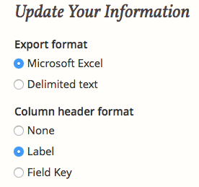

- Click ‘Download’

