Press Kit Guide
& Templates

A helpful guide for promoting your event

September 14, 2016

Sample Event Promotion Timeline

About:
For any event, properly planned and executed publicity is critical to success. A sample timeline for key milestones is as follows, but will need to be customized for each event:

Week 12 (Prior to Event)
- Hold kick off meeting
- Establish key stakeholders
- Assign tasks and leadership roles
- Outline communication plan
Week 11-7
- Reservation of space
- Development of collateral
  - If a large-quantity print piece is desired, art may need to be submitted to the printer by or before Week 11.
- Send a Save the Date email to your contacts on campus
- If you would like to send a promotional email to alumni, see External Email checklist
Week 6
- Submit press release to Rachel Schultz, rellersi@calpoly.edu
- Finalize printed collateral: posters, flyers, program
Week 5
- Distribution of press release to local media
- Post finalized release/information on website
- Submit information to promotional outlets — on and off campus
- Send printed collateral to printer: posters, flyers, program, etc.
Week 4
- Distribute posters, flyers
- Send e-blast with information and call to action
Week 3
- Prepare social media publicity: posts, cover photos, etc.
- Upload rotating hero image on website
Week 2
- Social media publicity — teasers
Week 1
- Social media publicity — teasers
- Send second e-blast with information and call to action
- Finalize PowerPoint
Week of Event
- Hold week of event/event execution meeting with stakeholders
- Social media publicity — pre-, during and post-event
- Final event execution
Week after Event
- Hold meeting with stakeholders to record what worked, what didn’t and what you would do differently, send thank you notes if appropriate

Press Releases

About:
Press releases are vehicles to convey information that may be of interest to the general public. Information suited for this communication vehicle:
- Event announcements (open to the public)
- Awards or significant accomplishments
- New programs or significant changes/impact

Process:
All press releases for departments and programs must be distributed through University Communications. As the College of Liberal Arts liaison, Rachel Schultz will coordinate with departments and programs to ensure that press releases meet university standards.

Cal Poly distributes releases to all local media — television, print and radio.

Timeline:
For events, it is recommended to submit your release four to six weeks prior to the event. Please anticipate 5-7 business days from submission to distribution.

Template:
Refer to the following pages for a template and examples.

Best Practices:
- Answer the five w’s: who, what, when, where, why as quickly as possible
- Structure information in an inverted pyramid — most important information first
- Keep it short — limit as much as possible to one page
- Include contact information
- Mention Cal Poly in the headline and the lead sentence
- Include any supporting links or photos (provide captions, please)

PRESS RELEASE TEMPLATE

FOR IMMEDIATE RELEASE
Month Day, Year

Contact: First Name Last Name
805-756-XXXX; email@calpoly.edu

Headline [ Mention Cal Poly ]
SAN LUIS OBISPO — Lead sentence [ Establish who, what, when, where and include Cal Poly]

Body copy [ 2-3 paragraphs with supporting information ]

Conclusion [ 1-2 sentences on sponsorship information ]

Link(s)s
- Link Name: url

Photo/Caption
- Description: Image Name.jpg
  - Caption information

About [ Entity Name ]
1 paragraph about the originating entity (example: About Cal Poly History Department). Katie VanMeter has about statements generated for all CLA departments.
# # #

EXAMPLE — EVENT

FOR IMMEDIATE RELEASE
April 10, 2014

Contact: Kim Barton
805-756-2543; kabarton@calpoly.edu

Author to Discuss ‘The Real American War in Vietnam’ April 22 at Cal Poly
SAN LUIS OBISPO — Award-winning journalist, historian and author Nick Turse will present “The Real American War in Vietnam” at 6 p.m. Tuesday, April 22, in Room 123 in the Bioresource & Agriculture Engineering Building (No. 8) at Cal Poly.

The talk will focus on topics Turse wrote about in his critically acclaimed book, “Kill Anything that Moves.”

In the book, Turse asserts that Americans have long been taught that events such as the notorious My Lai massacre were isolated incidents in the Vietnam War, carried out by a few “bad apples.” But through a groundbreaking investigation, Turse discovered the violence against Vietnamese civilians was not at all exceptional during the conflict. Rather, it was pervasive and systematic, the consequence of official orders to “kill anything that moves.”

Turse is also the author of “The Complex,” the managing editor for TomDispatch.com, and a fellow at the Nation Institute, a nonprofit media center dedicated to strengthening the independent press and advancing social justice and civil rights.

Turse’s investigations of American war crimes in Vietnam have gained him a Ridenhour Prize for Reportorial Distinction, a Guggenheim fellowship, and a fellowship at Harvard University’s Radcliffe Institute for Advanced Study. Additionally, he was the recent recipient of the prestigious Izzy Award from the Park Center for Independent Media.

The presentation is free and open to the public. It is co-sponsored by the College of Liberal Arts’ Doyle Fund and the departments of Ethnic Studies, History, Journalism and Political Science.

Links
- Ethnic Studies Department: cla.calpoly.edu/es.html
- History Department: cla.calpoly.edu/hist_events.html
- Journalism Department: journalism.calpoly.edu/
- Political Science Department: cla.calpoly.edu/pols.html
- College of Liberal Arts: cla.calpoly.edu

Photo/Caption
- Book cover: Kill Anything That Moves.jpg
- Headshot: Turse, Nick Headshot (credit Tam Turse).jpg

# # #

EXAMPLE — AWARD/ACCOMPLISHMENT (FACULTY)

FOR IMMEDIATE RELEASE
May 5, 2014

Contact: Rachel Schultz
805-756-1216; rellersi@calpoly.edu

Cal Poly Ethnic Studies Professor Awarded Fulbright Scholar Grant
SAN LUIS OBISPO – Cal Poly ethnic studies Professor Victor Valle has been selected to receive a 2014-15 Fulbright U.S. Scholar Grant.

The Fulbright Scholar Program gives faculty and professionals the opportunity to lecture, teach and conduct research in a foreign country, with the aim of building relationships across continents.

With the grant, Valle will temporarily live in Mexico to continue his research on his latest book project, “The Poetics of Fire: On the Art of Chile-Eating.” Valle’s project explores how North Americans perceive the aesthetics of chile-eating. The research examines the metaphors and narratives that drive how people discuss chile-eating and how these metaphors and narratives have evolved over time.

Valle has been with the Cal Poly since 1992. He began his writing career in the 1970s by publishing poetry and literature translations and editing literary magazines. After graduating from the Medill School of Journalism in 1981, he joined the staff of the Los Angeles Times. During his residency there, Valle and fellow Chicano journalists received a Pulitzer Prize and other honors for investigative journalism.

As an author, Valle’s book “Recipe of Memory: Five Generations of Mexican Cuisine,” has been reviewed in more than a dozen scholarly journals and has been reproduced in “American Food Writing: A Literary Anthology” by the Library of America publishers. His last book, “City of Industry: Genealogies of Power in Southern California,” was published in 2009.

“Professor Valle is not only an acclaimed scholar and writer but also an activist who truly lives out ethnic studies and Cal Poly’s commitment to transformative knowledge,” said Denise Isom, Ethnic Studies Department chair.

Links
- Ethnic Studies Department: http://cla.calpoly.edu/es.html
- Fulbright Scholar Program: http://www.cies.org/about-us

About the Cal Poly Ethnic Studies Department
The Cal Poly Ethnic Studies Department provides students with the skills required for critical inquiry that advance their analysis of race, ethnicity and cultural difference in an increasingly complex world. Students examine how social hierarchies frame access to political power, allocate economic resources, and influence expression. The curriculum’s interdisciplinary approach helps graduates better comprehend and properly address the issues of the world they live in.
# # #
EXAMPLE — AWARD/ACCOMPLISHMENT (STUDENT)

FOR IMMEDIATE RELEASE
May 7, 2014

Contact: Rachel Schultz
805-756-1216; rellersi@calpoly.edu

Cal Poly Graphic Communication Students Win First in Packaging Challenge
SAN LUIS OBISPO — Cal Poly graphic communication students won first place at the Phoenix Challenge Flexo Packaging Competition on April 26.

Ten schools and more than 80 students traveled to Baltimore to participate in the competition, sponsored by the Phoenix Challenge Foundation to encourage high school and college students to explore opportunities in the flexographic printing industry.

This year the students were charged with helping rebrand a company.

Cal Poly’s team showcased their skills by rebranding local winery Saarloos and Sons’ Rosé label, taking the lead in the categories of Best Concept, Design, Research and Execution.

The team’s rebranding strategy included printing a complex surface print-reverse view label with gold metallic ink. A label tag was incorporated using thermochromic ink that turns blue when the wine has been chilled to the proper temperature. The team also created a corrugated shipping container that functioned as a display.

Cal Poly’s Learn by Doing educational approach occurred throughout the project. Students worked with industry partners to receive donated materials to print their jobs. The team approached the project in a multidisciplinary manner, collaborating with Cal Poly faculty in the Wine & Viticulture, Agribusiness, Industrial Technology, and Graphic Communication departments to complete the project.

This year’s team comprised students Natalee Consulo, Mariah Linnett, Lena Haidar, Giulianna Riso, Connor Foltyn-Smith, Meredith Stewart and Mishay Murfield and Professors Colleen Twomey and Malcolm Keif.

Links
- College of Liberal Arts: http://www.cla.calpoly.edu/
- Graphic Communication Department: http://www.grc.calpoly.edu
- Phoenix Challenge Competition: http://phoenixchallenge.org

About the Cal Poly Graphic Communication Department
The Graphic Communication Department at Cal Poly is one of the best-known and largest programs of its kind in the western United States. The department is home to more than 33,000 square feet of laboratories filled with cutting-edge equipment donated in large part through industry partnerships. The department serves approximately 300 students pursuing a degree in graphic communication with an emphasis in one of four focus areas.
# # #

Additional Publicity Outlets

About:
In addition to press releases, there are other communication outlets available to publicize an event or award/accomplishment.

Process:
CLA Communications is the CLA administrator for the following free, on-campus publicity sources. If you would like your event promoted on one or more, please submit a request on the Faculty-Staff Resources page on cla.calpoly.edu.
This includes:
- Cal Poly Report
- Cal Poly Portal (as appropriate)
- CLA Weekly Announcements

Timeline:
Similar to press releases, it is recommended to submit your publicity statements four to six weeks prior to the event. For consistency, base publicity statements on the final press release distributed by the university. Please anticipate 5-7 business days from submission to distribution.

On Campus Publicity Outlets:
Cal Poly Report
- Weekly e-newsletter for Cal Poly faculty and staff
- Distributed every Wednesday morning during the regular academic year and monthly during the summer months
- Requirements:
  - 150 words or less
  - First sentence should include who, what, when, where
  - Include all url links separately (do not embed within text)
- Deadline: 4 p.m. Wednesday prior to publication

Cal Poly Portal
- Listing in the Cal Poly Portal
- Updated on an ad-hoc basis at the discretion of University Marketing
- Requirements:
  - 50 words or less
  - Include all url links separately (do not embed within text)
  - Requested start date
  - Requested stop date (announcements will run for seven working days maximum)

CLA Weekly Announcements
- Weekly email distributed to all CLA faculty and staff
- Focused on events and news items pertaining to the college
- Distributed every Monday
- Requirements:
  - 100-150 words or less
  - Include all url links separately (do not embed within text)
- Deadline: 5 p.m. Thursday prior to distribution
You may submit your events on the following sites. For consistency, base publicity statements on the final press release distributed by the university. CLA Communications will not submit to these publications for you.

Off Campus Publicity Outlets:
KCBX Community Calendar
http://www2.kcbx.org/Pages/Community/public_events.html
- Limited to 40 words

KSBY
http://www.ksby.com/calendar/
- Must create log in to submit a post

New Times
http://www.newtimesslo.com/calendar.php
- Limited to 250 characters

Tribune Events
http://events.sanluisobispo.com/listings

- Limited to 500 characters

- Must create log in to submit a post

Visit San Luis Obispo
http://www.visitsanluisobispocounty.com/
- Must be submitted by a chamber member

Signage: Posters and Flyers

About:
Posters and flyers are a great way to advertise to on and off campus entities.

Process:
Departments are responsible for the design and distribution of all posters/flyers. If assistance is needed, please contact Rachel Schultz, rellersi@calpoly.edu or 805-756-1216, and she can put you in touch with freelance designers to hire. University Marketing has created some flyer templates to aid in the process as well. Please contact Rachel for access to these templates.

EXCEPTION: CLA Communication will design “CLA Speaks” flyers and posters in order to keep the look and feel among all CLA Speaks events consistent.

Approval:
Please send near-final artwork to Rachel Schultz to approve. When distributed off-campus, flyers and posters may also need to be approved at the University level.

Timeline:
For events, it is recommended to distribute posters/flyers two to three weeks prior to the event. Plan on three days to have your flyer approved by CLA Communications. If you’re distributing to a wider audience, please leave seven days for approval at the university level as well.

Template:
Design is left to the discretion of departments. For community/off-campus focused distribution, strong adherence to Cal Poly brand visual requirements will aid in recognition, remembrance and approval.

Standard sizes are as follows:
- 8.5” x 11” flyer
- 11” x 17” small poster
- 18” x 24” medium poster
- 24” x 36” large poster
- 24.25” x 36” A-frame signage

Requirements:
- Cal Poly logo
- Correct implementation of Cal Poly visual and written style guide
- Sponsorship information
  - Sponsorship information for the lottery fund should be listed as follows: College of Liberal Arts' Lottery Speakers Fund
- The five w’s: who, what, when (date and time), where (building and room), why

Best Practices:
- Use a design that is visually appealing and photo-centric
- Limit description text to 150 words
- Utilize a clear hierarchy in presenting information
External Emails (PolyLink)

About:
An email blast, at the right time, is one of the best ways to reach your audience.

Timeline:
There are usually at least two stages of approval needed for external emails to alumni and donors, so consider this in your timeline. It is recommended to submit your email 10 days prior to intended distribution.

Template:
CLA Communications will use pre-approved, branded templates to send emails to alumni and donors on behalf of departments.

A banner graphic is optional, but can be eye-catching in the right context.

Images are strongly recommended. Images (with or without links) can be added to call attention to a key point of interest in the email and are shown to engage email viewers.

The email should include some kind of call to action, prompting the recipient to visit a specific site or perform a certain action.

The footer area is a useful place to put contact information and links to social media accounts.

For assistance with email content or design, please contact Rachel Schultz, rellersi@calpoly.edu or 805-756-1216, or Erik Salholm, esalholm@calpoly.edu or 805-756-2986.

Standard image sizes are as follows (all sizes are in pixels and at a standard RGB 72 dpi, unless otherwise stated).
- Banner graphic: (600 x 274px)
- Feature image (180 x 240px)

Best Practices:
- Keep emails short; make your message clear and succinct to ensure that you reach your audience
- Use a design that is visually appealing and photo-centric. Always use an alt tag in your images
- Use links strategically — where do you most want visitors to go from here? Too many links will confuse viewers
- Create a call to action — be specific about the one thing that you would like a viewer to do

PolyLink Email Check List

Contact: Rachel Schultz, rellersi@calpoly.edu, 805-756-1216

Note: This process normally takes 10 to 15 days and is managed by the CLA Communications Office.

Send the following items to the CLA Communications Office:
- Text with subject line
- Supporting images and graphics
- URL links
- Target audience
- Desired distribution date
- Sender email (cannot be personal email)

CLA Communications will send a test email to department/program for review

CLA Communications will request PolyLink distribution and audience

CLA Communications will send a test email to University Communications for review *

Finalize/distribute **

*Note: University Communications requires a minimum of five business days for all PolyLink approvals.

** In addition to distributing the PolyLink e-communication to the target audience, a copy is sent to 1) Department chair, 2) Additional department personnel regularly responsible for PolyLink requests, 3) CLA Communications Office, 4) CLA Dean’s Office, and 5) CLA Advancement.

Website Presentation

About:
Your website is a great place to publish information about your news and upcoming events. It can attract people to your website and provide a focal point for information about your work.

Process:
Departments are responsible for the design and maintenance of departmental and program websites. For assistance, please contact Erik Salholm at esalholm@calpoly.edu.

The simplest way to add events to your website is to add a News Item. See Drupal Guide for instructions on how to do so.

Timeline:
Publish online after the press release has been approved by UMC.

Template:
Design is left to the discretion of departments. Consider this to be community/off campus focused; respect Cal Poly brand visual requirements.

Standard sizes for website imagery are as follows (all sizes are in pixels and at a standard rgb 72 dpi, unless otherwise stated). If you need templates for image sizes, contact Erik.
- Hero image: 730 x 333px (on article page as 723 x 330 px)
- Half-page landscape: 365 x 274 px
- One-third-page landscape: 243 x 182 px
- One-quarter-page landscape: 183 x 137 px
- Half-page portrait: 365 x 487 px
- One-third-page portrait: 243 x 324 px
- One-quarter-page portrait: 183 x 244 px
- Sidebar button: 200 x 150 px
- Widget: 200 x 205 px

Hero Images (730 x 333px / 723 x 330px)
The images that appear in the rotator on the front page of many Cal Poly websites — including the main Cal Poly website — are called “hero” images.

In Drupal 7, users can create “hero” items which then appear automatically in the rotator. Hero images are 730 x 333 px.

We can use an image with the same dimensions, displayed a little smaller — 723 x 330px — to display at full width in articles.

Hero Images (continued)
Using a hero image can be a great way to make a strong impact in an article, while instantly telling the story. It can also give a page substance, if your release is short.

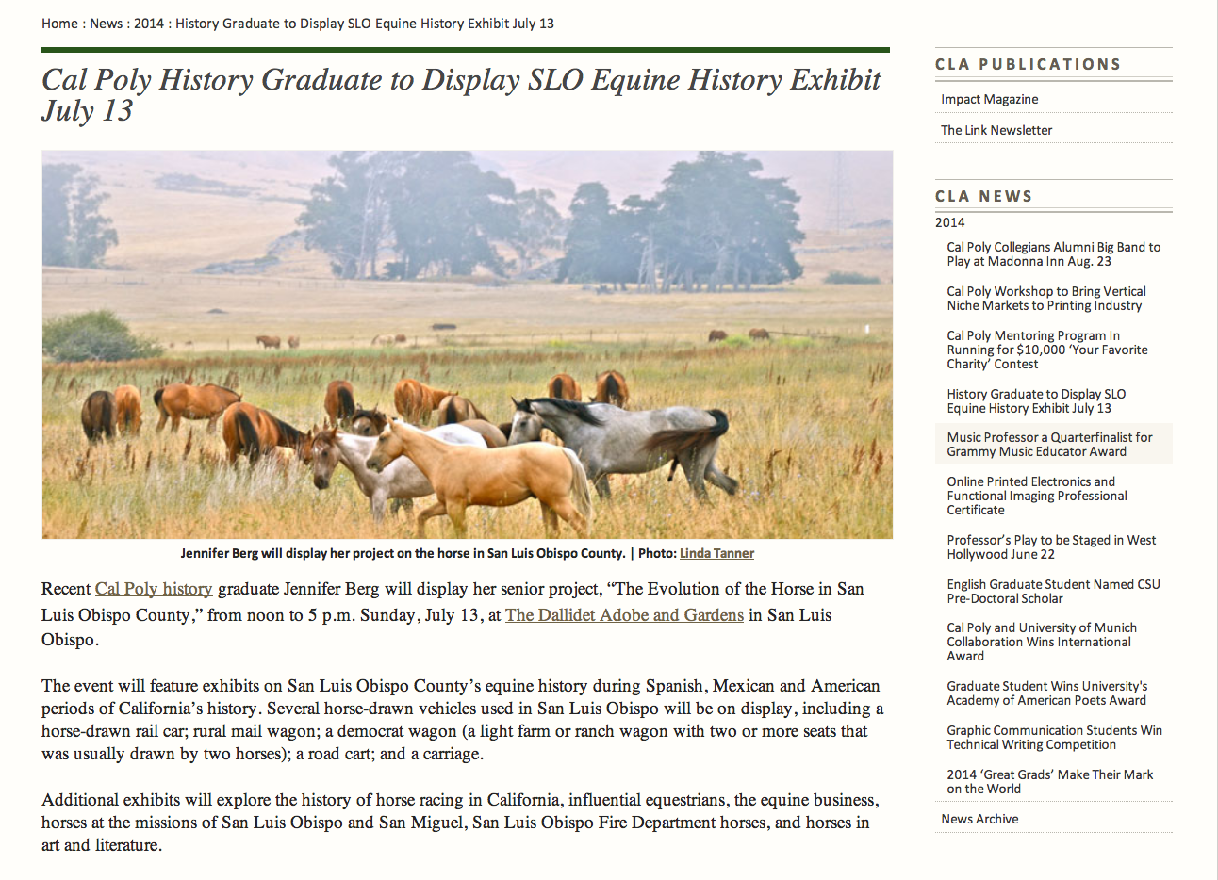

Half-width (365 x 274 px / 365 x 487 px) and
One-third-width (243 x 182 px / 243 x 324 px) Images
If you do not have a large image, or the space to incorporate one, a half-width image still makes a good impact and can be great for group shots, as in the example below.

One-third-width images are a useful size — big enough to give visual impact, but small enough not to drive a longer article too far down the page. These images can be aligned left or right to create visual interest.
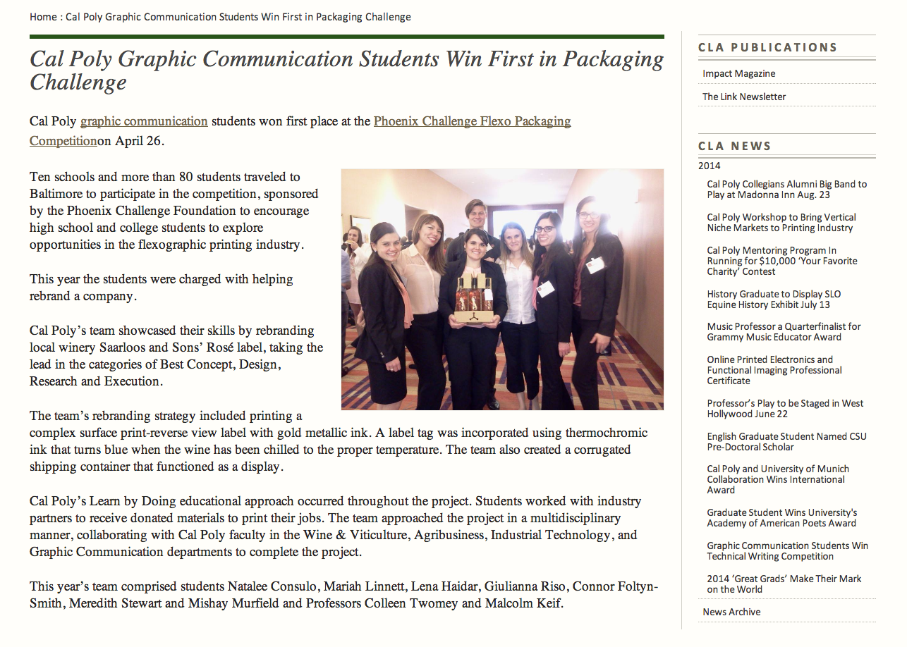
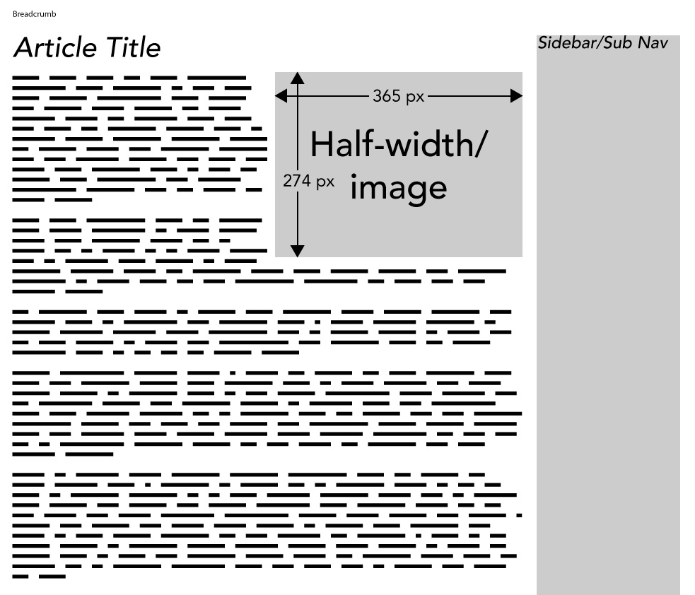

One-quarter-width Images (183 x 147 px / 183 x 244 px)
Small images (particularly headshots/portraits) are effective as one-quarter-width images; several images of this size can be comfortably accommodated on one page.
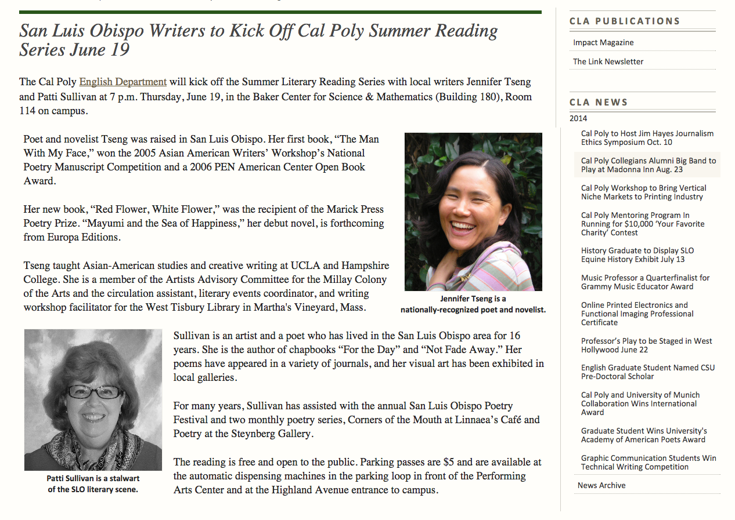

One-quarter-width landscape format images (183 x 147 px) may be too small to be effective for all but the boldest image.

Complex Layouts
One-third-width or one-quarter-width images (aligned left or right) also combine well with a hero image.

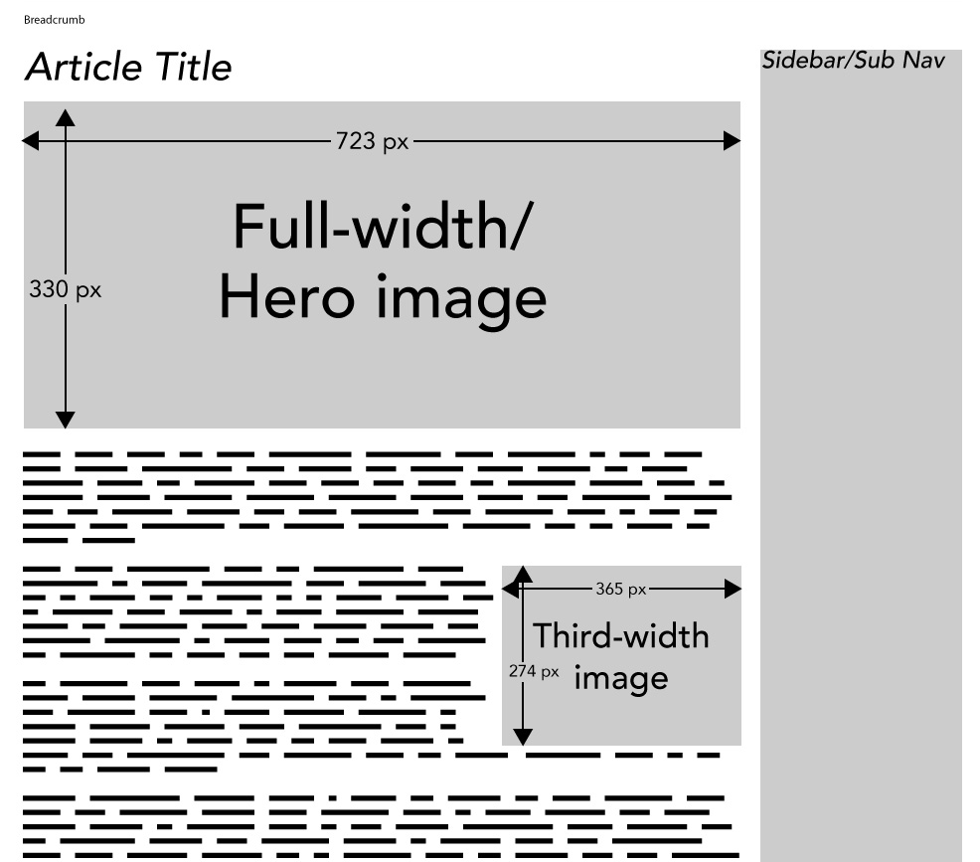
There is great scope for creativity in website article layout.

Requirements:
- Correct implementation of Cal Poly visual and written style guide
- Caption images and credit photos, if possible (i.e., “Dean Doug Epperson at CLA Awards 2014. | Photo: Rachel Schultz”)

Best Practices:
- Use a design that is visually appealing and photo-centric
- Use links strategically — ask where do you most want visitors to go from here? Too many links will confuse viewers
- Utilize a clear hierarchy in presenting information — try to place images where they will complement the text
- Always use an alt tag in your images
- If you have created a poster for your event, but not a press release, do NOT simply upload the image; likely there is a great deal of useful information that search engines cannot “see” in a static image.
It will be far more useful to create a simple page with the information contained in your poster. Search engines (and their users) will be able to find your event in a search.
You can still use a graphic element from your poster to create visual interest.

