Step 1: Log into Canvas.
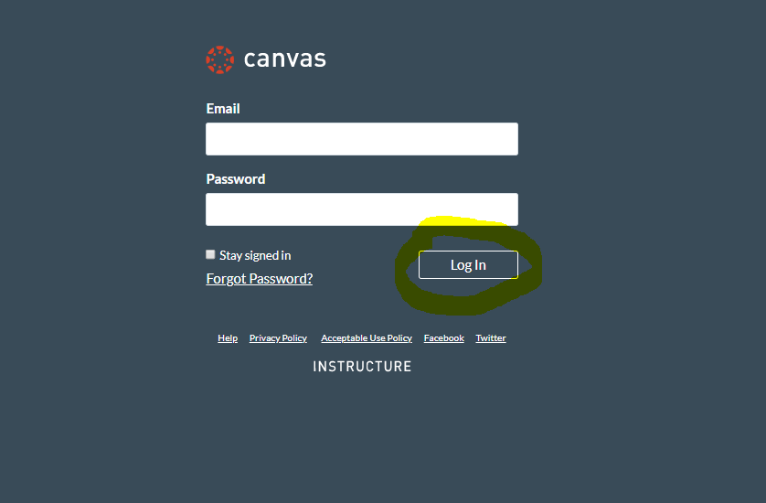

Step 2: Under Courses, locate and enter Canvas course.
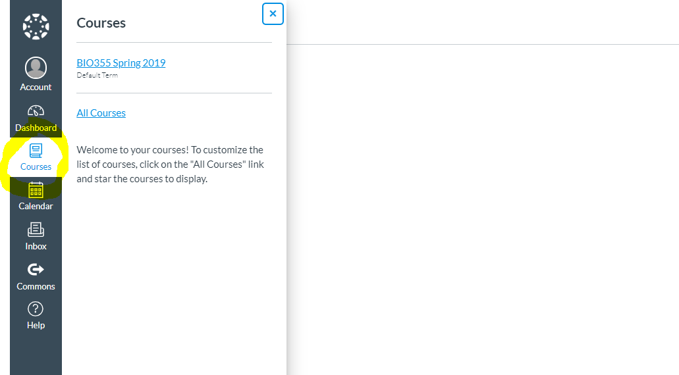

Step 3: Click on Settings (located via the Canvas course navigation menu).
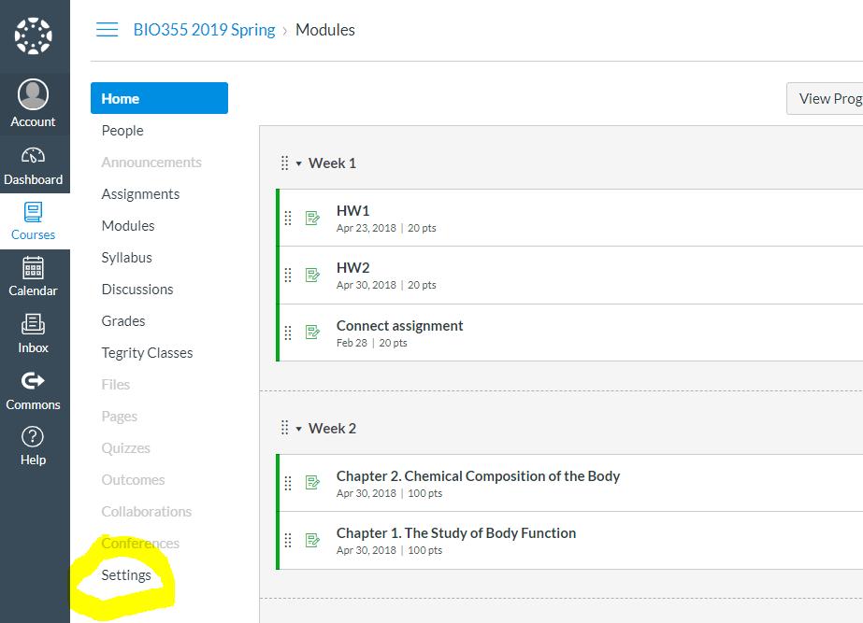
Step 4: Click on Navigation.
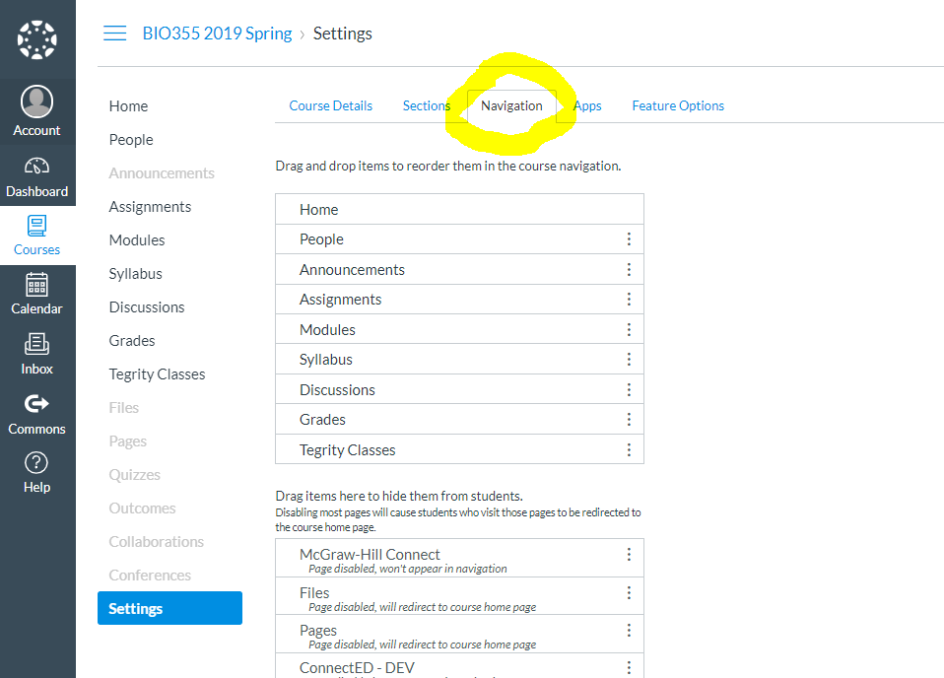
Step 5: Locate and enable the McGraw Hill Connect integration option. Click SAVE.
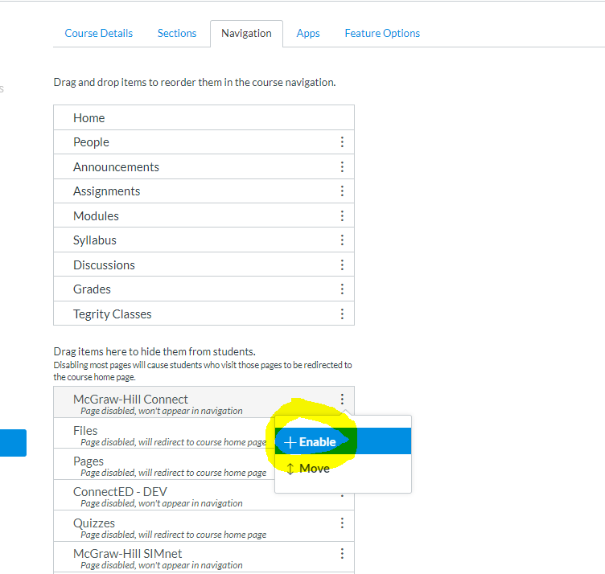
Step 6: The McGraw Hill Connect deep integration link is now visible and available via the Canvas course navigation menu.
