Step 1. Log into Canvas and enter Canvas course.
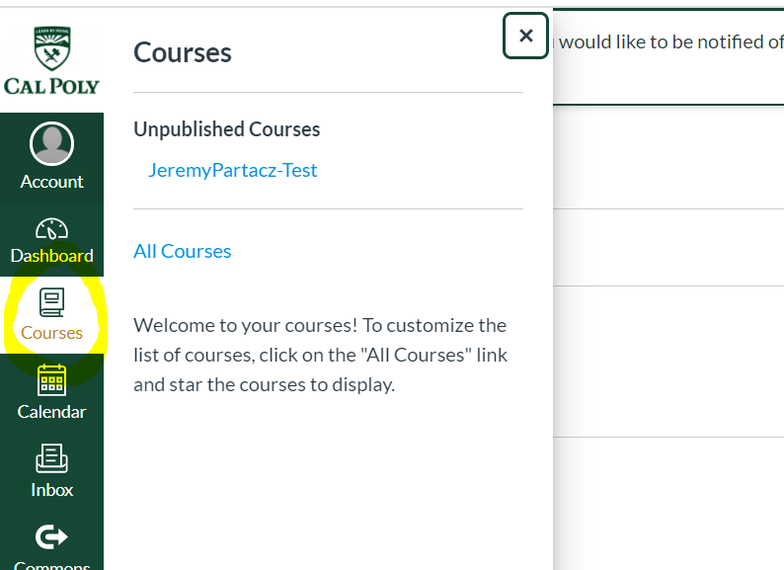
Step 2. Click on Settings.
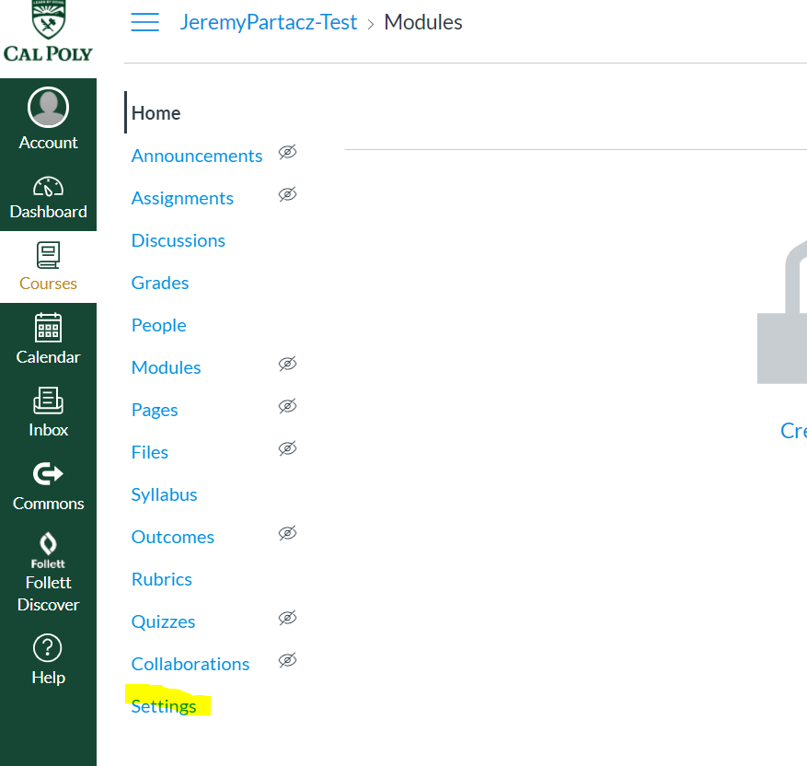
Step 3. Click on the Navigation tab.
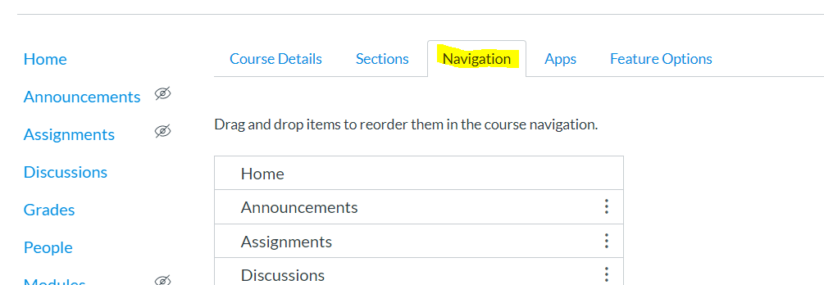

Step 4. At the bottom of the page, locate and Enable the McGraw Hill Connect tool link.
Click SAVE.
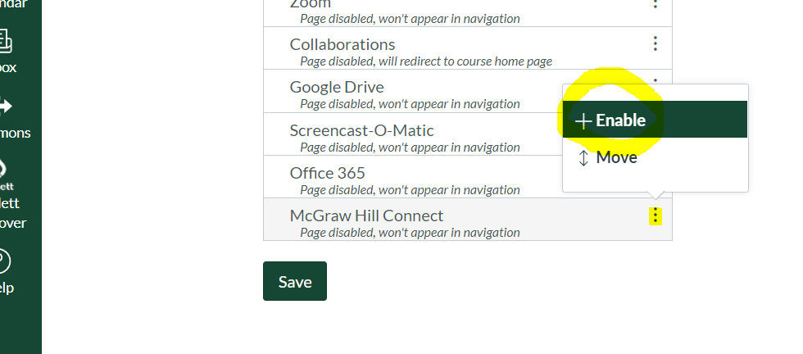

Step 5. Locate and click on the McGraw Hill Connect tool via the course navigation menu.
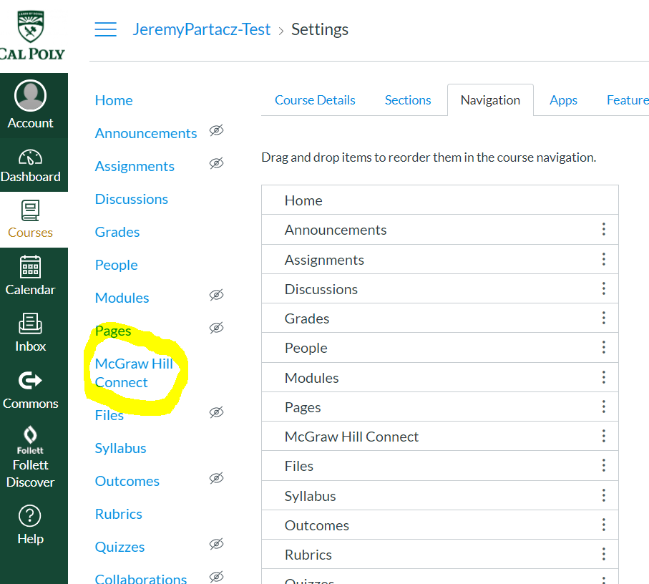

Step 6. Click on Authorize (one-time step).
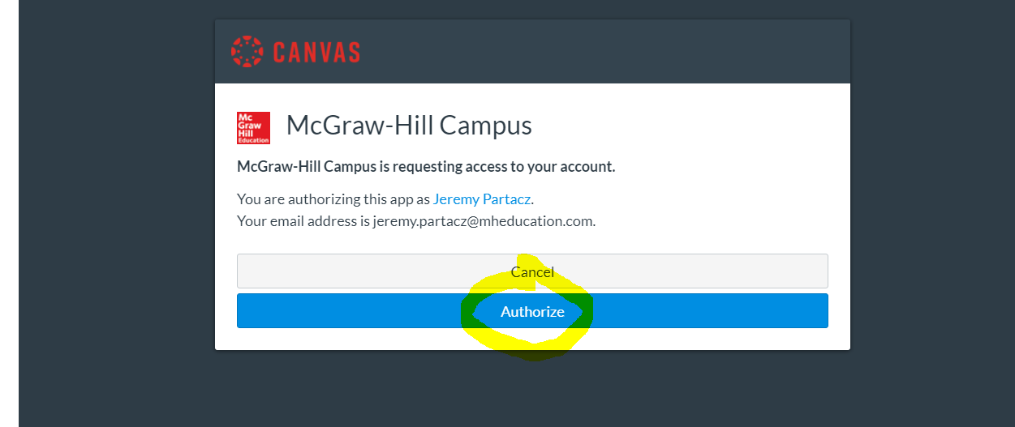

Step 7. Click Begin.
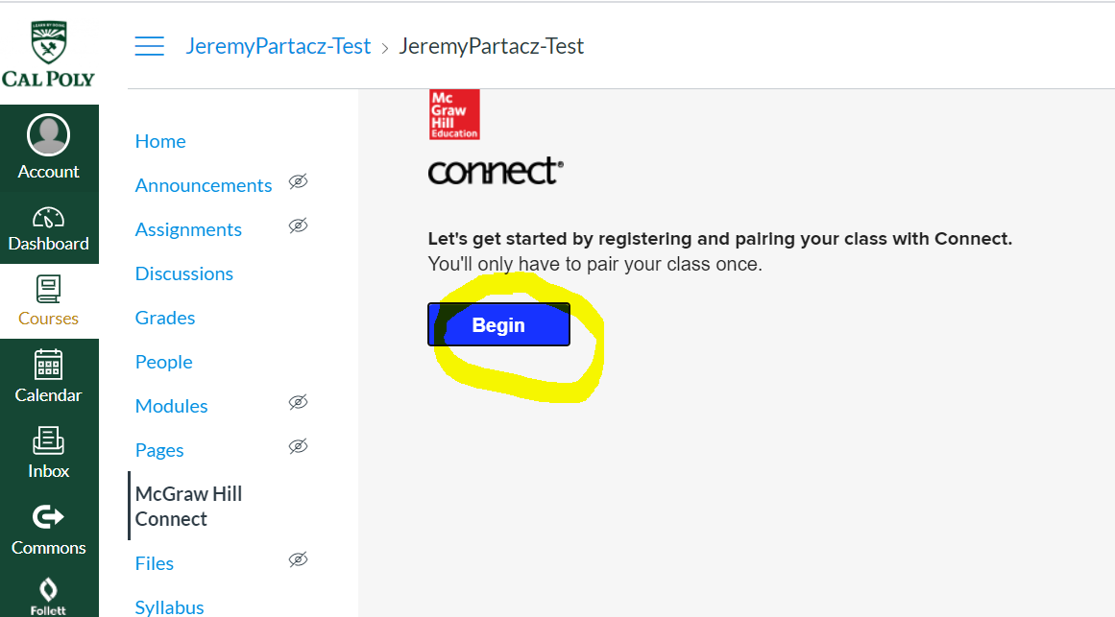

Step 8. Sign into Connect using your Connect email address (username) and password.
Click SIGN IN.
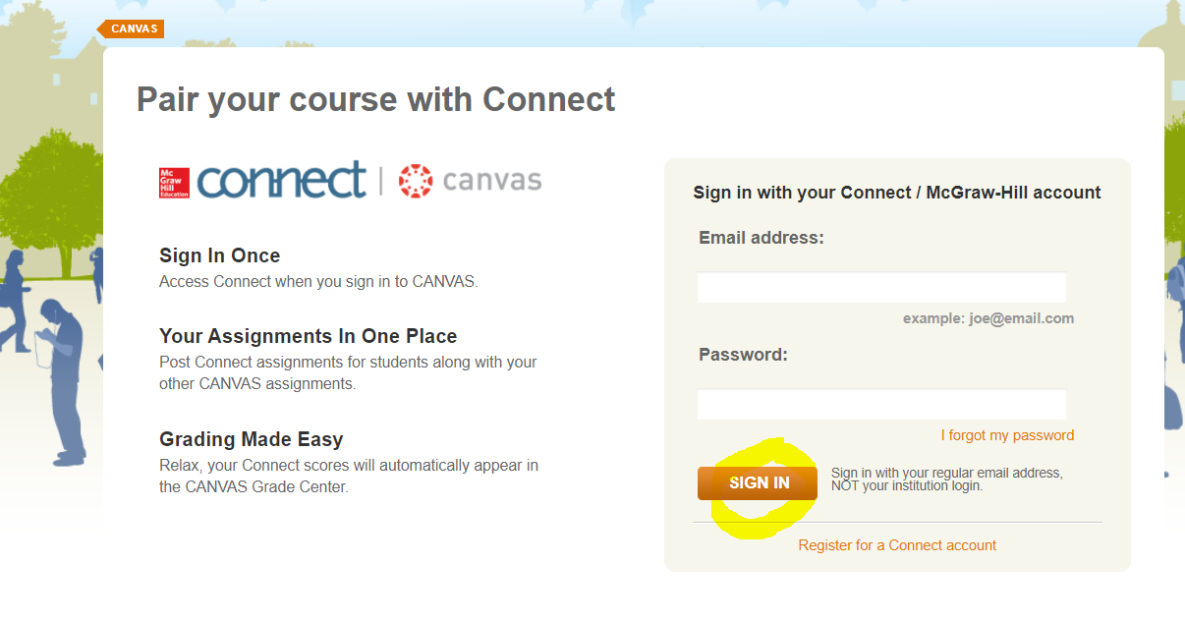

Step 9. Select, “A section in an existing Connect course.”
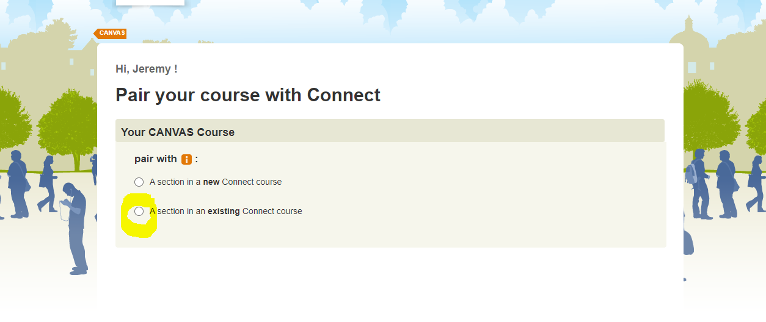

Locate and select the Connect section to pair. Click SAVE.
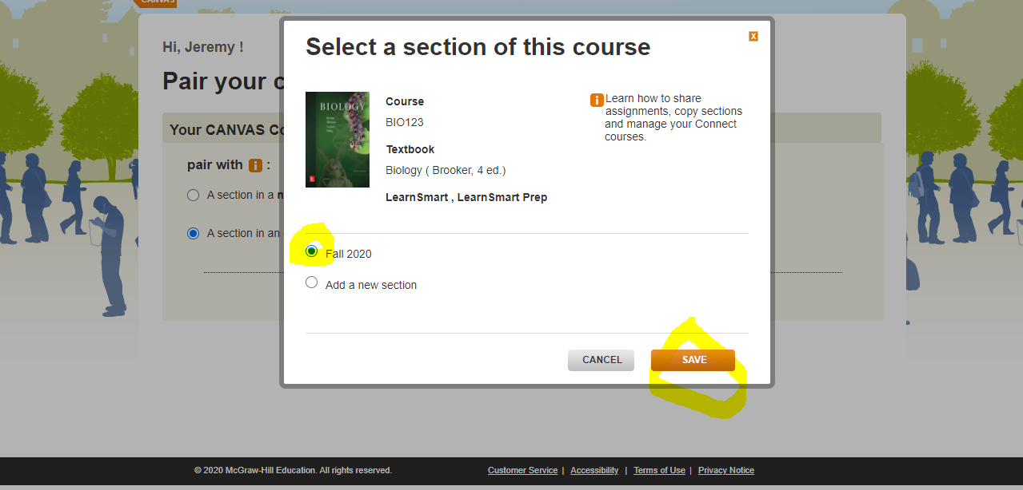

Canvas course is now paired with Connect.
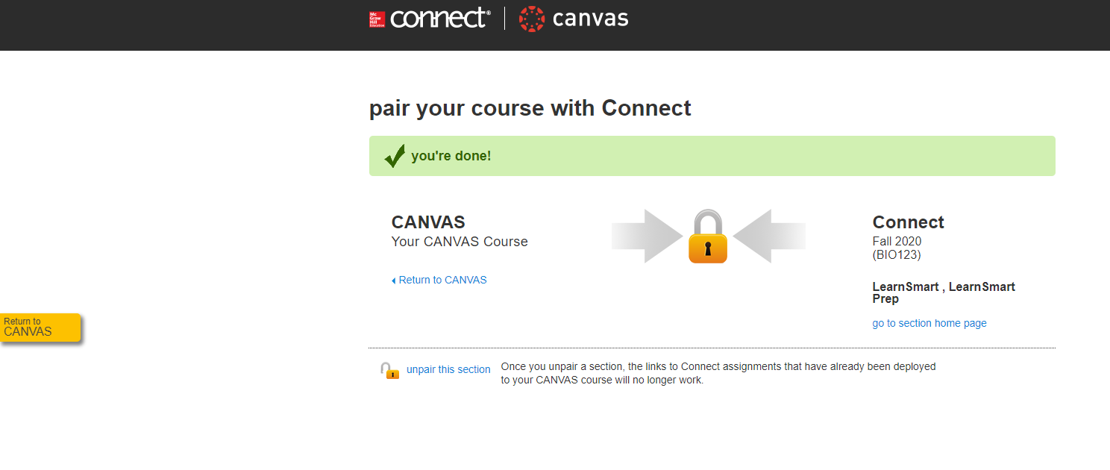
Step 10. Go to your Connect section to deploy your Connect assignment content into Canvas.
Select a Connect assignment(s) (place a check to the right of the Connect assignment).
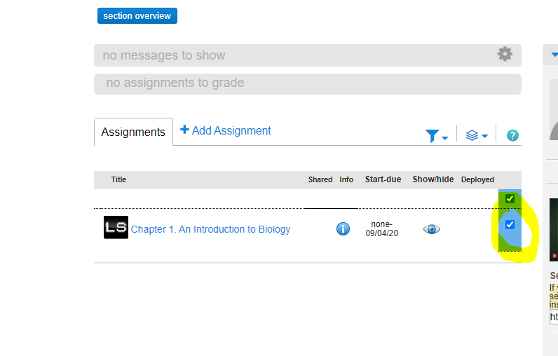

Under the 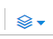 drop down menu, click on Deploy/Manage.
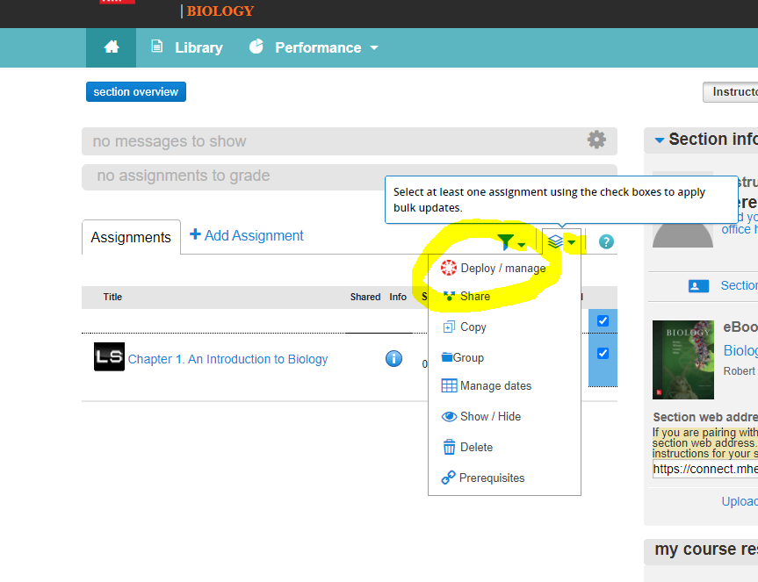

Click Deploy
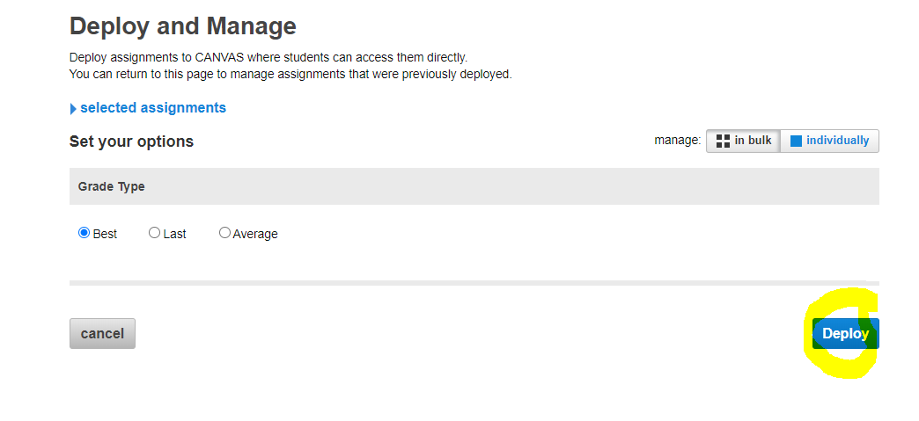

All Connect assignments will deploy into your Assignment folder in Canvas. You can drag/drop the assignment links to their appropriate groupings, if needed.
A grade item will be created automatically for each deployed Connect assignment.
Student grades will automatically sync over from Connect into Canvas upon a student’s submission.
