WHO WE ARE
Based out of Modesto, California, G3 Enterprises was founded by the 3rd Generation of the Gallo Family with the vision of expanding services and increasing productivity to better serve the wine and spirits industry. With more than four decades of experience, we deliver results while building partnerships with our customers and suppliers throughout all of California.
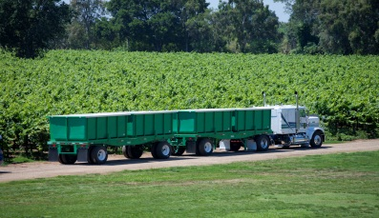

PAID INTERNSHIP OR SEASONAL WORK BEGINNING LATE JULY
As a G3 Enterprises Intern or Seasonal Hire you will report directly to the Manager of Agricultural Transportation. You will assist the Agricultural Transportation team in executing on the group’s mission, including, but not limited to: service integrity, outstanding customer interactions, billing systems input and analysis,
and special projects.

QUALIFICATIONS & RESPONSIBILITIES:
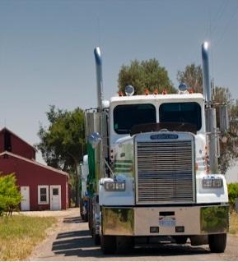
- Must be able to take Fall Quarter off (Harvest is July - November)
- Ability to work 6 days a week, 12 hour days
- Coordinating delivery times and grape varieties with Winery Grower Relations
- Assisting Dispatching Towers for scheduling grapes & pomace
- Collecting vineyard data & paperwork from contracted growers
- Participating in billing systems for transportation of grapes and pomace
- Responsible for day-to-day winery processes from Dispatch Center
- Maintain a written weekly schedule of activities and attend required meetings
- If hired under the Internship Program, the intern will create a project/binder that synthesizes their work over the course of harvest

CURRENT OPPORTUNITIES FOR HARVEST
- Field Dispatcher. You will be required to communicate with growers, truck drivers, and winery dispatch. The field dispatcher is the eyes and ears out in the field and will help coordinate deliveries. A vehicle will be supplied. Clean driving record required. Bilingual in Spanish is helpful, but not required.

- Shuttle Operations. Coordinate grape loads at the winery to the crush pits. Strong communication and operational skills needed. Bilingual in Spanish is helpful, but not required.

- Billing Systems. You will be required to talk with carriers, truck drivers, and winery dispatch. Focus on process improvements and billing accuracy for grape and pomace loads. Able to learn new systems quickly and handle large volumes of paperwork daily. Proficient in Excel. Bilingual in Spanish is helpful, but not required.
WHAT WE OFFER
We offer excellent experience, very competitive salary, and potential for future career opportunities.
Contact: Patrick Frazier at Patrick.Frazier@G3Enterprises.com

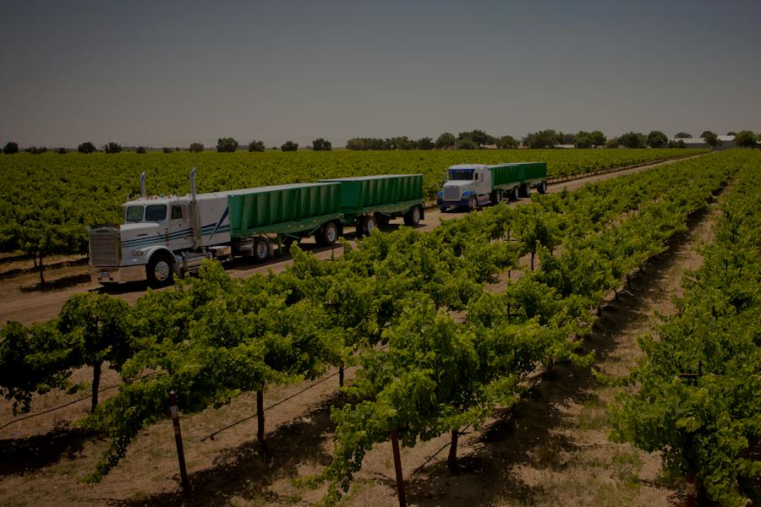
PROFESSIONAL EXPERIENCE YOU WILL GAIN

The G3 Enterprises Agricultural Transportation Internship Program is a three to four month internship designed to give broad-based exposure to the day-to-day activities of transporting grapes and pomace. Interns in the program can be expected to participate in include Fresno, Livingston, Lodi, Central and North Coast

