ARI
Final Report

  - Date: February 17, 2004

  - Reporting Period: June 30, 2002- March 31, 2003

  - Project Number: 46940

  - Project Title: Can The Addition of Silicon to the Solution of Hydroponically-grown Roses Improve the quality of the Fresh Flower Product

  - Principal Investigator (s):
Name (first and last) Virginia R. Walter
Address Horticulture and Crop Science Dept.
Phone and fax 805-756-2897, 805-756-6504
University affiliation California Polytechnic State University

  - Co-Principal Investigator (s):
Name (first and last)
Address
Phone and fax
University affiliation

  - Cooperator (s):
Name (first and last) Steven R. Rein
Address Statistics Department
Phone and fax 805-756-2941
University affiliation California Polytechnic State University

  - Prepared by:
Name (first and last) Virginia R. Walter
Address Horticulture and Crop Science Dept.
Phone and fax805-756-2897, 805-756-6504
Project affiliation California Polytechnic State University

  - Executive Summary:
Summarize the details of the research project.
This experiment started in July 2000 to determine the effects of adding 100 ppm potassium silicate to the nutrient solution of hydroponically grown roses. Initially, established hydroponic rose plants were to be used, but it soon became apparent that replanting with young grafted rose plants made sense. These young plants were established during the winter of 2001 and the nutrient solution tests started soon thereafter. Because of incorrect solutions and plant dieback due to pests and pesticide application, initial data was deemed unusable. Tests started again in earnest in summer of 2002 resulting in two significant flushes of growth on ‘Kardinal’ rose cultivar. Data collected included date of flowering, number of stems per plant, stem length, and a post harvest life study consisting of fresh flowers removed from refrigeration 1, 2, and 3 weeks after harvest date. Observations in a typical room temperature environment included days until no longer acceptable as well as possible reasons for being unacceptable. Based on statistical analysis, silicon had a positive effect on the length of stems on ‘Kardinal’ roses, but had no significant effect on post harvest life.

Introduction: There has been a fair amount written about the positive affects of silicon (Si) on the growth of a variety of plants. Si strengthens cell walls and may improve water uptake as well as use of other nutrients. Benefits to fresh flowers, especially roses, have been alluded to, but few conclusive tests have been done. Reported benefits include longer shelf life, more resistance to pests and diseases, and possibly better overall quality. This test was designed to determine the quality affects of Si (stem length) as well as determine if there are greater numbers of stems produced or if there is an effect on post harvest life. The cultivar tested, ‘Kardinal’ has been a mainstay red rose for many years in the domestic flower producing industry and is a good research plant due to its dependable return from bending and pinching.

Procedures: Young grafted ‘Kardinal’ rose plants were planted in a straight coir media, using 40 buckets, each with 4 plants. Greenhouse conditions remained the same for all plants, with average nighttime temperatures of 65°F and full light intensity conditions. Irrigation was timed to occur frequently during the day with a slight flushing effect with each day’s initial irrigation. A complete nutrient solution containing all essential elements was used. The nutrient solution was provided by an Ammi computerized fertilizer mixing unit. The Si was applied at each irrigation to one-half of the randomly selected buckets. Potassium silicate was added at 100 ppm using a Smith R-3 injector. The source of the silicon was Pro-Tekt® provided by the Dyna-Gro Company. Test plants were pinched and or bent August 22, 2002 to provide a flush of flowers. Harvesting commenced in early October. This flush returned another flush, and harvest of that flush started in mid-November. All stems were harvested uniformly, leaving the same number of leaves each time to minimize data corruption and at the same stage of maturity. Harvested stems were measured for length, recut, and placed in a well-lighted 35°F refrigerator in straight water. Stems placed in post harvest conditions were randomly selected with 5 stems of each nutrient solution per glass vase for each date. Stems were recut to the average of 50 cm in length and placed in a Floralife® Crystal Clear™ solution using 40 grams/gallon. Stems were placed in a lighted, room temperature environment at one week, two weeks, and three weeks after harvest date for each harvest date that had sufficient stems to conduct the tests. Solution was replenished as necessary. Stem condition as to bluing, wilting or other attributes was noted daily. Nutrient, media, and foliar analysis verified the presence of Si in the Si buckets and plants as compared to the others.

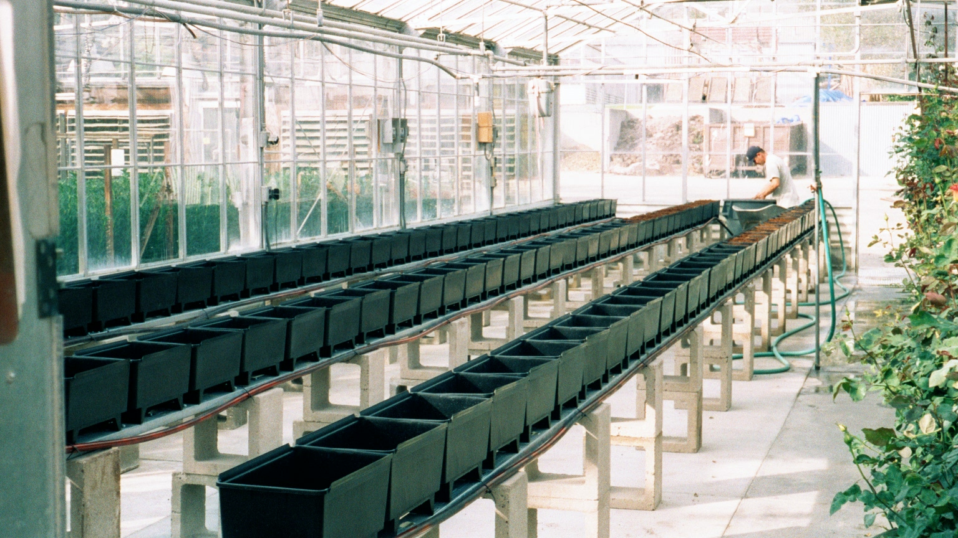
Hydroponic bucket arrangement.

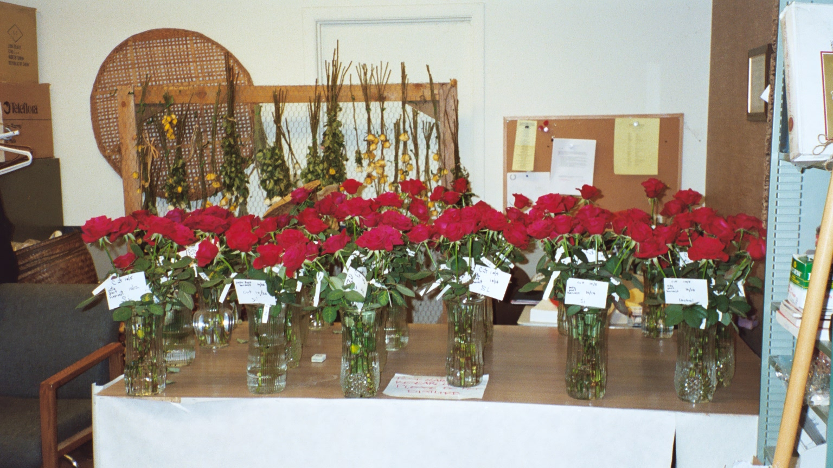
Post-Harvest study.

  - Major Accomplishments:
State the situation of the research and the findings. Describe how the research was beneficial as well as the solutions that were found and by what means. Identify these points by numbers and/or bullets.

This project was to determine the effects of a silicon additive to the growing solution of greenhouse roses. Quality parameters examined include post harvest life, numbers of stems produced, and length of stems as affected by silicon. The following results were determined:

•Although silicon did not significantly influence post harvest life of ‘Kardinal’ roses, it was determined that for every 4 days the harvested roses were stored at 35°F, a rose flower loses one day in the length of its post harvest life.

•There were no significant differences in numbers of stems harvested comparing silicon and control plants.

•There was a significant difference in silicon treatment stem length. The stems were approaching 2 inches greater in length from plants grown with the silicon additive.

We used ANOVA to estimate the effects of explanatory factors on cut rose length. Block and East/West are significantly related to the length of cut roses. Roses from Si treated buckets are significantly longer than roses from the control buckets (p<.001) and a 95% CI for the increase in length from adding Si is 2.3 to 6.2 cm. No other factors are significantly related to the length.

  - Impact Statements:
List the project impacts in priority order using as many numbers as needed.

Roses are a high value, perishable agriculture commodity. Rose growers make use of every environmental factor possible to ensure they are competitive in the market place. Any factor that improves fresh flower quality could have a positive influence of the financial viability of domestic rose growers. It have been determined that rose stem length is significantly longer on roses grown in hydroponic solutions containing the silicon additive. This factor can have a positive influence on the financial return to hydroponic rose growers.

  - Dissemination, publications and presentations of research:
- List all activities in chronological order by category and date (most recent first) including any planned activities.
- Include all names of those presenting and/or coauthoring material.
- State name of publications and identify as refereed journal/paper or trade publication.
- State names and places where presentation(s) were or will be made.
- Attach copies of all disseminated materials including senior projects and graduate theses.

I plan to present the research results at the 2004 American Society for Horticultural Science Annual Meeting in July at Austin, Texas.

The final rose report to the Joseph H. Hill Memorial Foundation was submitted in March 2003 to this granting agency. The report appeared in subsequent editions of a trade publication, Bulletin, the monthly publication of the International Cut Flower Growers Association.

