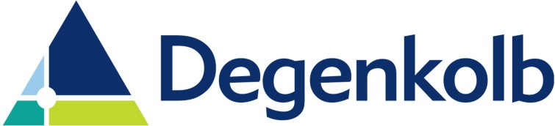

The 2022 Degenkolb Engineers Scholarship + Internship

Degenkolb Engineers has been in the continuous practice of structural engineering for over 80 years with offices currently located in San Francisco, Oakland, Orange County, Sacramento, Los Angeles, San Diego, and Seattle. ALL of our offices are hiring summer Interns. We provide a range of structural engineering services with much of our work in the areas of new design, seismic evaluations, seismic risk assessments, forensic engineering, and rehabilitation and retrofit designs. Clients include a broad spectrum of architects, contractors, government agencies, universities, and corporate clients.
Degenkolb maintains a strong commitment to furthering the standards of the profession through active participation in leading engineering societies, as well as through sharing lessons learned from extensive earthquake reconnaissance worldwide. In our practice, we have found that a graduate education is essential to be effective in the rapidly evolving and technically demanding field of structural engineering.
The Degenkolb Engineers Scholarship has been established to encourage students to pursue a graduate education in structural engineering. The scholarship will be awarded to the Intern applicant that best demonstrates a commitment to furthering the standards of the profession and pursuit of knowledge.

Candidate Qualifications:
- Candidates shall have intent to enroll (or continue enrollment) in the Master of Science in Architectural Engineering program in the Fall 2022
- Candidates shall have excellent academic and leadership skills.

Award:
- Paid 10-week internship with Degenkolb Engineers during the summer of 2022
- $3,000 grant awarded after registration for the ARCE MS program in the Fall 2022 quarter.

Application:
- Submit a targeted cover letter of two pages or less to explain:
- Individual career goals in the structural engineering profession.
- Goals for a graduate school education.
- Individual academic and leadership skills.
- Submit application online https://recruit.hirebridge.com/v3/application/applink.aspx?cid=6099&jid=573038 by March 1, 2022.
- Please include both your resume and your transcripts within our application system.

Please contact Aimee Nalle at analle@degenkolb.com if there are any issues on the application process.

LAST UPDATED: February 4, 2022

