Apply Now!
***2016 Stocker Cattle Enterprise***
at Swanton Pacific Ranch
Gain Experience In:
- Cattle management
- Ranch work
- Basic health care of large animals
- Beef enterprise business management

Requirements:
- Must commit to at least four full weekends (or equivalent) a quarter for both winter and spring quarters
- Willingness to perform ranch work outdoors in sometimes wet and cold weather

- Strongly desired: ASCI 221 (Intro Beef), previous or concurrent enrollment
- Open to all majors
- Enterprise (ASCI 290) meets once/week from 7:10-8am on Wednesdays.
- Transportation, lodging, and meals for weekend ranch trips all provided.

For applications and more information, please contact
Dr. Marc Horney, 10-101; mhorney@calpoly.edu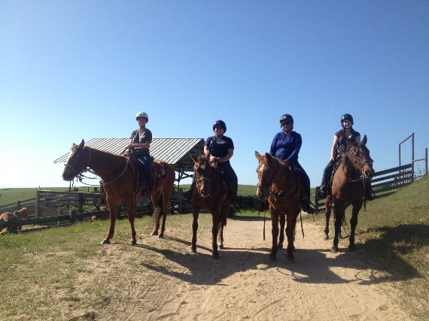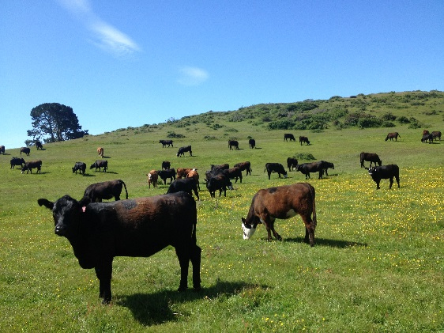

Application and resume – due Nov 13th, 2015
http://animalscience.calpoly.edu/CurrentStudents/forms_current

